Lesson 10: Write Expressions and Equations to Represent Arrays
- Let’s write equations to represent arrays.

Warm-up: True or False: Expressions that Represent Arrays
Decide if each statement is true or false. Be prepared to explain your reasoning.
- $2+2+2=3+3$
- 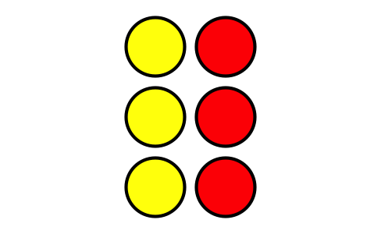
- $4+4+4=3+3+3+3$
- 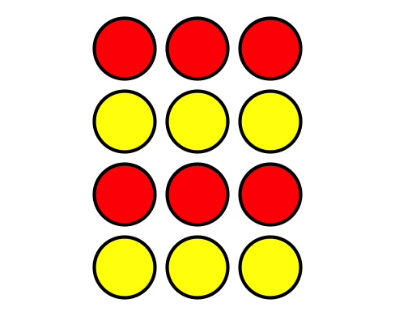
- $5+5+5=3+3+3$

10.1: Build Arrays and Write Equations
- Use 20 counters to make an array with 4 rows.
  - How many columns does your array have?
  - Fill in the blanks to create equations with equal addends that represent the array.
  - $\underset{_}{}+\underset{_}{}+\underset{_}{}+\underset{_}{}=\underset{_}{}$
  - $\underset{_}{}+\underset{_}{}+\underset{_}{}+\underset{_}{}+\underset{_}{}=\underset{_}{}$
- Use 15 counters to make an array with 3 columns.
  - How many rows does your array have?
  - Fill in the blanks to create equations with equal addends that represent the array.
  - $\underset{_}{}+\underset{_}{}+\underset{_}{}+\underset{_}{}+\underset{_}{}=\underset{_}{}$
  - $\underset{_}{}+\underset{_}{}+\underset{_}{}=\underset{_}{}$
- Choose an even number of counters between 6 and 24. Make an array.
  - How many rows does your array have?
  - How many columns does your array have?
  - Write equal addends equations that represent the array.

10.2: Arrange Veggies to Make Arrays
- Make an array that shows how to plant 9 potatoes. Draw it.
Write an equation to represent your array.
- Make an array that shows how to plant 16 carrot seeds. Draw it.
Write an equation to represent your array.
- Make an array that shows how to plant 15 potatoes. Draw it.
Write an equation to represent your array.
- Make an array that shows how to plant 12 carrot seeds. Draw it.
Write an equation to represent your array.
© CC BY 2021 Illustrative Mathematics®

