Lesson 13: More Story Problems with Teen Numbers
- Let’s solve story problems.

Warm-up: Number Talk: Add Ones
Find the value of each expression mentally.
- $3+4$
- $4+3$
- $10+3$
- $14+3$

13.1: Sitting or Standing
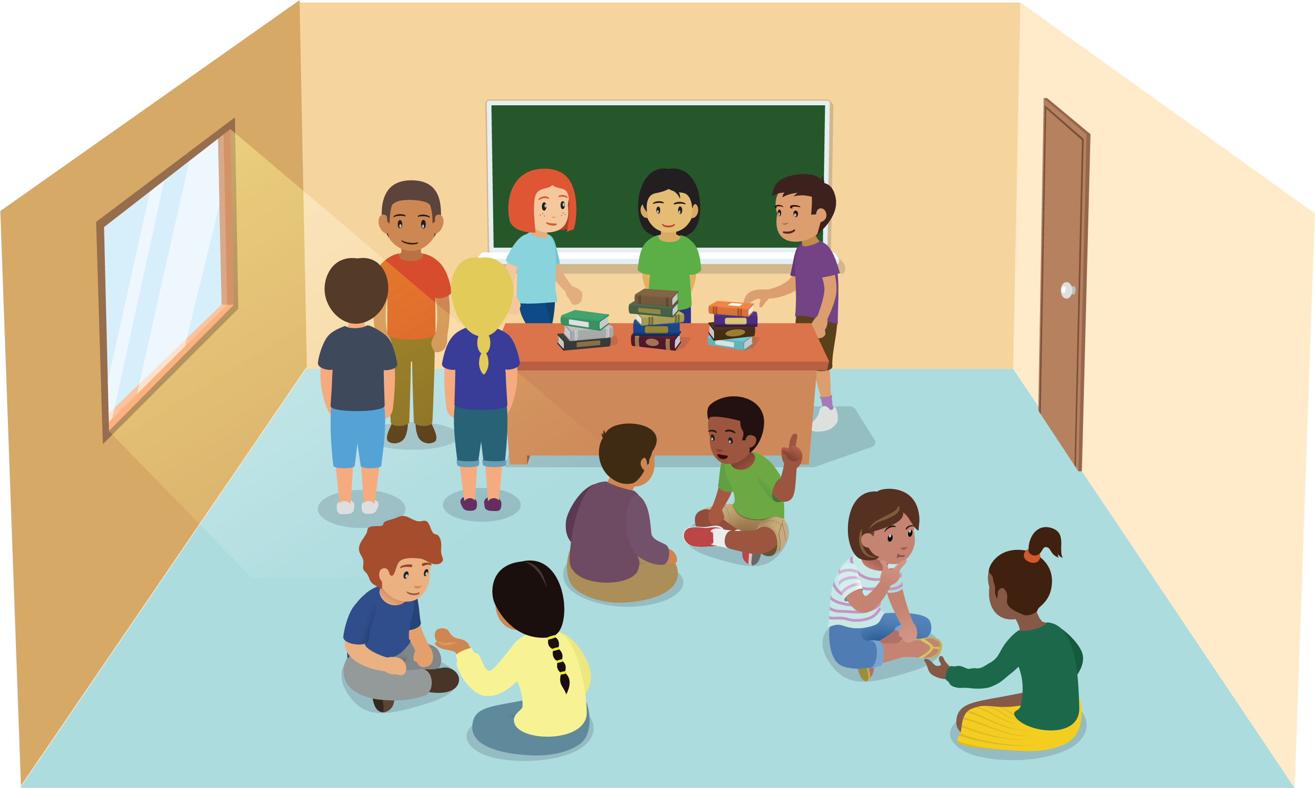
- There are students standing in the classroom.
Some of the students sit down on the rug.
There are still some students standing.
- There are 15 students standing in the classroom.
Some of the students sit down on the rug.
There are still 5 students standing.
How many students sat down on the rug?
Show your thinking using drawings, numbers, or words.
- Equation: ________________________________

13.2: Solve Story Problems and Compare Methods
- There are 17 students in the classroom.
4 students go home.
How many students are still in the classroom?
Show your thinking using drawings, numbers, or words.
- Equation: _____________________________
- There are 17 students in the classroom.
Some students go home.
Then there are 4 students in the classroom.
How many students went home?
Show your thinking using drawings, numbers, or words.
- Equation: _____________________________

13.3: Centers: Choice Time
Choose a center.
Shake and Spill
Compare
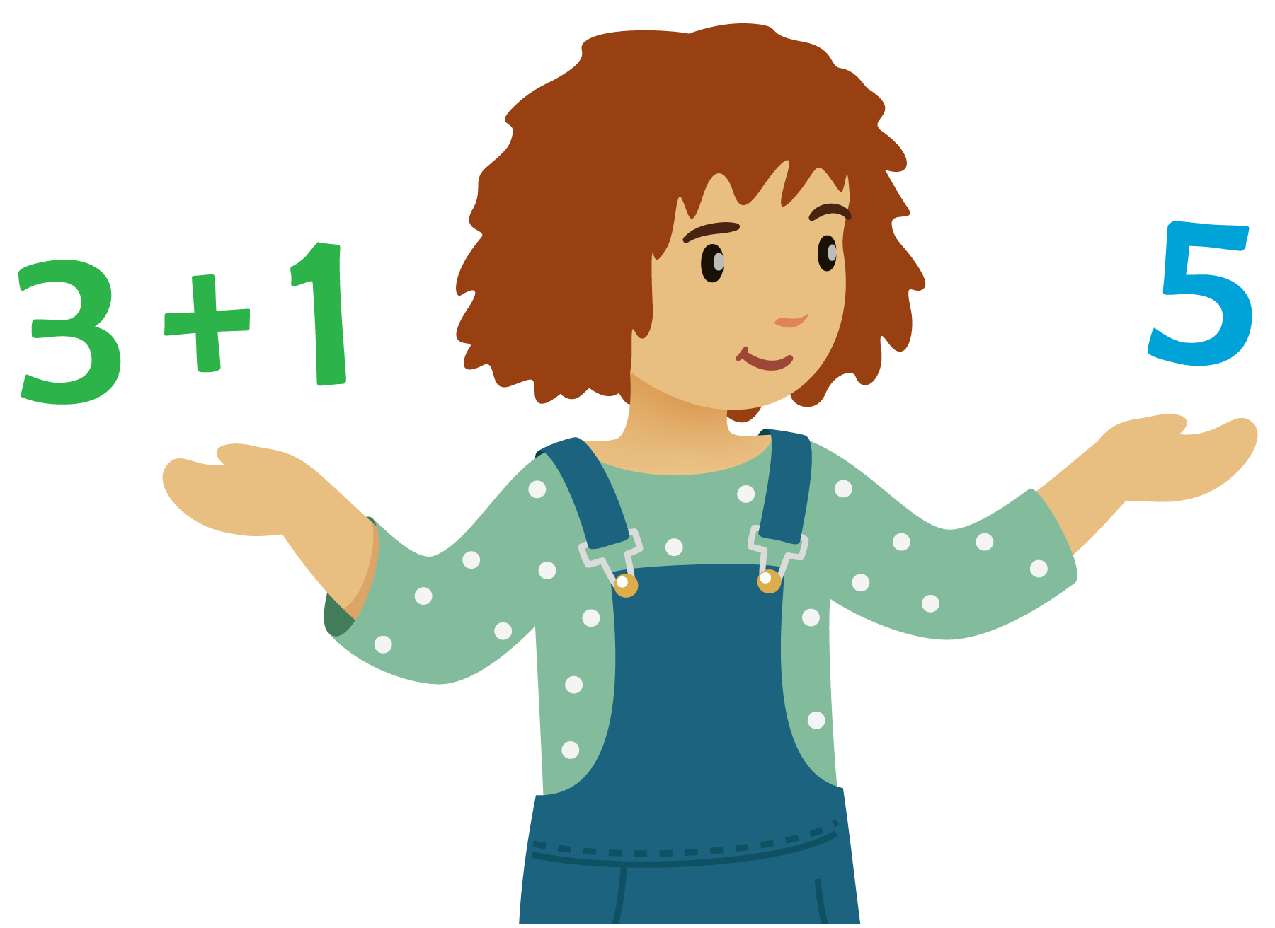
Number Puzzles
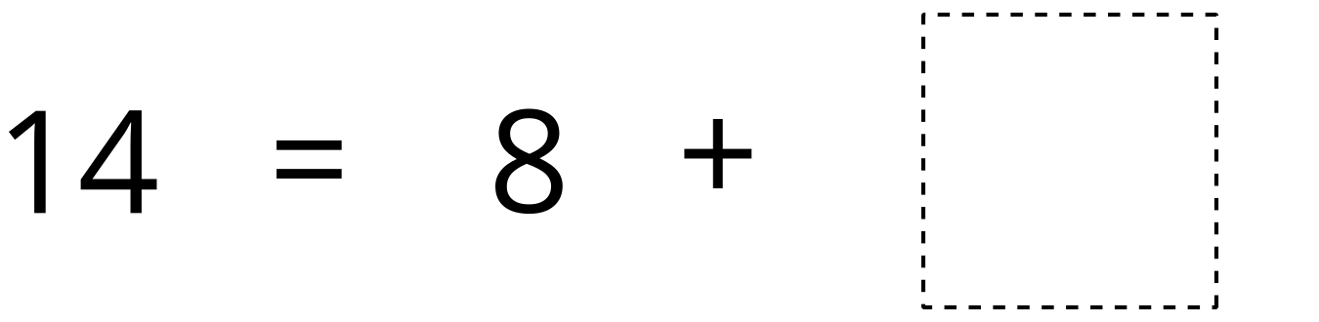

Section Summary
Section Summary
We learned that 10 ones make a ten.
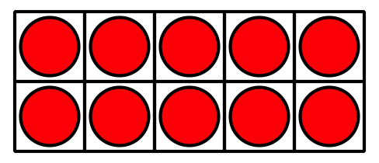
We learned that all teen numbers can be represented as a ten and some ones.
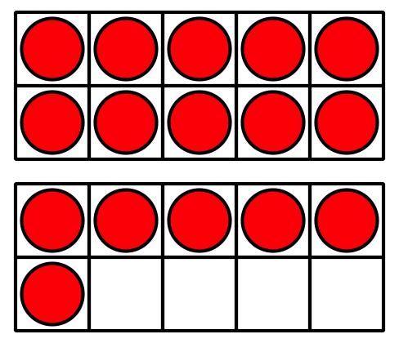
We used that understanding to find missing numbers in addition and subtraction equations with teen numbers.
10+6=16
10+2=6​​​​​​
5+6=15
13−10=6​​​​​​
19−9=6​​​​​​
We solved a new type of story problem where we don't know how many to subtract. We used different equations to match the story.
There are 17 students in the classroom.
Some students go home.
Then there are 4 students in the classroom.
How many students went home?
17−3=4
17−4=6
© CC BY 2021 Illustrative Mathematics®

