Lesson 4: Create Scaled Picture Graphs

Standards Alignments
Addressing | 3.MD.B, 3.MD.B.3
Building Towards | 3.MD.B.3

Teacher-facing Learning Goals
- Represent data using scaled picture graphs.

Student-facing Learning Goals
- Let’s make a scaled picture graph.

Lesson Purpose
The purpose of this lesson is for students to create a scaled picture graph to represent categorical data.
In a previous lesson, students interpreted and answered questions about scaled picture graphs. In this lesson, they gather and organize data about ways that students would like to travel and represent the data in a scaled picture graph with a scale of 2. Students make sense of how to represent a single student on a scaled picture graph that has a scale of 2.
Math Community
Explain to students that norms are expectations that help everyone in the room feel safe, comfortable, and productive doing math together. Tell students that some of these norms may apply to both you and me, however there may be things you need me to do to support you in doing math each day. Offer an example, such as “It may help us share our ideas as a whole class if we have the norm ‘Listen as others share their ideas.’” Tell students you will pause at two different points of the lesson to identify norms that help everyone do math.

Access for:

Students with Disabilities
- Representation (Activity 2)

English Learners
- MLR8 (Activity 2)

Instructional Routines
How Many Do You See? (Warm-up)

Lesson Timeline
Warm-up | 10 min
Activity 1 | 15 min
Activity 2 | 20 min
Lesson Synthesis | 10 min
Cool-down | 5 min

Teacher Reflection Question
What was the best question you asked students today? Why would you consider it the best one based on what students said or did?

Cool-down
(to be completed at the end of the lesson) 5min
Complete the Picture Graph

Standards Alignments
Addressing | 3.MD.B.3

Student-facing Task Statement
A group of students were asked, “How would you like to travel?”
Their responses are shown in this picture graph:
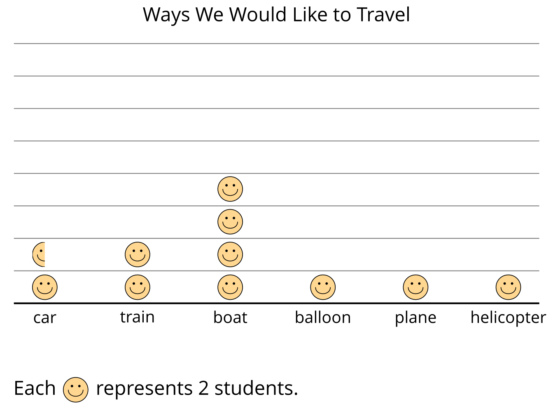
Four students were absent when this data was collected. They would like to travel by plane.
Add their data to the graph.

Student Responses
Students draw two more smiley faces in the plane column.

