Lesson 9: Add 2 Two-digit Numbers
- Let’s add two-digit numbers.

Warm-up: Number Talk: Make a Ten
Find the value of each expression mentally.
- $38+2$
- $40+3$
- $38+5$
- $38+15$

9.1: How Did You Find the Value?
Find the value of $17+36$.
Show your thinking using drawings, numbers, or words.

9.2: Grab and Add
Round 1:
Grab a handful of towers of ten and a handful of single cubes.
I have ______________ cubes and my partner has ______________ cubes.
How many cubes do you and your partner have altogether?
Show your thinking using drawings, numbers, or words.
Round 2:
I have ______________ cubes and my partner has ______________ cubes.
How many cubes do you and your partner have altogether?
Show your thinking using drawings, numbers, or words.
Round 3:
I have ______________ cubes and my partner has ______________ cubes.
How many cubes do you and your partner have altogether?
Show your thinking using drawings, numbers, or words.
Round 4:
I have ______________ cubes and my partner has ______________ cubes.
How many cubes do you and your partner have altogether?
Show your thinking using drawings, numbers, or words.
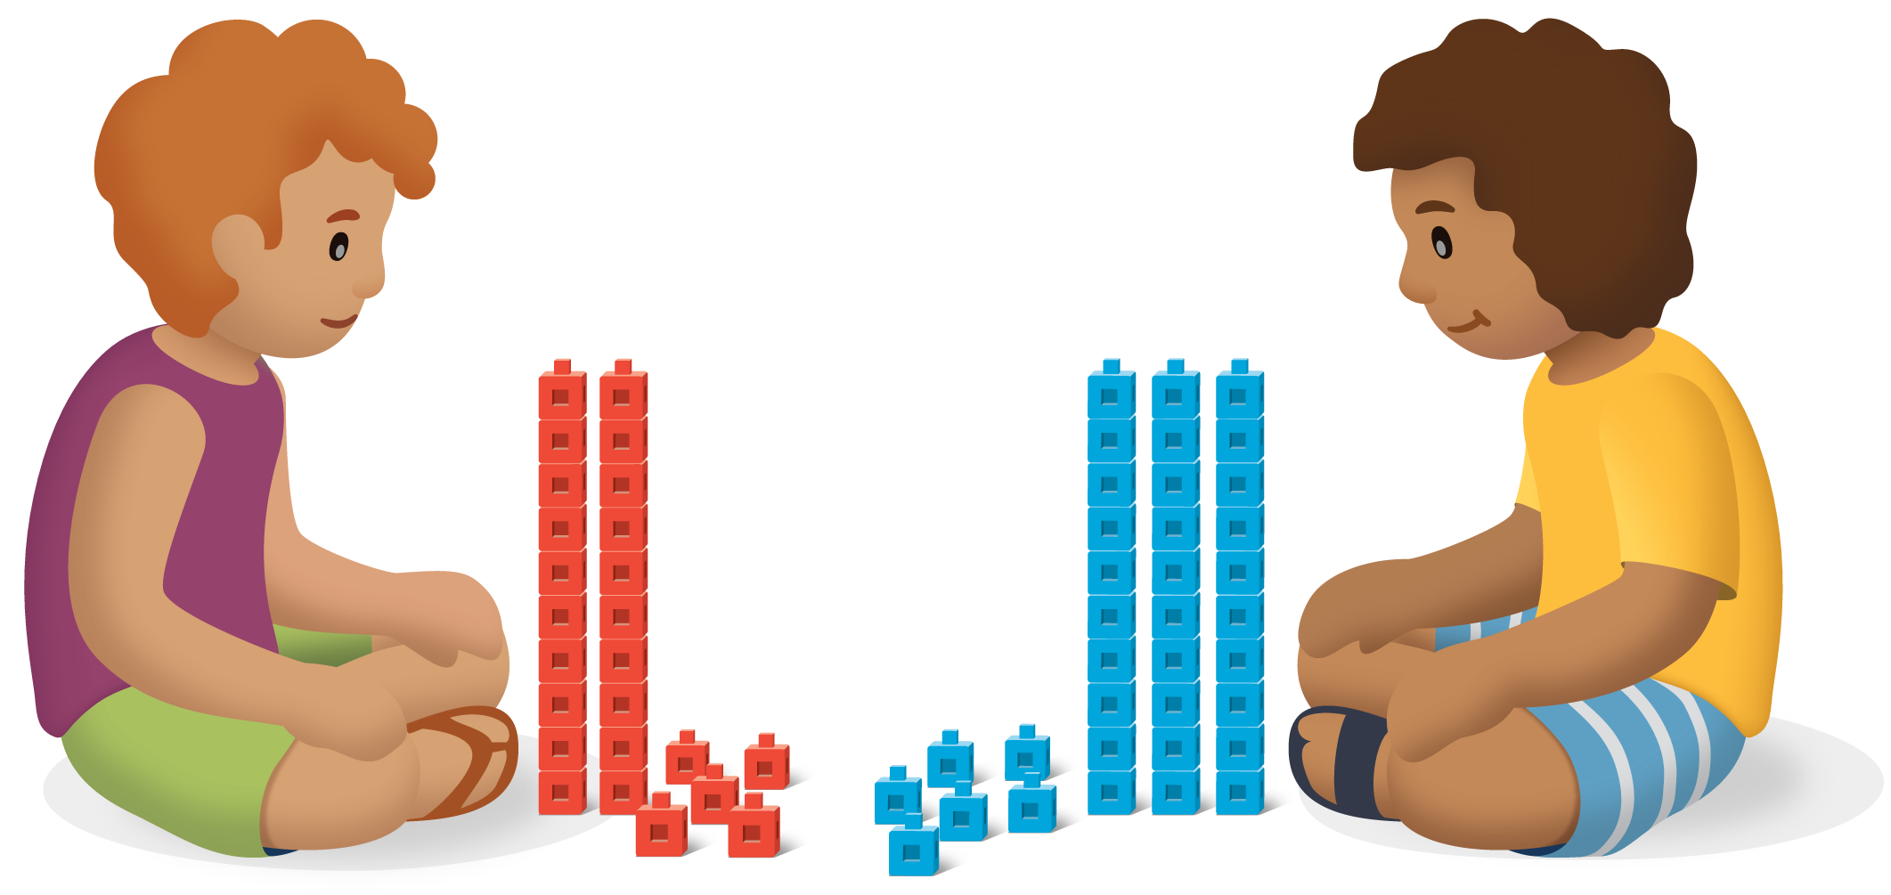
© CC BY 2021 Illustrative Mathematics®

