Lesson 13: Center Day 2
- Let’s skip-count and practice addition and subtraction.

Warm-up: True or False: Two or False
Decide if each statement is true or false. Be prepared to explain your reasoning.
- $2+2+2+2=4+4$
- $2+2+2=3+3$
- $2+2+2+2+2+2=5+5$

13.1: Centers: Choice Time
Choose a center.
Write Numbers
Target Numbers
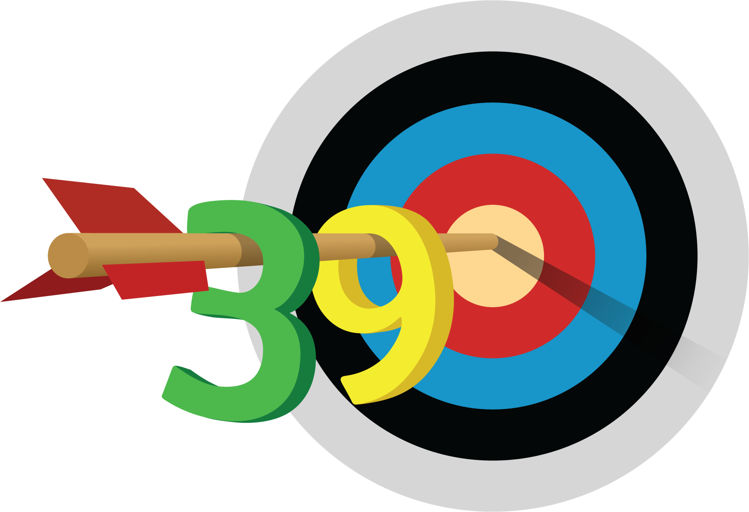
Five in a Row
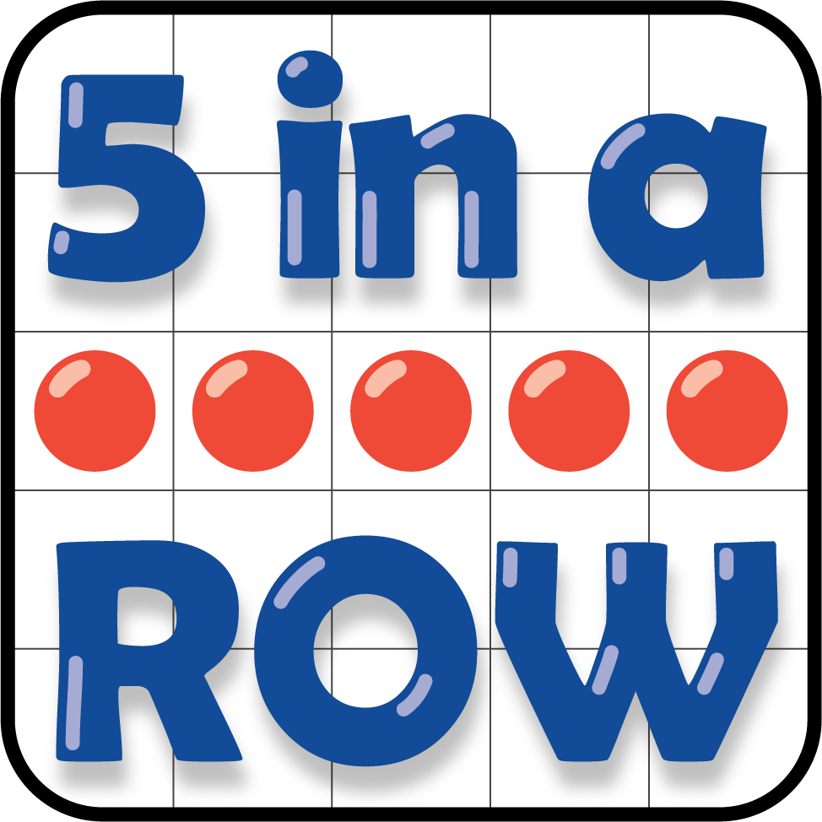
How Close
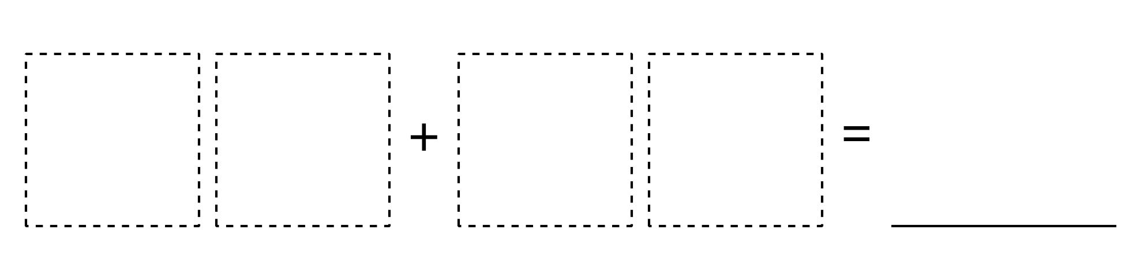
© CC BY 2021 Illustrative Mathematics®

