Unit 5 Lesson 6: Find That Factor

1 Multiplication and Division (Warm up)

Images for Launch

Student Task Statement
Here are some multiplication and division equations. Write the missing pieces. The first one is completed, as an example.
- $6÷2=3$ and $2⋅3=6$
- $20÷4=5$ and $\underset{_}{​}$
- $\underset{_}{​}$ and $1.5⋅12=18$
- $9÷\frac{1}{4}=36$ and $\underset{_}{​}$
- $12÷15=\underset{_}{​}$ and $\underset{_}{​}$
- $a÷b=c$ and $\underset{_}{​}$

2 Scaling Segments

Student Task Statement
For each question, the length of the second segment (on the right) is some fraction of the length of the first segment (on the left). Complete the division and multiplication equations that relate the lengths of the segments.

figure 1
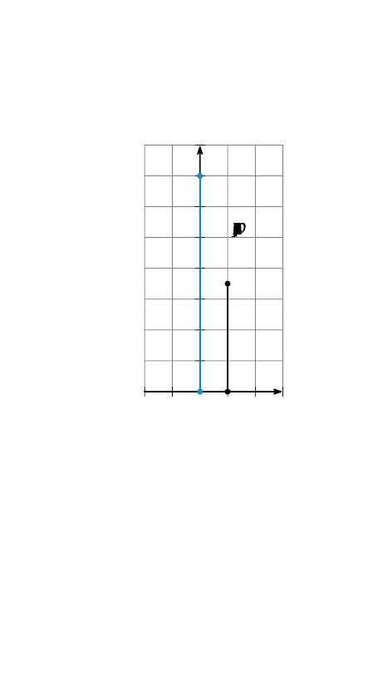

figure 2
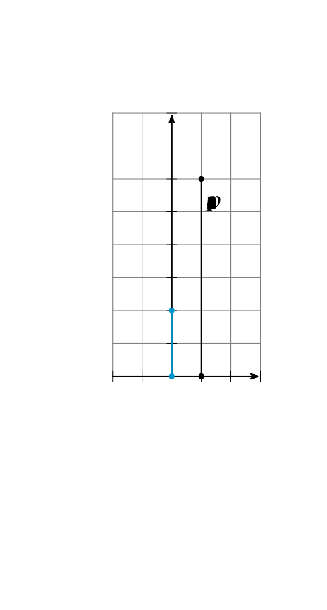

figure 3
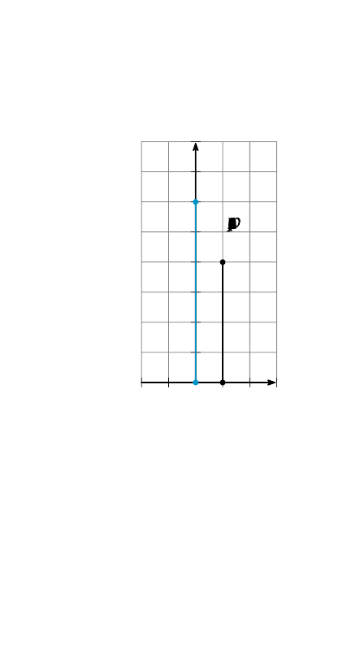
$7÷14=\frac{1}{2}$
$14⋅\frac{1}{2}=7$
33÷33=3
33⋅33=12
8÷12=33
12⋅33=8

figure 4
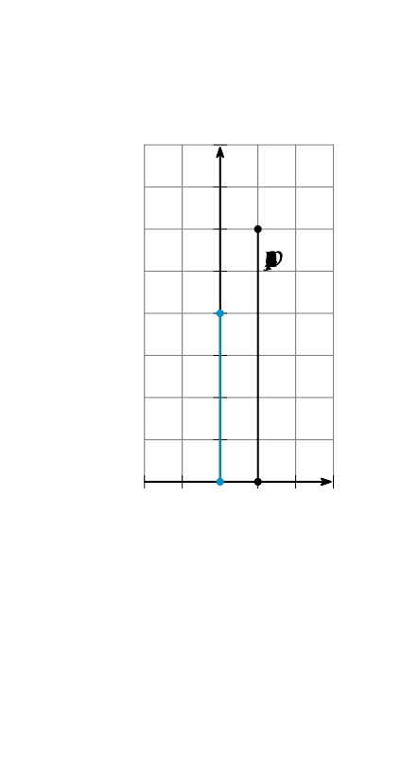

figure 5
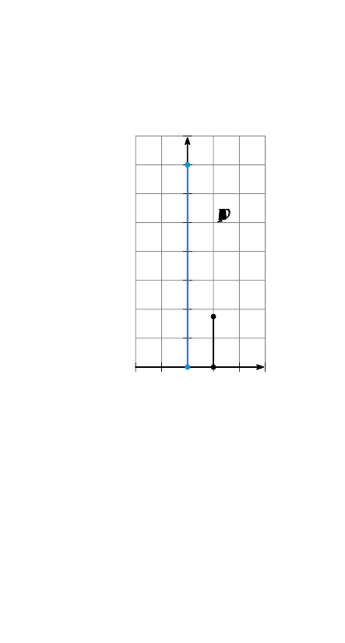

figure 6
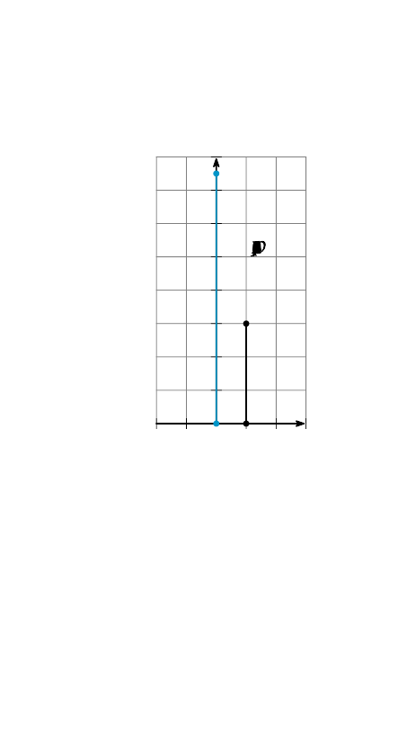
33÷33=33
33⋅33=33
33÷33=33
33⋅33=33
33÷33=33
33⋅33=33

3 Medicine Wears Off

Student Task Statement
Some different medications were given to patients in a clinical trial, and the amount of medication remaining in the patient’s bloodstream was measured every hour for the first three hours after the medicine was given. Here are graphs representing these measurements.

Medicine A
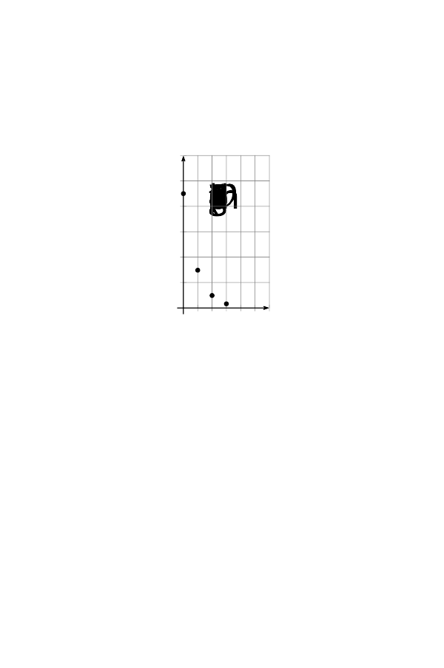

Medicine B
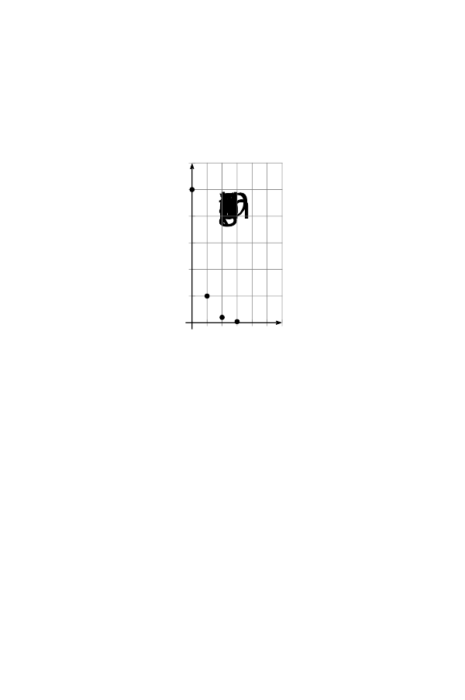

Medicine C
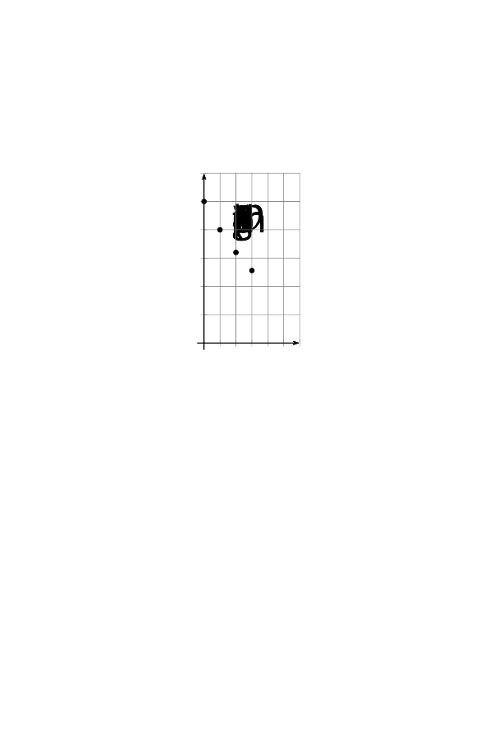

Medicine D
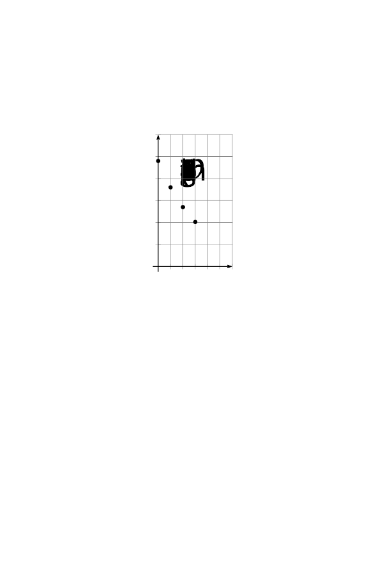

Medicine E
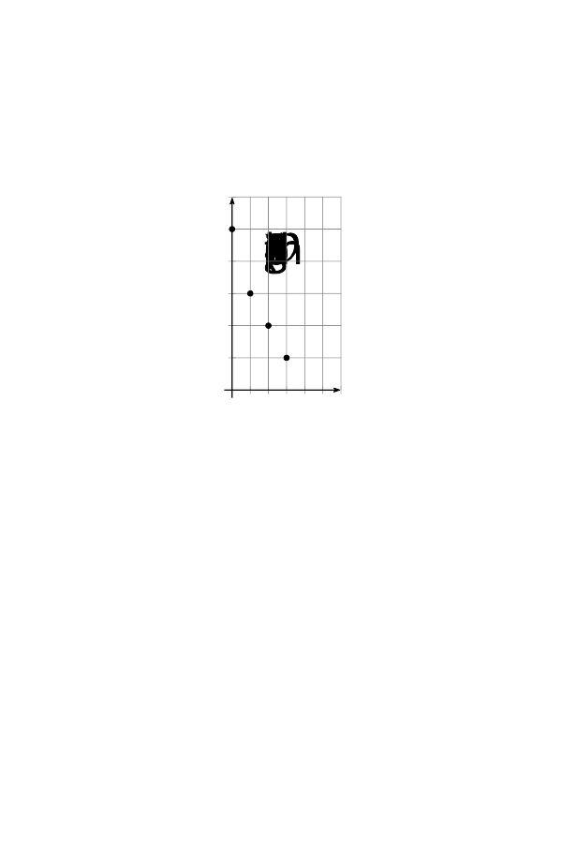

- For one of these medicines, the relationship between medicine remaining and time is not exponential. Which one? Explain how you know.
- For the other four medicines:
  - How much was given to the patient?
  - By what factor does the medicine remaining change with each passing hour?
  - How much medicine will remain at 4 hours?
- Which medicine leaves the bloodstream the quickest? The slowest? Explain how you know.
© CC BY 2019 by Illustrative Mathematics®

