Unit 9 Lesson 1: Tessellations of the Plane

1 Notice and Wonder: Polygon Patterns (Optional)

Student Task Statement
What do you notice? What do you wonder?
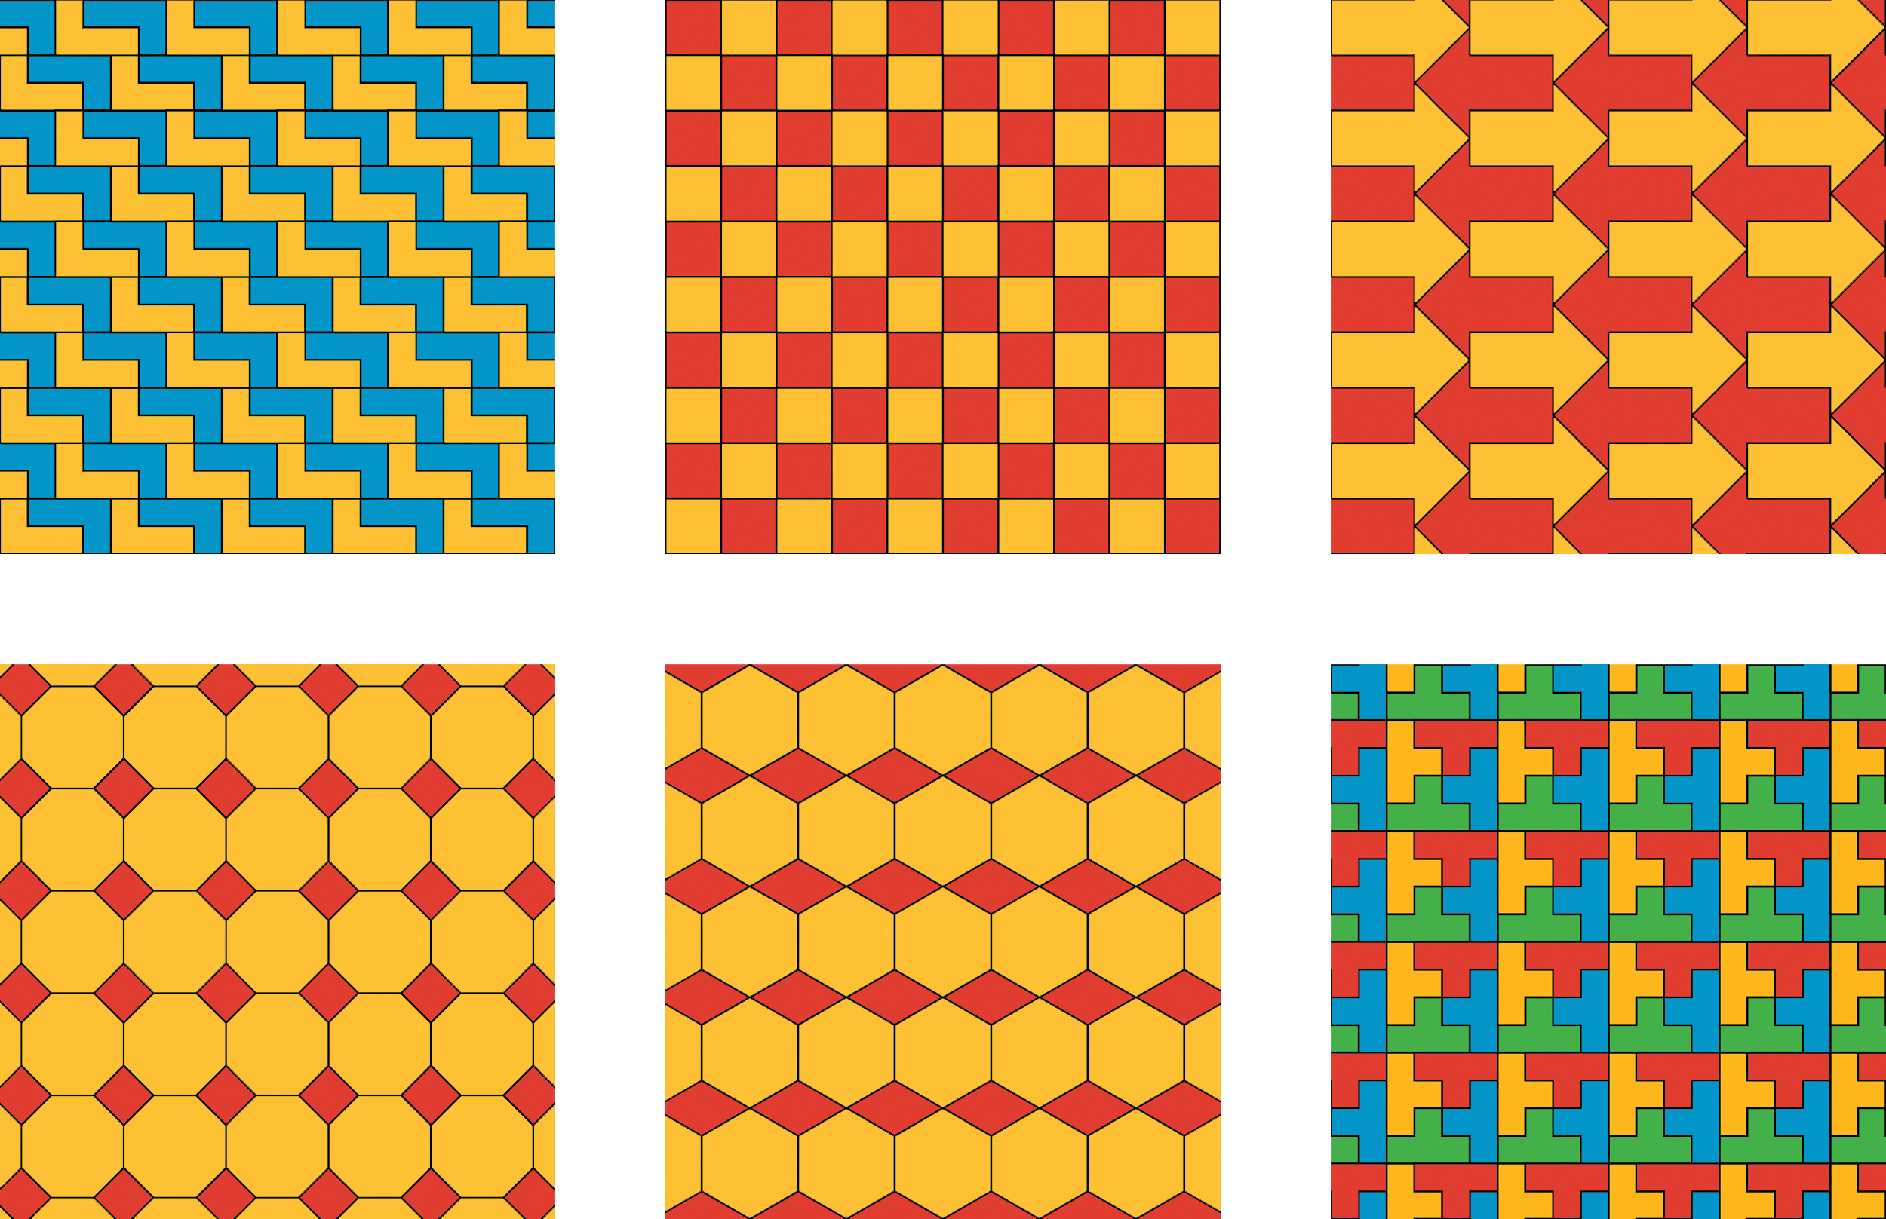

2 Tessellations (Optional)

Student Task Statement
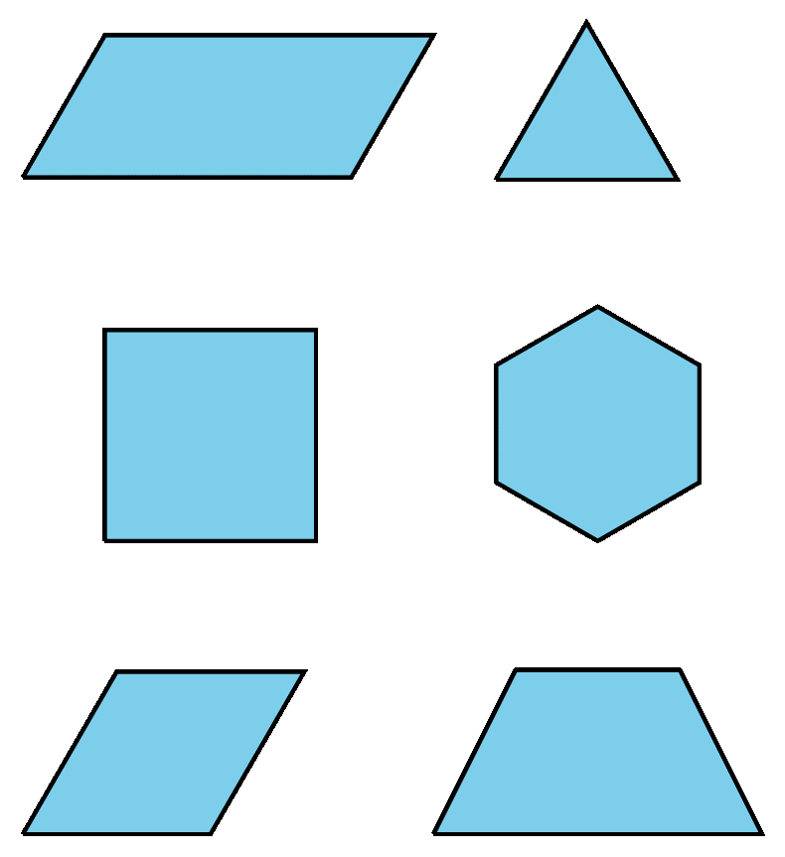
- Pick one of the shapes. Create a tessellation by tracing copies of your shape. Make sure to use the same shape as your partner.
- Compare your tessellation to your partner’s. How are they similar? How are they different?
- If possible, make a third tessellation of the plane with your shape (different from the ones you and your partner already created). If not possible, explain why it is not possible.

3 Describing a Tessellation (Optional)

Student Task Statement
- Pick one of the figures and describe the tessellation. Your partner will identify which tessellation you are describing. Then trade roles so your partner describes the tessellation and you identify the figure.
- 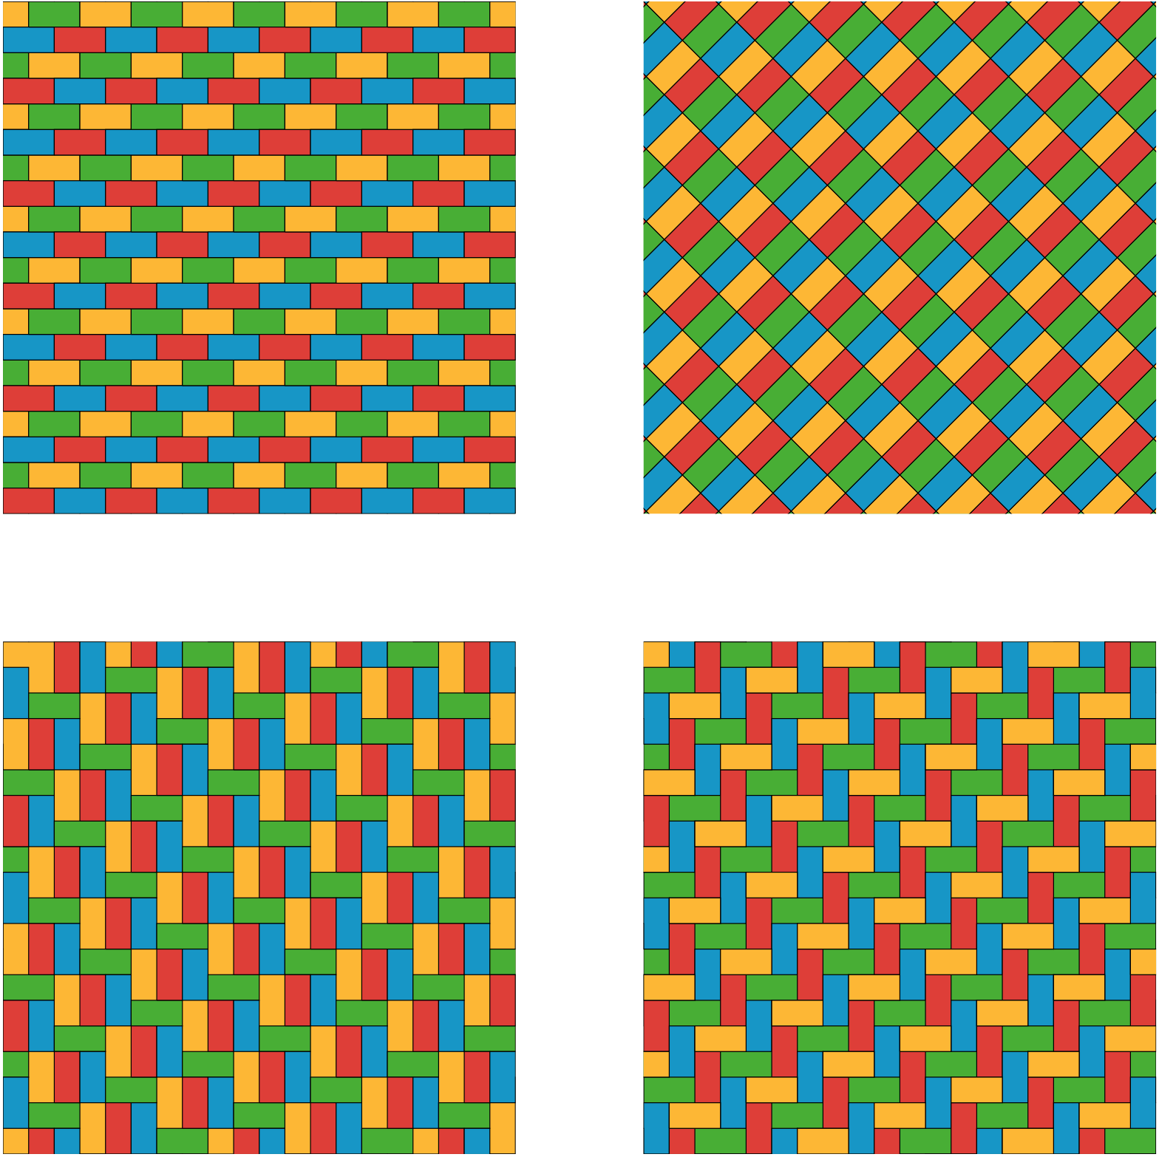
- You and your partner each have a card with a tessellation. Describe what is on your card so that your partner can produce the tessellation (this should be done so that you cannot see your partner’s work until it is complete).

- Check together to see if your partner’s tessellation agrees with your card and discuss any differences.
- Change roles so your partner describes a tessellation, which you attempt to produce.
- Check the accuracy of your construction and discuss any discrepancies.
© CC BY Open Up Resources. Adaptations CC BY IM.

