Lesson 14: Representing Fractions on a Line Plot

Standards Alignments
Addressing | 5.MD.B.2, 5.NF.A.1
Building Towards | 5.MD.B.2

Teacher-facing Learning Goals
- Create line plots and use the information to solve problems.

Student-facing Learning Goals
- Let’s make a line plot and analyze the data we collect.

Lesson Purpose
The purpose of this lesson is for students to make and interpret line plots displaying fractions in eighths.
In this lesson, students use fraction arithmetic to solve problems about line plots. Students make line plots by generating data and using given data and then they solve problems about the line plots. Students have worked with these line plots in a previous course. The new part of the work in this lesson and the next is the level of complexity of the questions they answer. In this lesson they perform arithmetic with the fractions and answer questions that involve thinking about all the data as a whole and certain measurements as a fraction of that whole (MP2).

Access for:

Students with Disabilities
- Engagement (Activity 1)

English Learners
- MLR8 (Activity 2)

Instructional Routines
Which One Doesn’t Belong? (Warm-up)

Materials to Gather
- Paper clips: Activity 1
- Pencils: Activity 1

Lesson Timeline
Warm-up | 10 min
Activity 1 | 15 min
Activity 2 | 20 min
Lesson Synthesis | 10 min
Cool-down | 5 min

Teacher Reflection Question
How did the student work that you selected, particularly in the second activity, impact the direction of the discussion? What student work might you pick next time if you taught the lesson again?

Cool-down
(to be completed at the end of the lesson) 5min
A Dozen Eggs

Standards Alignments
Addressing | 5.MD.B.2

Student-facing Task Statement
Here are the weights of a different collection of chicken eggs.
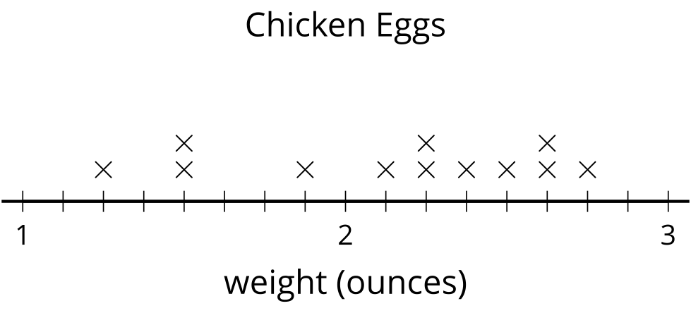
What is the combined weight of all the eggs that weigh more than $2\frac{1}{2}$ ounces? Explain or show your reasoning.

Student Responses
8 ounces or equivalent. There are 2 eggs that weigh $2\frac{5}{8}$ ounces and 1 egg that weighs $2\frac{3}{4}$ ounces or $2\frac{6}{8}$ ounces. If I add them up, I get $6\frac{16}{8}$ ounces which is the same as 8 ounces.

