Lesson 7: Does it Make a New Ten?
- Let’s add one-digit and two-digit numbers and write equations.

Warm-up: Which One Doesn’t Belong: Expressions
Which one doesn’t belong?
A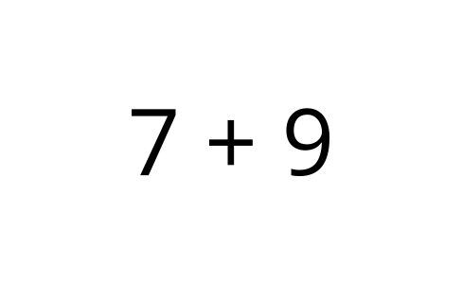
B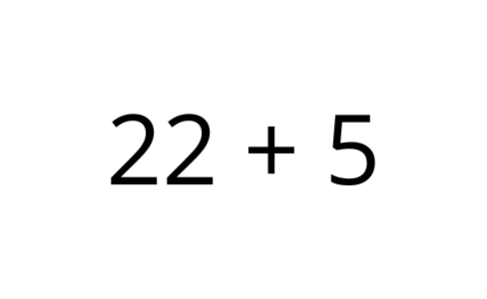
C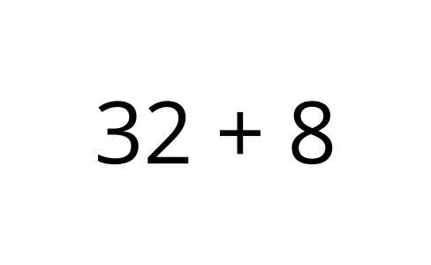
D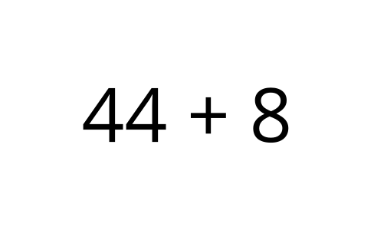

7.1: A Ten or Not a Ten?
Jada likes to look for ways to make a new ten when she adds. Would she be able to a make a new ten when she adds to find the value of these sums?
If Jada could make a new ten, circle “Yes.”
If Jada could not make a new ten, circle “No.”
- Does the expression make a new ten?
- $45+5$
- Yes
- No
- Explain how you know.
- Find the value.
- Write equations to show how you found the value of the sum.
- Does the expression make a new ten?
- $9+63$
- Yes
- No
- Explain how you know.
- Find the value.
- Write equations to show how you found the value of the sum.
- Does the expression make a new ten?
- $26+3$
- Yes
- No
- Explain how you know.
- Find the value.
- Write equations to show how you found the value of the sum.
- Does the expression make a new ten?
- $8+47$
- Yes
- No
- Explain how you know.
- Find the value.
- Write equations to show how you found the value of the sum.

7.2: Missing Numbers
Lin’s brother spilled water on her math work!
Figure out what number Lin wrote before it got smudged.
- Lin wrote a one-digit number with which you can make a new ten when you find the value of the sum.
- What could Lin’s number be?
Write equations to show your thinking.
- Lin wrote a one-digit number with which you can not make a new ten when you find the value of the sum.
- What could Lin’s number be?
Write equations to show your thinking.
- Lin wrote a two-digit number with which you can make a new ten when you find the value of the sum.
- What could Lin’s number be?
Write equations to show your thinking.
- Lin wrote a two-digit number with which you can not make a new ten when you find the value of the sum.
- What could Lin’s number be?
Write equations to show your thinking.
- How do you know whether or not you can make a new ten when you are finding the value of a sum?

Section Summary
Section Summary
We added one-digit numbers and two-digit numbers.
We used different methods to add.
We learned you can think of counting on to make a new ten.
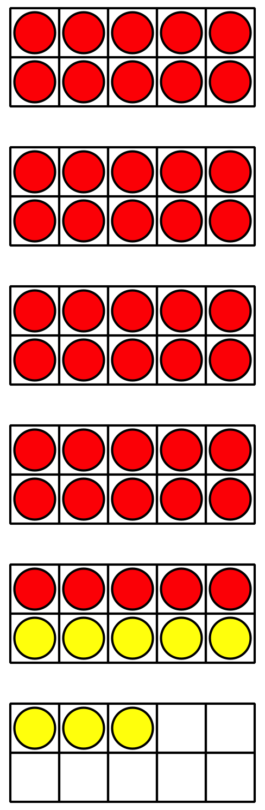
$45+8$
$45+5+3=\boxed{53}$
We also saw you can think of adding all the ones and then the tens.
Sometimes when you add the ones you might be able to make a new ten.
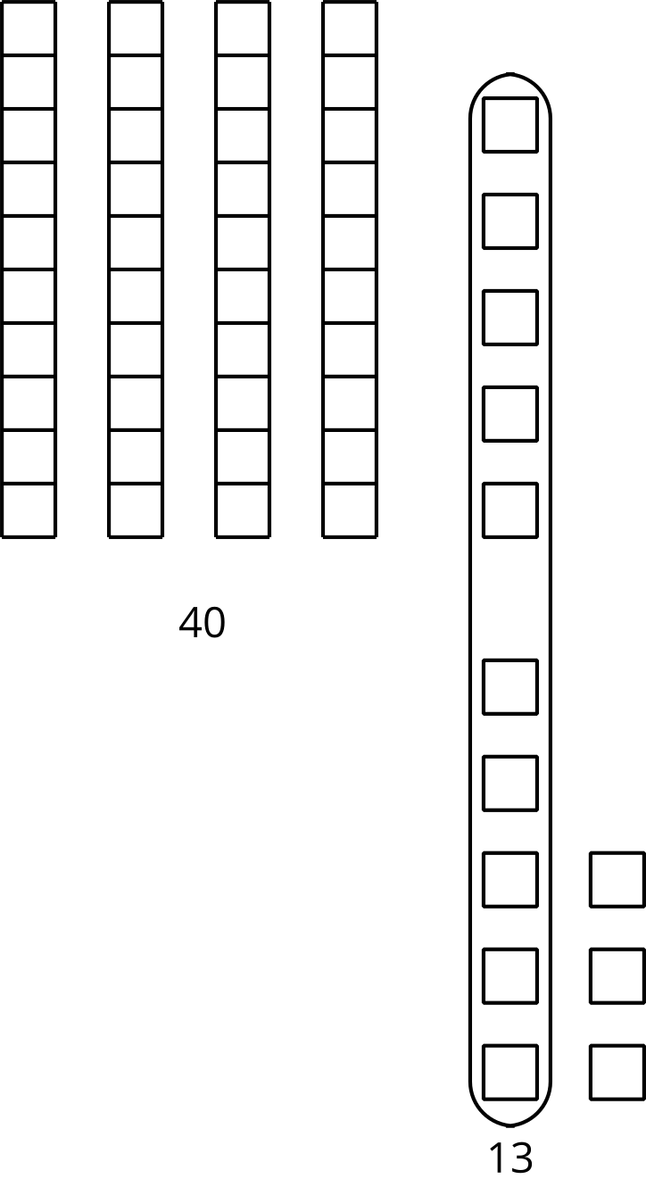
$5+8=13$
$40+13=53$
© CC BY 2021 Illustrative Mathematics®

