Unit 3 Lesson 16: Interpret Measurement Data

WU Number Talk: Addition within 50 (Warm up)

Student Task Statement
Find the value of each expression mentally.
- $15+5+1$
- $25+6$
- $16+7$
- $37+6$

1 The Plant Project

Student Task Statement
Use the data in this table to create a line plot.
Group B | plant heights (centimeters)
Andre | 33
Clare | 25
Diego | 27
Elena | 25
Han | 35
Jada | 33
Kiran | 26
Noah | 30
Priya | 26
Tyler | 33

2 Interpret Measurement Data on a Line Plot

Student Task Statement
The Plant Project
Answer the questions based on your line plot.
- What was the shortest plant height?
- What was the tallest plant height?
- What is the difference between the height of the tallest plant and the shortest plant? Write an equation to show how you know.
- 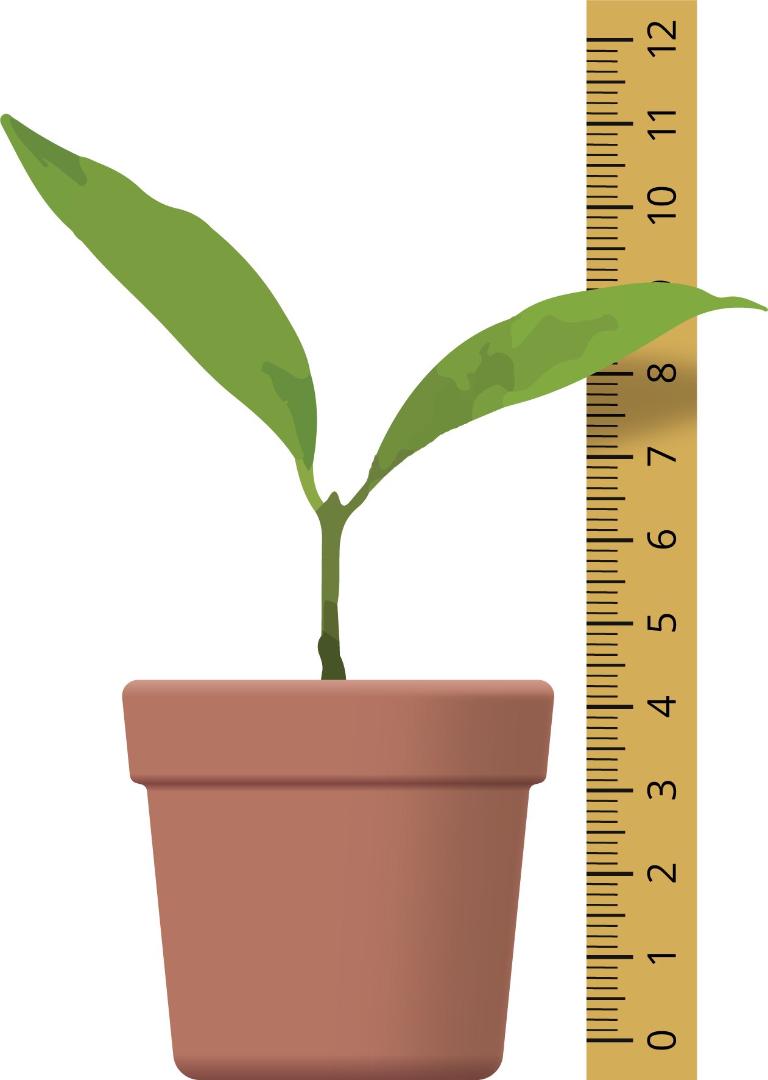
- Answer the questions based on Han’s line plot.
- 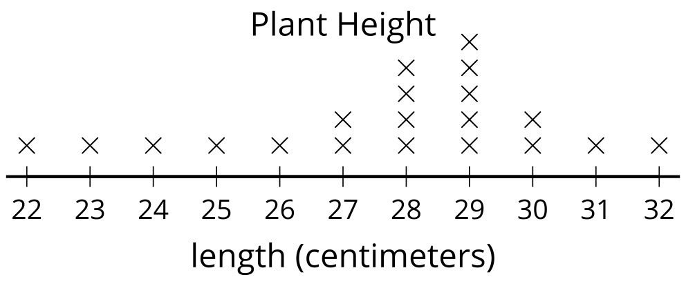
- Han looked at this line plot and said that the tallest plant was 29 centimeters. Do you agree with him? Why or why not?
- How many plants were measured in all?
- Write a statement based on Han’s line plot.

Images for Activity Synthesis
© CC BY 2021 Illustrative Mathematics®

