Lesson 11: Arrays and Rectangles
- Let’s make arrays and rectangles using tiles.

Warm-up: Which One Doesn’t Belong: All Kinds of Arrays
Which one doesn’t belong?
A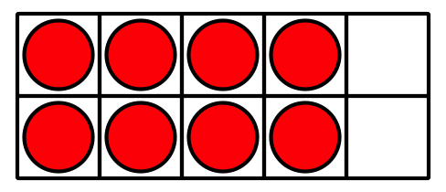
B
C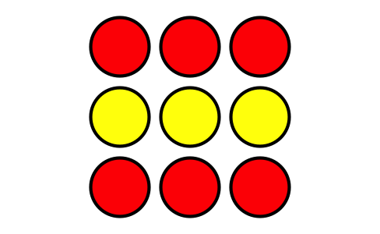
D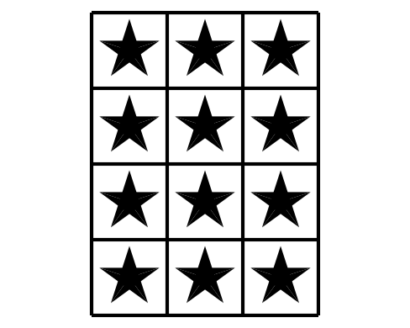

11.1: Use Tiles to Make Arrays
Choose a number of tiles.
12 | 15 | 16 | 18 | 20

Arrange all the tiles in an array. Then push them together to make a rectangle.
- Shade in the same arrangement of squares on the grid paper.
- 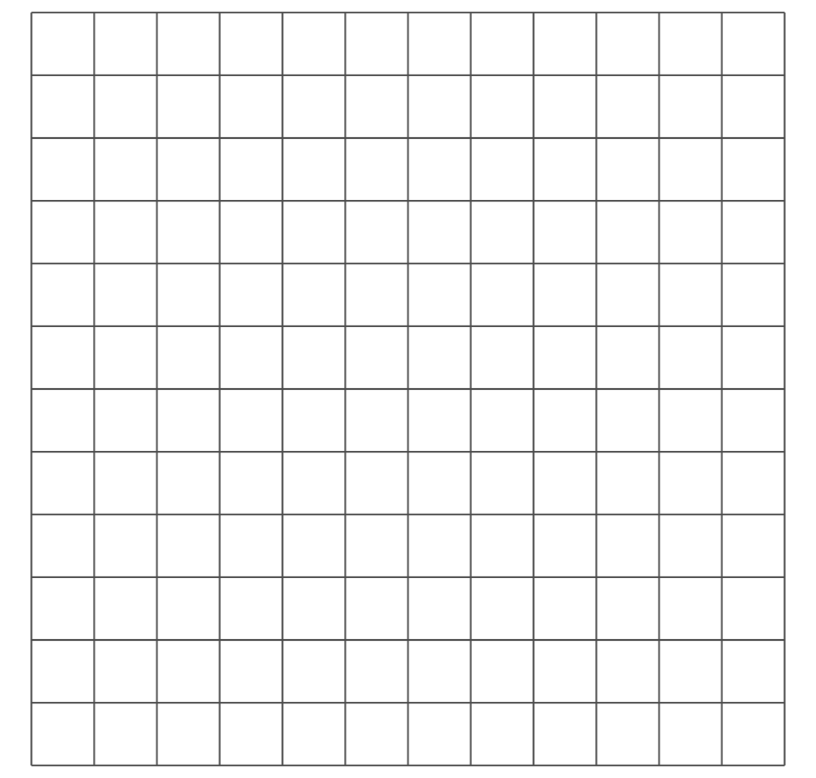
- How many rows of squares does your rectangle have? ______
- How many columns does your rectangle have? ______
- How many tiles are in your rectangle? ______
- Write 2 equations to represent the number of squares in your rectangle.

11.2: Make Equal-size Squares

  - Draw lines so that the rectangle is completely filled with equal-size squares.
  - 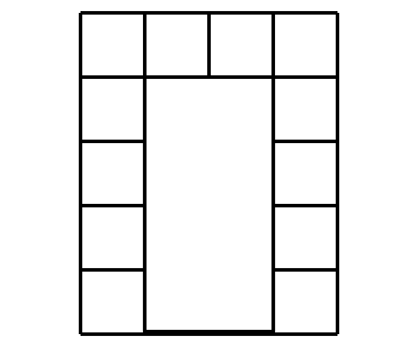
  - Color the rows different colors.
  - How many rows of equal-size squares are there?
  - How many squares are in each row?
  - Write an equation to represent the sum of the squares in each row.

  - Draw lines so that the rectangle is completely filled with equal-size squares.
  - 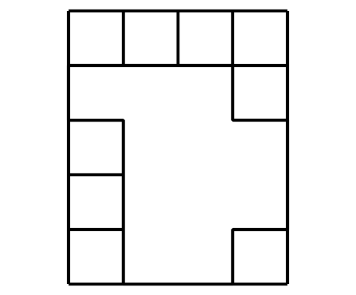
  - Color the columns different colors.
  - How many columns of equal-size squares are there?
  - How many squares are in each column?
  - Write an equation that represents the sum of squares in each column.

  - Draw lines so that the rectangle is completely filled with equal-size squares.
  - 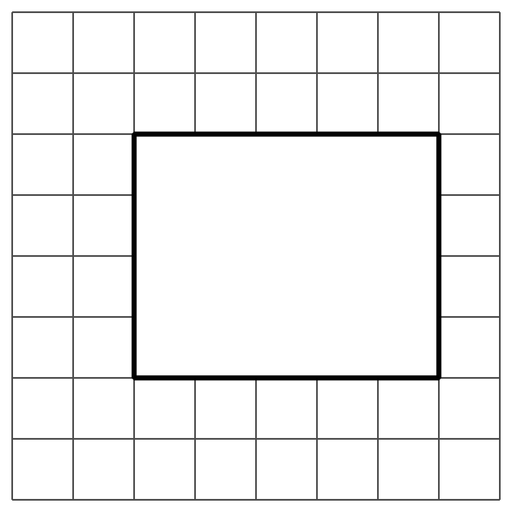
  - How many columns of equal-size squares are there? How many squares are in each column?
  - How many rows of equal-size squares are there? How many squares are in each row?
  - Write 2 equations to represent the number of equal-size squares in the rectangle.
© CC BY 2021 Illustrative Mathematics®

