Lesson 14: Center Day 2
- Let’s play games to practice adding and subtracting.

Warm-up: True or False: Expressions on Both Sides
Decide whether each statement is true or false.
Be prepared to explain your reasoning.
- $3+2=3+2$
- $5+1=5+2$
- $4+6=3+7$

14.2: Centers: Choice Time
Choose a center.
Number Puzzles
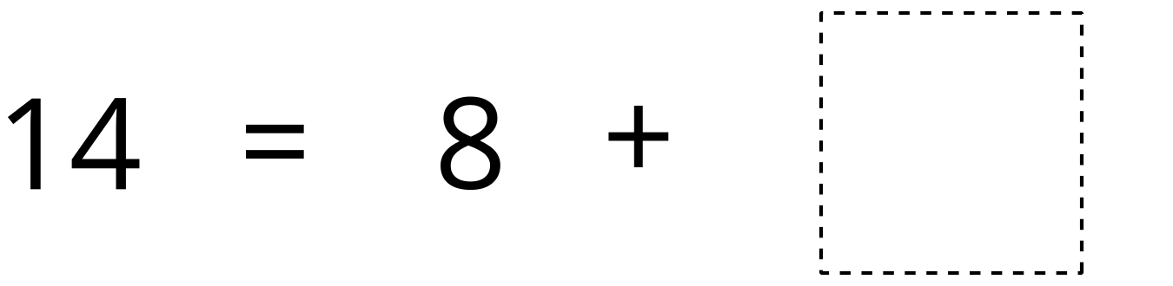
Shake and Spill
Compare
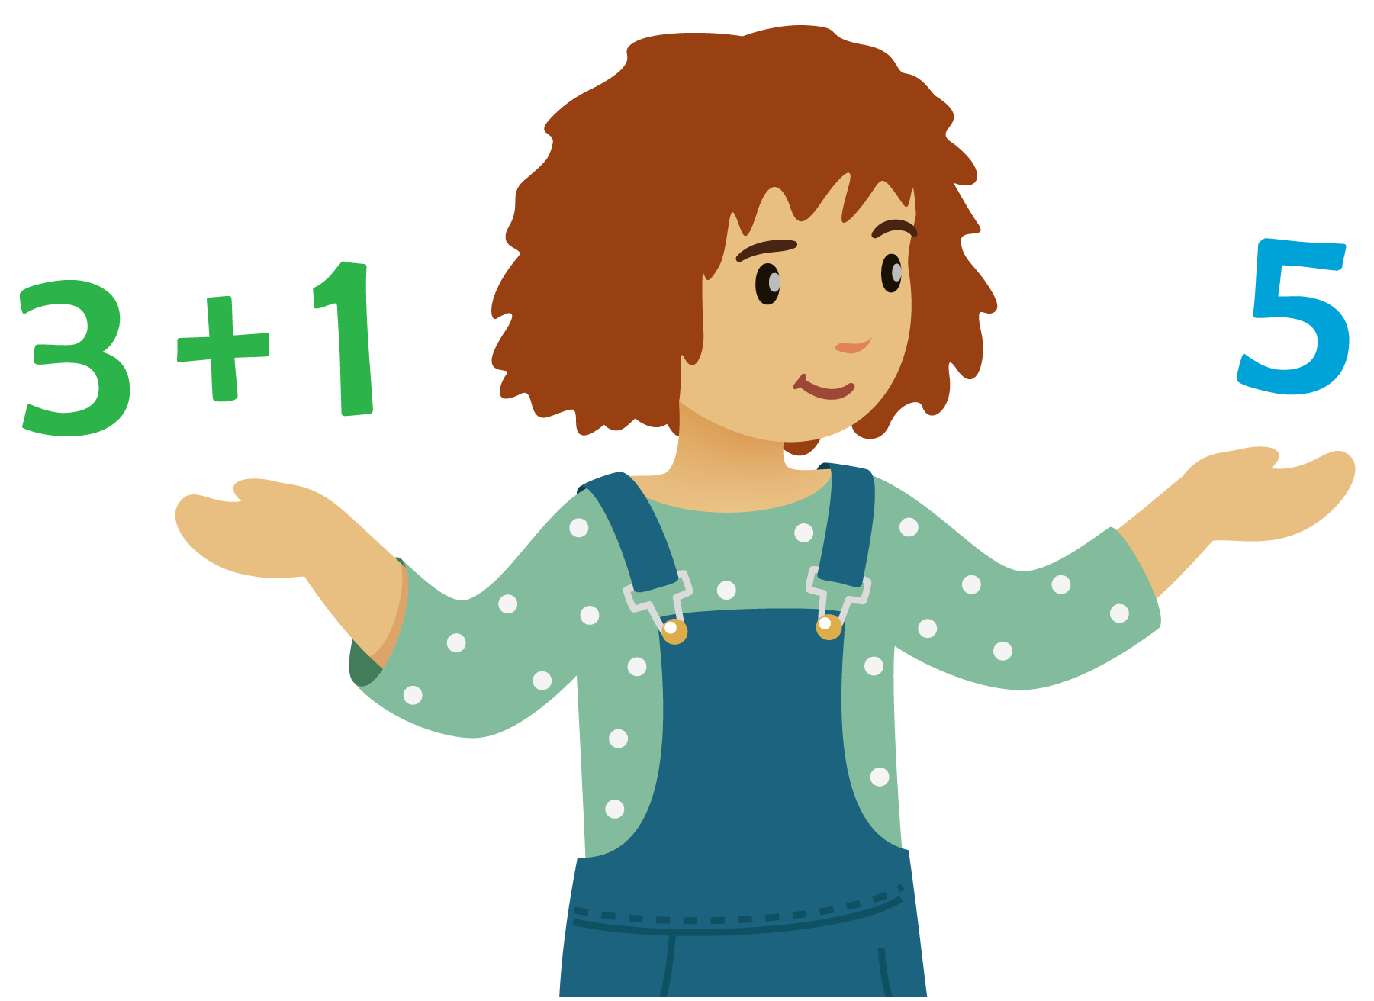
© CC BY 2021 Illustrative Mathematics®

