Unit 6 Lesson 2 Cumulative Practice Problems
- The table shows the number of apples and the total weight of the apples.
- number of apples | - weight of apples (grams)
- 2 | - 511
- 5 | - 1200
- 8 | - 2016
- Estimate the weight of 6 apples.
- (From Unit 3, Lesson 1.)
- Select all stories that the tape diagram can represent.
- 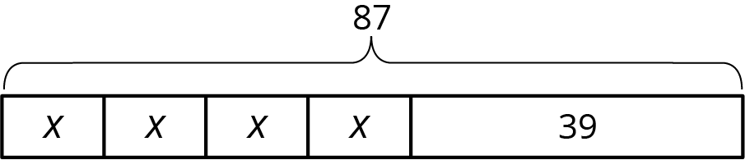
  - There are 87 children and 39 adults at a show. The seating in the theater is split into 4 equal sections.
  - There are 87 first graders in after-care. After 39 students are picked up, the teacher put the remaining students into 4 groups for an activity.
  - Lin buys a pack of 87 pencils. She gives 39 to her teacher and shared the remaining pencils between herself and 3 friends.
  - Andre buys 4 packs of paper clips with 39 paper clips in each. Then he gives 87 paper clips to his teacher.
  - Diego’s family spends $87 on 4 tickets to the fair and a $39 dinner.
- Andre wants to save $40 to buy a gift for his dad. Andre’s neighbor will pay him weekly to mow the lawn, but Andre always gives a $2 donation to the food bank in weeks when he earns money. Andre calculates that it will take him 5 weeks to earn the money for his dad’s gift. He draws a tape diagram to represent the situation.
- 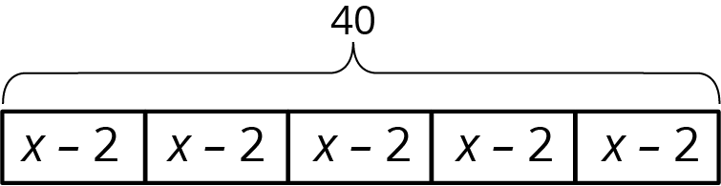
  - Explain how the parts of the tape diagram represent the story.
  - How much does Andre’s neighbor pay him each week to mow the lawn?
- Without evaluating each expression, determine which value is the greatest. Explain how you know.
  - $7\frac{5}{6}−9\frac{3}{4}$
  - $(\text{-}7\frac{5}{6})+(\text{-}9\frac{3}{4})$
  - $(\text{-}7\frac{5}{6})⋅9\frac{3}{4}$
  - $(\text{-}7\frac{5}{6})÷(\text{-}9\frac{3}{4})$
- (From Unit 5, Lesson 13.)
- Solve each equation.
  - $(8.5)⋅(\text{-}3)=a$
  - $(\text{-}7)+b=(\text{-}11)$
  - $c−(\text{-}3)=15$
  - $d⋅(\text{-}4)=32$
- (From Unit 5, Lesson 15.)
© CC BY Open Up Resources. Adaptations CC BY IM.

