Lesson 14 Practice Problems
- For each situation, write an expression answering the question. The expression should only use multiplication.
  - A person's salary is $2,500 per month. She receives a 10% raise. What is her new salary, in dollars per month?
  - A test had 40 questions. A student answered 85% of the questions correctly. How many questions did the student answer correctly?
  - A telephone cost $250. The sales tax is 7.5%. What was the cost of the telephone including sales tax?
- In June, a family used 3,500 gallons of water. In July, they used 15% more water.
- Select all the expressions that represent the number of gallons of water the family used in July.
  - $3,​500+0.15⋅3,​500$
  - $3,​500+0.15$
  - $3,​500⋅\left(1−0.15\right)$
  - $3,​500⋅\left(1.15\right)$
  - $3,​500⋅\left(1+0.15\right)$
- Han’s summer job paid him $4,500 last summer. This summer, he will get a 25% pay increase from the company.
- Write two different expressions that could be used to find his new salary, in dollars.

  - Military veterans receive a 25% discount on movie tickets that normally cost $16. Explain why $16\left(0.75\right)$ represents the cost of a ticket using the discount.
  - A new car costs $15,000 and the sales tax is 8%. Explain why $15,​000\left(1.08\right)$ represents the cost of the car including tax.
- The number of grams of a chemical in a pond is a function of the number of days, $d$, since the chemical was first introduced. The function, $f$, is defined by $f\left(d\right)=550⋅{\left(\frac{1}{2}\right)}^{d}$.
  - What is the average rate of change between day 0 and day 7?
  - Is the average rate of change a good measure for how the amount of the chemical in the pond has changed over the week? Explain your reasoning.
- (From Unit 5, Lesson 10.)
- A piece of paper is 0.004 inches thick.
  - Explain why the thickness in inches, $t$, is a function of the number of times the paper is folded, $n$.
  - Using function notation, represent the relationship between $t$ and $n$. That is, find a function $f$ so that $t=f\left(n\right)$.
- (From Unit 5, Lesson 8.)
- The function $f$ represents the amount of a medicine, in mg, in a person's body $t$ hours after taking the medicine. Here is a graph of $f$.
  - How many mg of the medicine did the person take?
  - Write an equation that defines $f$.
  - After 7 hours, how many mg of medicine remain in the person's body?
- 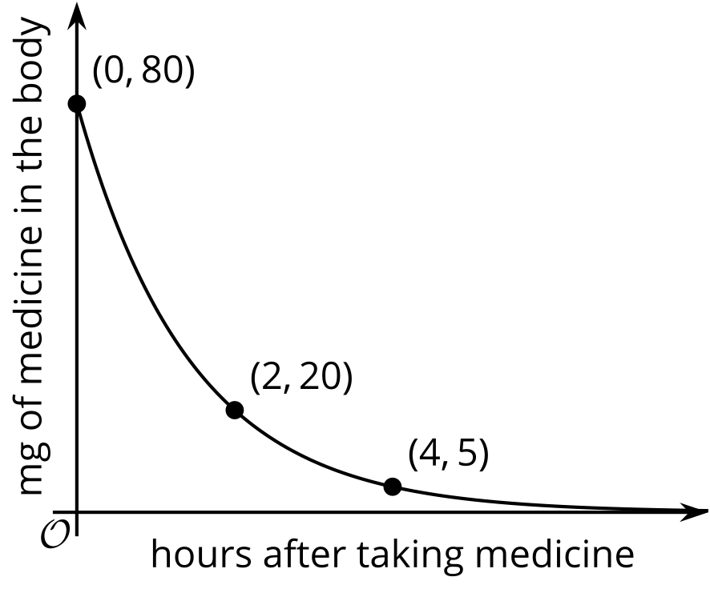

- (From Unit 5, Lesson 13.)
- Match each inequality to the graph of its solution.
  - $3x+4y≤36$
  - $12x+3y≤36$
  - $6x+4y≥36$
  - $3x−9y≥36$
  - $4x−6y≤36$
  - 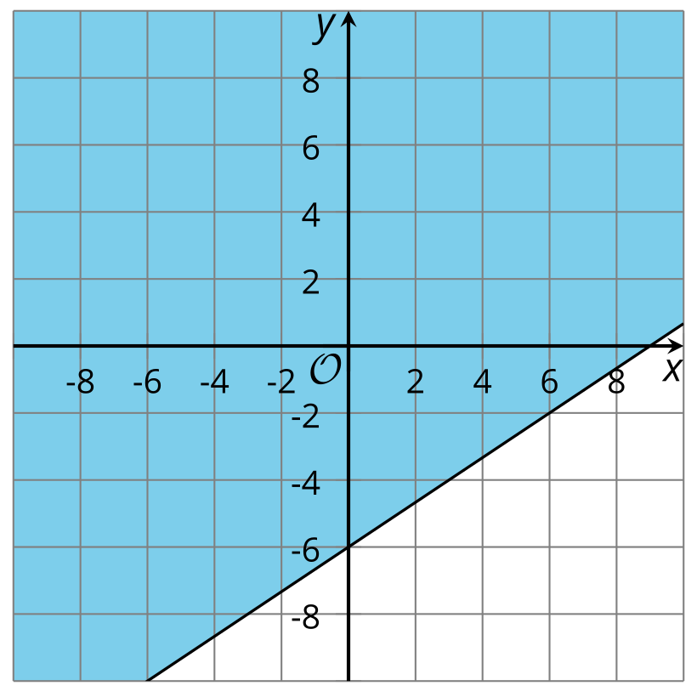
  - 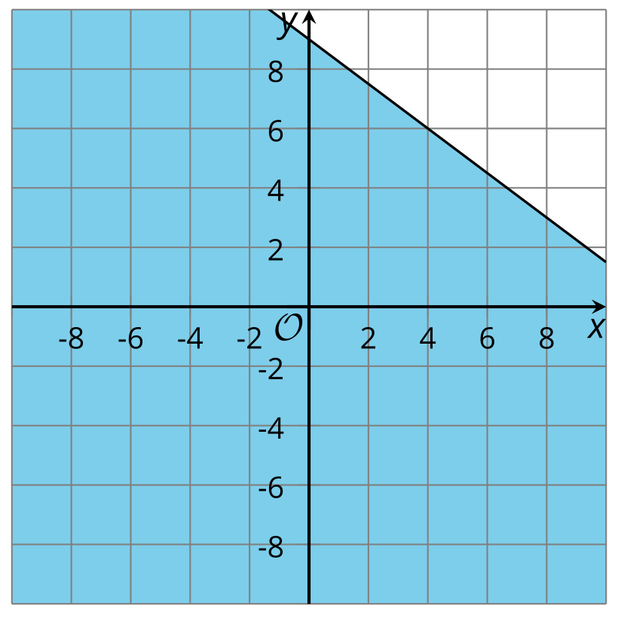
  - 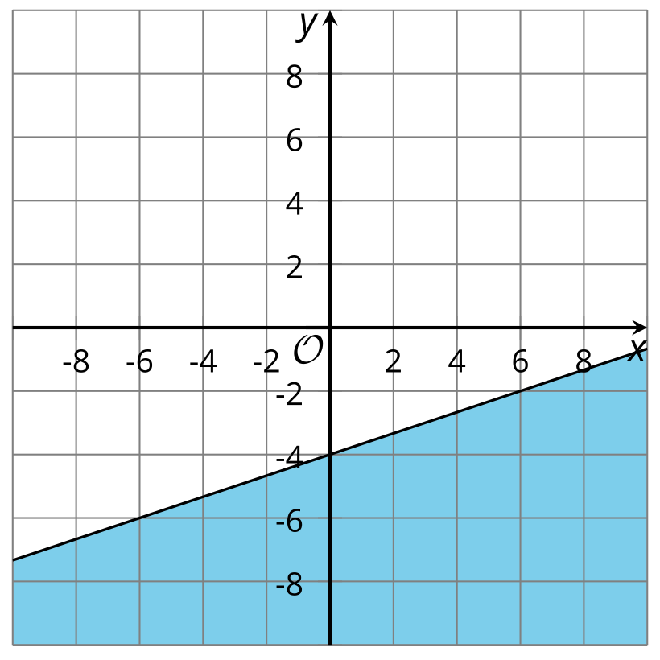
  - 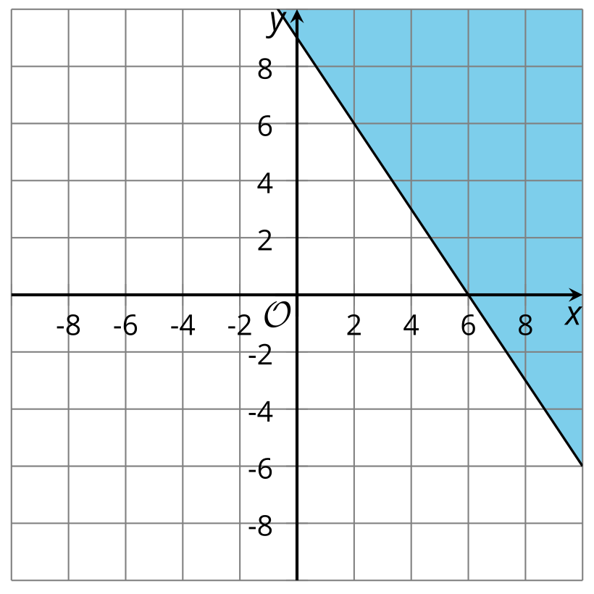
  - 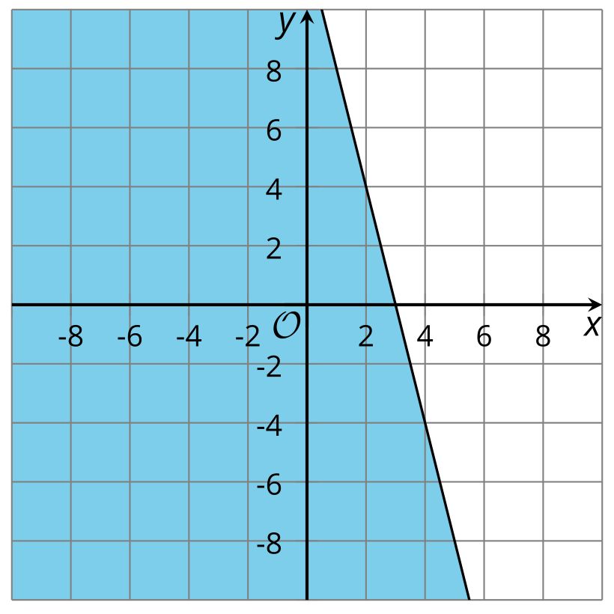
- (From Unit 2, Lesson 23.)
© CC BY 2019 by Illustrative Mathematics®

