Lesson 5 Practice Problems
- The cell phone plan from Company C costs $10 per month, plus $15 per gigabyte for data used. The plan from Company D costs $80 per month, with unlimited data.
- Rule $C$ gives the monthly cost, in dollars, of using $g$ gigabytes of data on Company C’s plan. Rule $D$ gives the monthly cost, in dollars, of using $g$ gigabytes of data on Company D’s plan.
  - Write a sentence describing the meaning of the statement $C(2)=40$.
  - Which is less, $C(4)$ or $D(4)$? What does this mean for the two phone plans?
  - Which is less, $C(5)$ or $D(5)$? Explain how you know.
  - For what number $g$ is $C(g)=130$?
  - Draw the graph of each function.
- Function $g$ is represented by the graph.
- For what input value or values is $g(x)=4$?
- 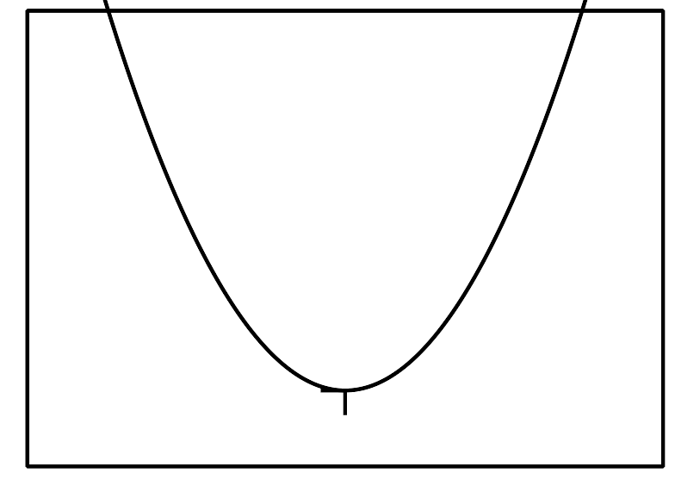
  - 2
  - -2 and 2
  - 16
  - none
- Function $P$ gives the perimeter of an equilateral triangle of side length $s$. It is represented by the equation $P(s)=3s$.
  - What does $P(s)=60$ mean in this situation?
  - Find a value of $s$ to make the equation $P(s)=60$ true.
- Function $G$ takes a student’s first name for its input and gives the number of letters in the first name for its output.
  - Describe the meaning of $G(\text{Jada})=4$.
  - Find the value of $G(\text{Diego})$.
- (From Unit 4, Lesson 2.)
- $W$ gives the weight of a puppy, in pounds, as a function of its age, $t$, in months.
- Describe the meaning of each statement in function notation.
  - $W(2)=5$
  - $W(6)>W(4)$
  - $W(12)=W(15)$
- (From Unit 4, Lesson 3.)
- Diego is building a fence for a rectangular garden. It needs to be at least 10 feet wide and at least 8 feet long. The fencing he uses costs $3 per foot. His budget is $120.
- He wrote some inequalities to represent the constraints in this situation:
- $f=2x+2y$​​​​​​
- $x≥10$
- $y≥8$
- $3f≤120$
  - Explain what each equation or inequality represents.
  - His mom says he should also include the inequality $f>0$. Do you agree? Explain your reasoning.
- (From Unit 2, Lesson 18.)
© CC BY 2019 by Illustrative Mathematics®

