Lesson 8: Center Day 2
- Let’s add within 100.

Warm-up: Number Talk: Add Within 100
Find the value of each expression mentally.
- $68+2$
- $3+68$
- $5+45$
- $45+7$

8.2: Centers: Choice Time
Choose a center.
Target Numbers
Number Puzzles
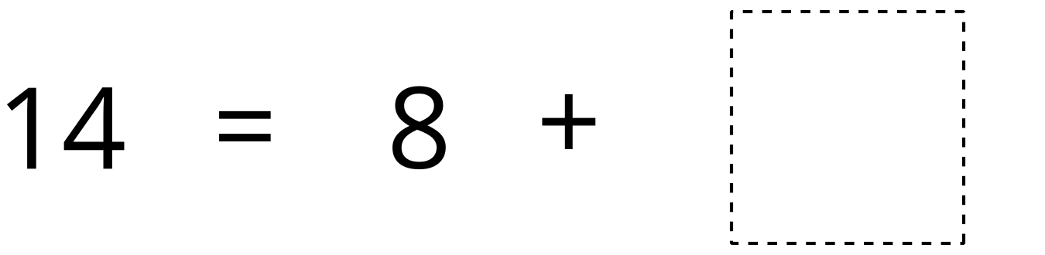
Five in a Row

8.3: Addition Stories
- Priya watched a football game.
The home team scored 35 points in the first half.
In the second half they scored 6 more points.
How many points did they score all together?
Show your thinking using drawings, numbers, or words.
- At the football game, 9 fans cheered for the visiting team.
There were 45 fans who cheered for the home team.
How many fans were at the game all together?
Show your thinking using drawings, numbers, or words.
© CC BY 2021 Illustrative Mathematics®

