Unit 3 Lesson 17: Center Day 3

WU Number Talk: Subtract from a Multiple of 10 (Warm up)

Student Task Statement
Find the value of each expression mentally.
- $60−10$
- $60−11$
- $60−21$
- $70−32$

1 Introduce Creating Line Plots, Inches and Centimeters

Student Task Statement

2 Centers: Choice Time

Student Task Statement
Choose a center.
Estimate and Measure
Number Puzzles
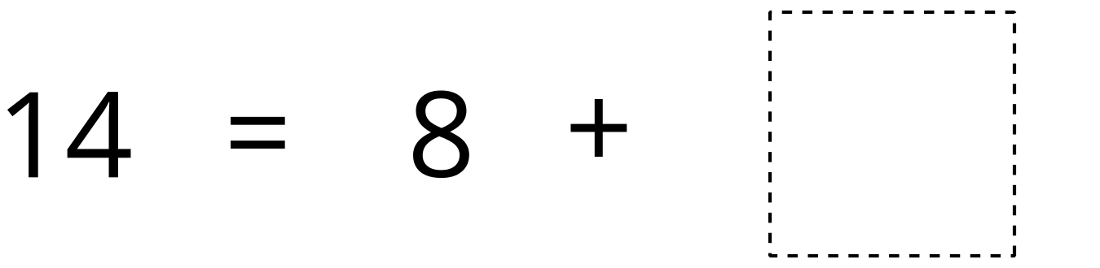
Target Measurements
© CC BY 2021 Illustrative Mathematics®

