Lesson 12: Partition Rectangles into Squares
- Let’s partition rectangles into squares.

Warm-up: Estimation Exploration: Fill it Up
How many little squares would fill the rectangle?
Record an estimate that is:
too low | about right | too high

12.1: How Many Squares?
- Build a rectangle with 8 tiles arranged in 2 rows. Use a ruler to partition the rectangle to match the rectangle you made.
- 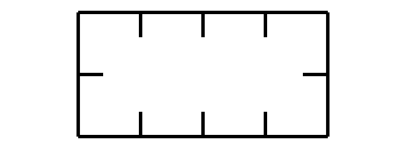
- Use a ruler to partition the rectangle using the tick marks as a guide.
  - How many rows of equal-size squares did you make?
  - How many columns did you make?
  - Write 2 equations to represent the total number of equal-size squares.
- Use a ruler to partition the rectangle using the tick marks as a guide.
- 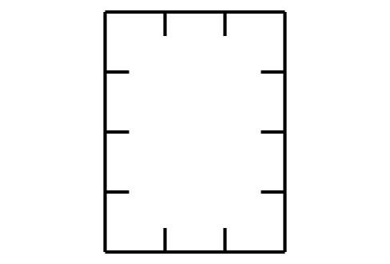
  - How many rows of equal-size squares did you make?
  - How many columns did you make?
  - Write 2 equations to represent the total number of equal-size squares.

12.2: Partition Rectangles
- Use 12 tiles to make a rectangle. Split one of the rectangles into equal-size squares to match your rectangle made of tiles.
  - Write 2 equations to represent the total number of squares.
- Split this rectangle into equal-size squares.
  - Write 2 equations to represent the total number of squares.
- Split this rectangle into equal-size squares.
  - Write 2 equations to represent the total number of squares.

Section Summary
Section Summary
In this section, we learned that arrays are groups of objects that are organized into rows and columns. Arrays have the same number of objects in each row and the same number of objects in each column. We practiced different ways to count the objects in an array and used expressions with equal addends to show that you can find the total objects in an array by adding the sum of each row or the sum of each column. We also learned that rectangles can be composed of an array of equal-size squares. We practiced partitioning rectangles into rows and columns of equal-size squares.
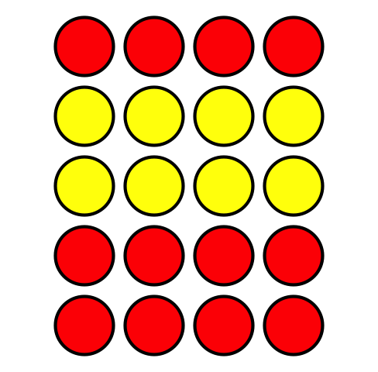
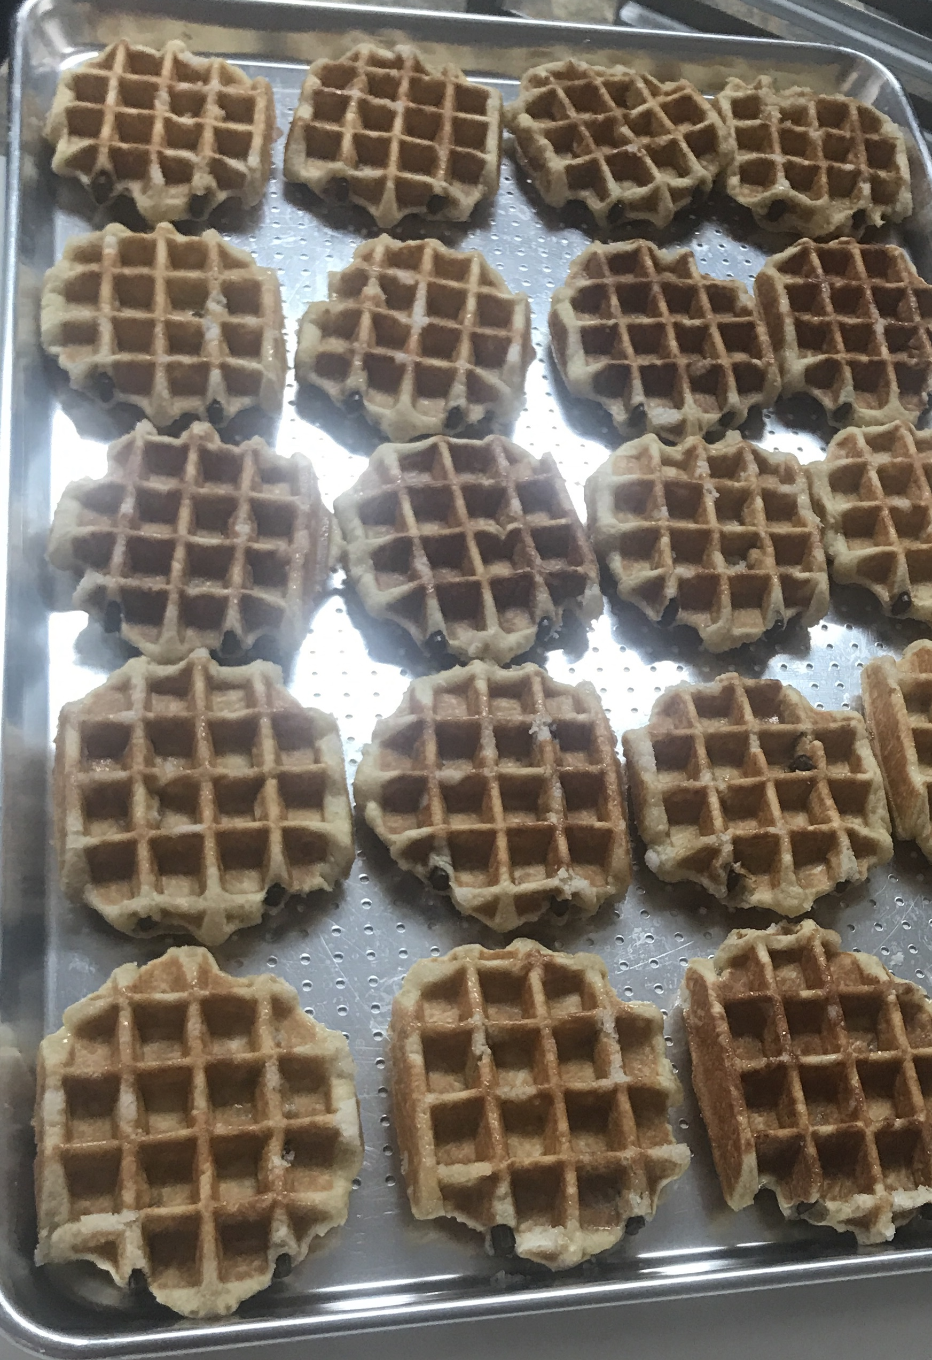
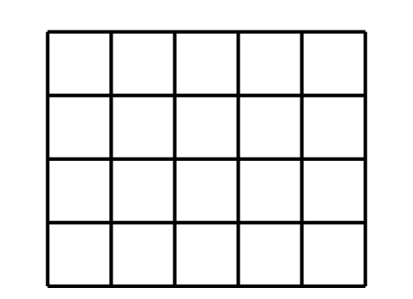
$4+4+4+4+4=20$ or $5+5+5+5=20$
© CC BY 2021 Illustrative Mathematics®

