Unit 3 Lesson 16: Round and Round Again

WU Number Talk: More Groups, Fewer Groups (Warm up)

Student Task Statement
Find the value of each expression mentally.
- $5×7$
- $4×7$
- $6×7$
- $4×8$

1 All the Numbers

Student Task Statement
- What are all the numbers that would round to 50 if you're rounding to the nearest ten? You can use this number line if it helps you.
- What are all the numbers that would round to 70 if you're rounding to the nearest ten?
- What are all the numbers that would round to 600 if you're rounding to the nearest hundred?
If you finish early, find the numbers that would round to 100 and to 500 if you’re rounding to the nearest hundred. Compare your lists with a partner's lists and discuss patterns you see.

2 What’s My Mystery Number?

Student Task Statement
Write down a number between 100 and 1,000 on your index card. This is your mystery number.
Fold your index card in half so that no one can see your mystery number. ​​​​
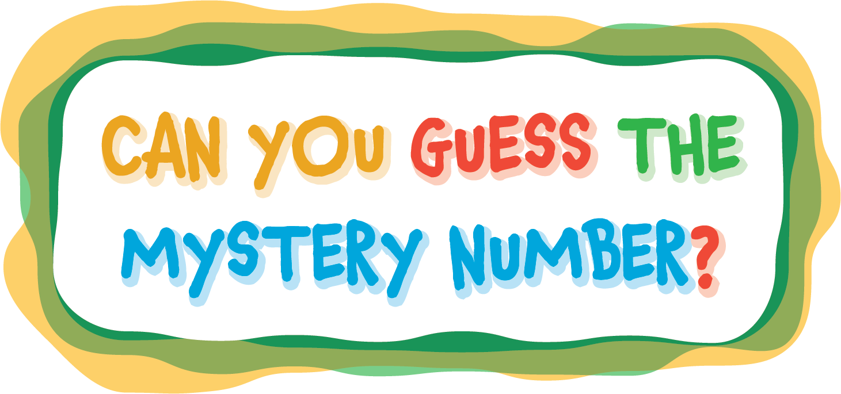
Write down 3 clues about your mystery number by finishing these sentences:
- My mystery number is (odd or even) _____.
- My mystery number rounds to _____.
- My mystery number is between _____ and _____.
Play What’s My Number?
- Read the clues for your mystery number.
- Starting with the person on your right, have every member in your team try to guess your mystery number and explain their reasoning.
- If they haven’t guessed the mystery number by the time the last person shares, reveal the mystery number.
- Repeat steps 1 through 3 with the next person in the group reading the clues for their mystery number.
© CC BY 2021 Illustrative Mathematics®

