Unit 5 Lesson 5: Connections between Representations

1 Math Talk: Evaluating Expressions (Warm up)

Student Task Statement
Evaluate mentally:
$6,​400−400x$ when $x$ is 0
$6,​400−400x$ when $x$ is 2
$6,​400⋅{\left(\frac{1}{10}\right)}^{x}$ when $x$ is 0
$6,​400⋅{\left(\frac{1}{10}\right)}^{x}$ when $x$ is 2

2 A Good Night’s Sleep

Student Task Statement
Is more sleep associated with better brain performance? A researcher collected data to determine if there was an association between hours of sleep and ability to solve problems. She administered a specially designed problem solving task to a group of volunteers, and for each volunteer, recorded the number of hours slept the night before and the number of errors made on the task.
The equation $n=40−4t$ models the relationship between $t$, the time in hours a student slept the night before, and $n$, the number of errors the student made in the problem-solving task.
- Use the equation to find the coordinates of 5 data points on a graph representing the model. Organize the coordinates in the table.
- Create a graph that represents the model.
- hours of sleep, $t$ | - number of errors, $n$
- 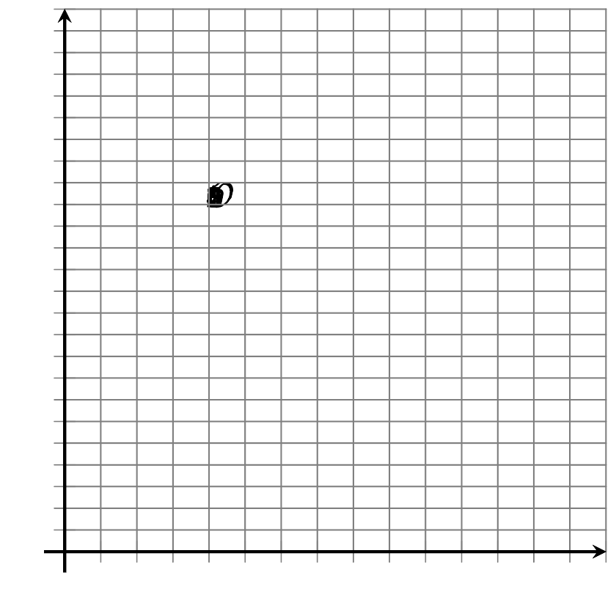
- In the equation $n=40−4t$, what does the 40 mean in this situation? Where can you see it on the graph?
- In the equation $n=40−4t$, what does the -4 mean in this situation? Where can you see it on the graph?
- How many errors would you expect a person to make who had slept 3.5 hours the night before?

3 What’s My Equation?

Student Task Statement
The sleep researcher repeated the study on two more groups of volunteers, collecting different data. Here are graphs representing the equations that model the different sets of data:

A
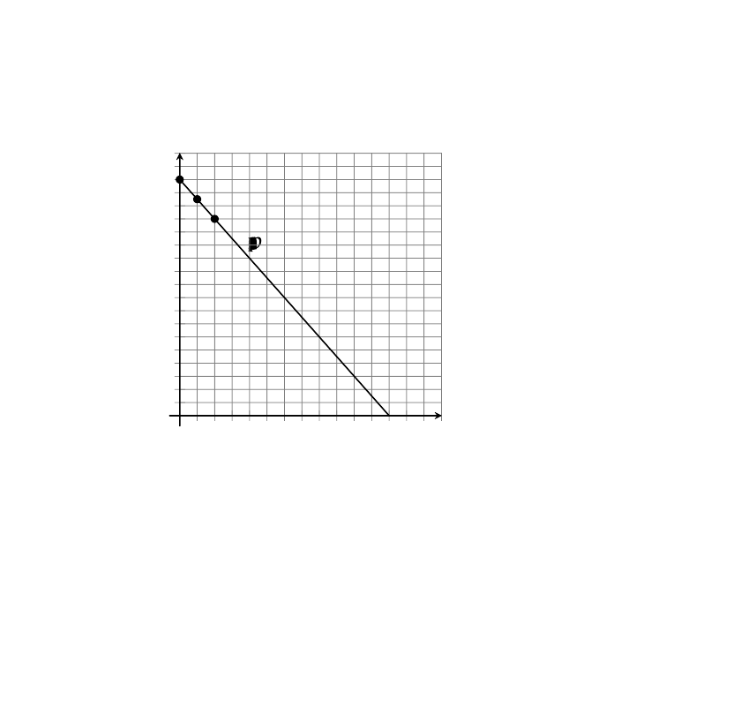

B
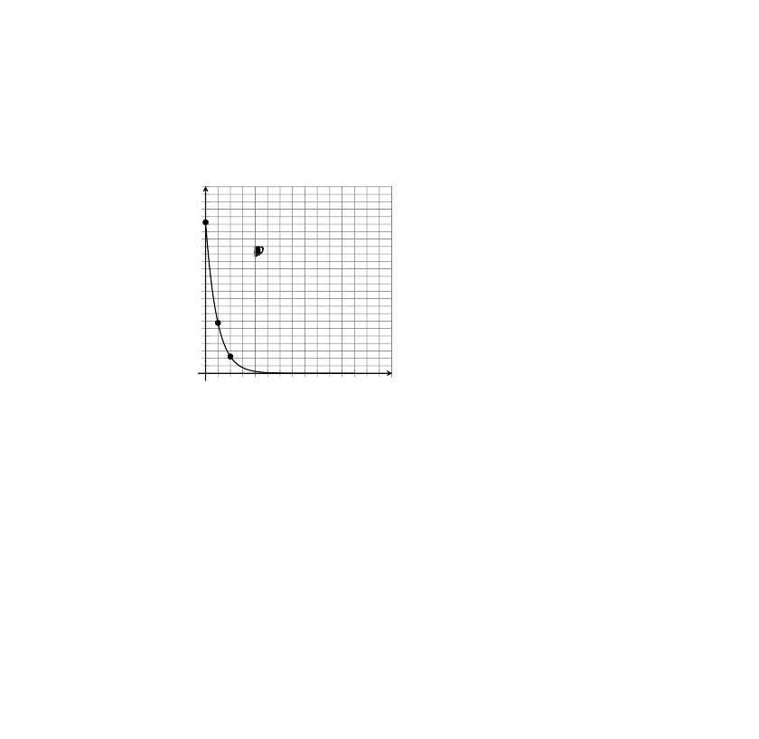
- Write an equation for Model A. Be prepared to explain how you know. Explain what the numbers mean in your equation.
- Model B is exponential.
  - How many errors did participants make with 0 hours of sleep?
  - How many errors with 1 hour of sleep?
  - What fraction of the errors from 0 hours of sleep is that?
- Complete the table for Model B for 3, 4, and 5 hours of sleep.
- $t$ | - 0 | - 1 | - 2 | - 3 | - 4 | - 5
- $n$ | - 81 | - 27 | - 9
- Which is an equation for Model B? If you get stuck, test some points!
$n=81−3t$
$n=81−\frac{1}{3}t$
$n=81⋅{\left(3\right)}^{t}$
$n=81⋅{\left(\frac{1}{3}\right)}^{t}$
© CC BY 2019 by Illustrative Mathematics®

