Unit 8 Lesson 12: Decimal Game Day

WU True or False: Adding Decimals (Warm up)

Student Task Statement
Decide if each statement true or false. Be prepared to explain your reasoning.
- $0.99+0.1=0.9+0.1+0.09$
- $0.99+0.01=0.9+0.1$
- $0.99+0.1=1.99$

1 Race to One or One Tenth

Student Task Statement
Use the directions to play Race to One or One Tenth with your partner. If there is time, play both versions of the game.
Race to One
- Roll the number cube.
- Decide if you want the number to represent tenths or hundredths.
- Add the number to the last sum on your score sheet. If it is your first turn, you will add the number you roll to zero.
- Take turns continuing to roll the number cube, decide the value, and add the number to your previous sum.
- The first player to reach exactly 1 is the winner.
- If you go over one, you lose your turn. For example, if your last sum was .95 and you roll a 6, you cannot go.
- You may not need to use all the blank spaces on your score sheet or you may need to write more spaces.
 | number rolled | 0.1 | 0.01 | equation to represent the total
1
2
3
4
5
6
Race to One Tenth
- Roll the number cube.
- Decide if you want the number to represent hundredths or thousandths.
- Add the number to the last sum on your score sheet. If it is your first turn, you will add the number you roll to zero.
- Take turns continuing to roll the number cube, decide the value, and add the number to your previous sum.
- The first player to reach exactly 0.1 is the winner.
- If you go over 0.1, you lose your turn. For example, if your last sum was .095 and you roll a 6, you cannot go.
- You may not need to use all the blank spaces on your score sheet or you may need to write more spaces.
 | number rolled | 0.01 | 0.001 | equation to represent the total
1
2
3
4
5
6

2 Decimal Race to 500

Student Task Statement
Use the directions to play Decimal Race to 500 with a partner.
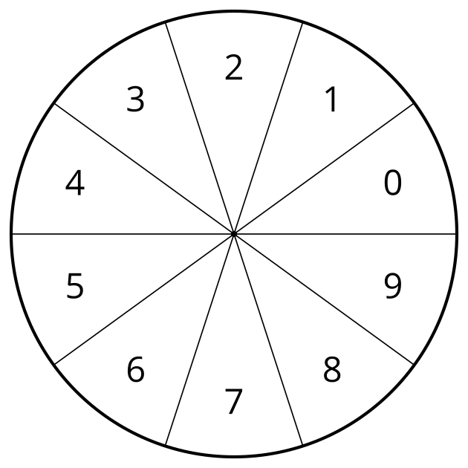
- Spin the spinner three times.
- Arrange the digits to make a decimal number that follows this rule:
  - Odd numbers can only be used in the tenths, hundredths, or thousandths place.
  - Even numbers can only be used in the ones, tens, and hundreds places.
  - For example, if you spin the numbers 2, 3, and 9, these are some of the possible numbers you could make: 2.39 or 2.93.
- Add your number to your previous sum. If it is your first turn, you will add your number to zero.
- Continue taking turns until one person has reached 500 or more.
© CC BY 2021 Illustrative Mathematics®

