Unit 8 Lesson 1: Addition Fluency Within 10

WU How Many Do You See: Within 10 (Warm up)

Student Task Statement
How many do you see?
How do you see them?
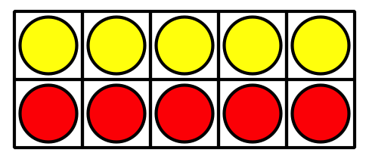
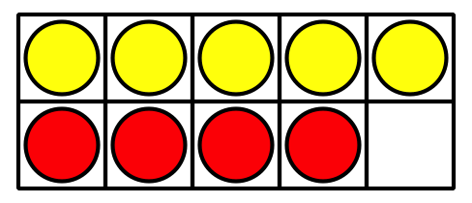
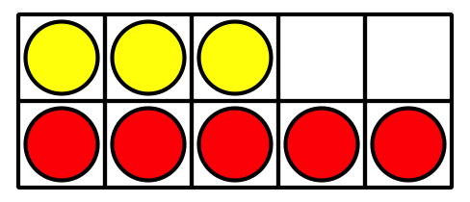

1 Sums I've Got

Student Task Statement
Color the sums you know the value of from memory.
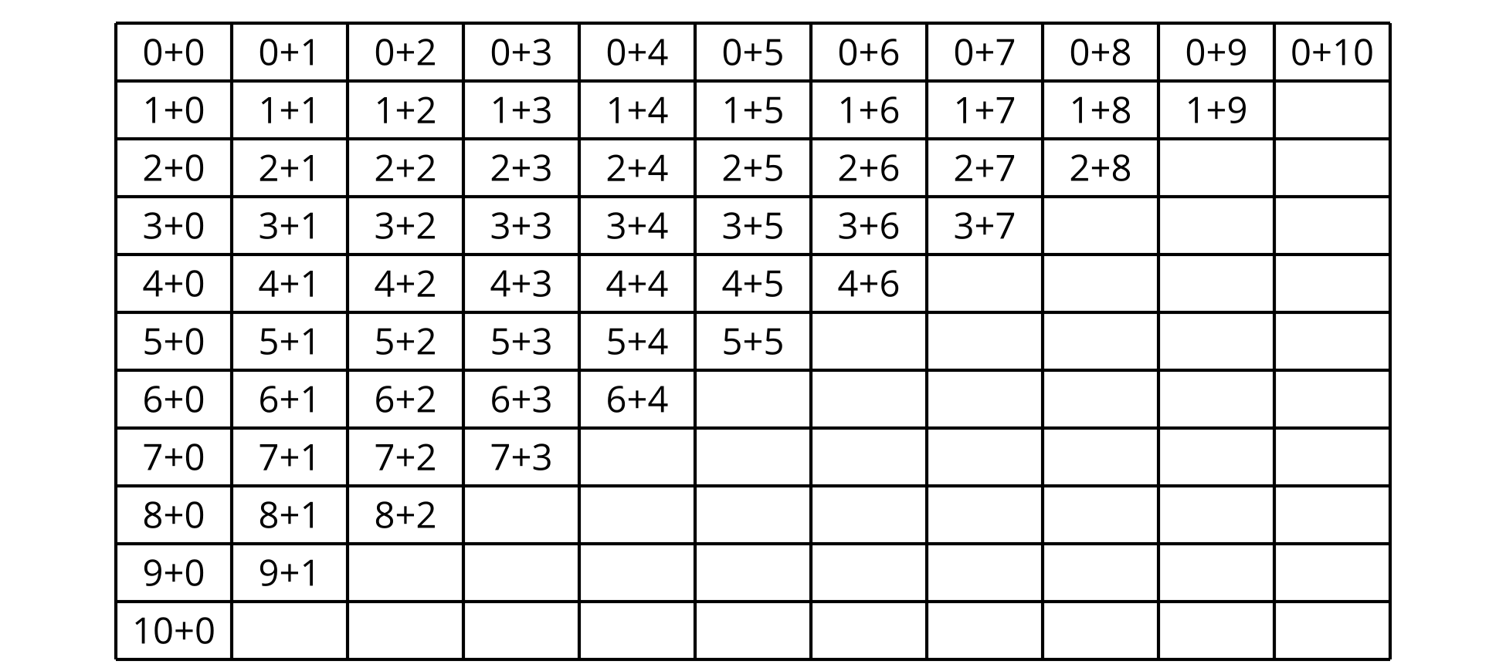
Write each sum that is not colored, on an index card.
Use the cards to practice these sums.

2 Centers: Choice Time

Student Task Statement
Choose a center.
Check it Off
Number Puzzles
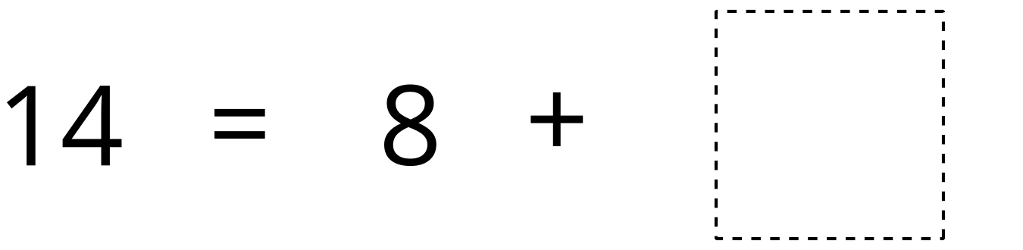
Capture Squares
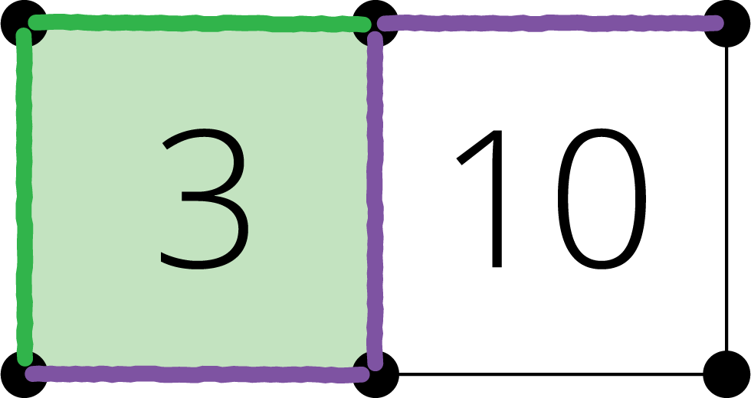
© CC BY 2021 Illustrative Mathematics®

