Unit 3 Lesson 14: Problems about Fractional Measurement Data

WU Notice and Wonder: Shoe Sizes (Warm up)

Student Task Statement
What do you notice? What do you wonder?
US youth shoe size | insole length in inches
1 | $7\frac{6}{8}$
1.5 | 8
2 | $8\frac{1}{8}$
2.5 | $8\frac{2}{8}$
3 | $8\frac{4}{8}$
3.5
4 | $8\frac{6}{8}$
4.5 | 9
5 | $9\frac{1}{8}$
5.5
6 | $9\frac{4}{8}$
6.5 | $9\frac{5}{8}$
7 | $9\frac{6}{8}$
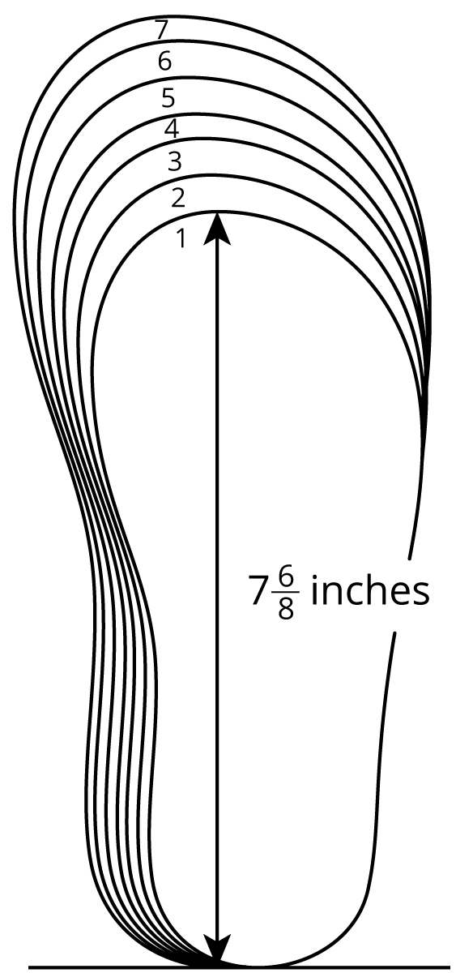

1 Shoe Lengths

Student Task Statement
Students in a fourth-grade class collected data on their shoe sizes and lengths. They plotted the shoe lengths on a line plot.
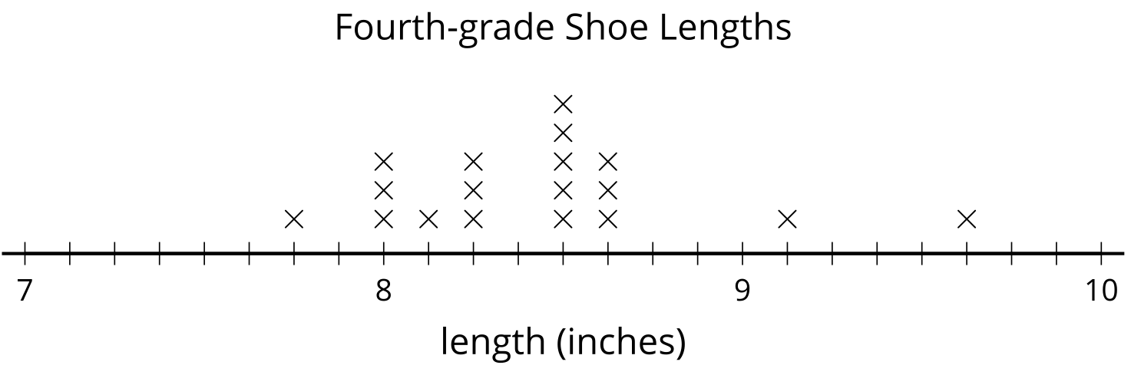
The line plot is missing the shoe lengths of six students:
9 | $9\frac{1}{8}$ | $8\frac{6}{8}$ | $7\frac{6}{8}$ | $9\frac{2}{8}$ | $8\frac{1}{8}$

- Complete the line plot with the missing data.
- Use the completed line plot to answer the following questions:
  - What is the largest shoe length?
  - What is the smallest shoe length?
  - What is the difference between the largest and smallest shoe lengths? Explain or show your reasoning.
  - The student who recorded 9 inches for her shoe length made a mistake when reading the shoe chart. Her actual shoe length is $\frac{7}{8}$ inches shorter.
  - What’s her shoe length? Plot her corrected data point on the line plot.

2 Larger Shoes, Anyone?

Student Task Statement
Ten students recorded their shoe lengths in third grade and then again in fourth grade.
They found how much their feet have grown over a year and organized the data in a table and on a line plot.
student | change in shoe length (inches)
Jada | $\frac{5}{4}$
Priya | $\frac{7}{8}$
Andre | $\frac{3}{4}$
Elena | $\frac{1}{2}$
Han | $1\frac{2}{8}$

student | change in shoe length (inches)
Clare | $1$
Tyler | $1\frac{1}{8}$
Kiran | $\frac{6}{8}$
Diego | $1\frac{1}{4}$
Lin | $\frac{5}{8}$
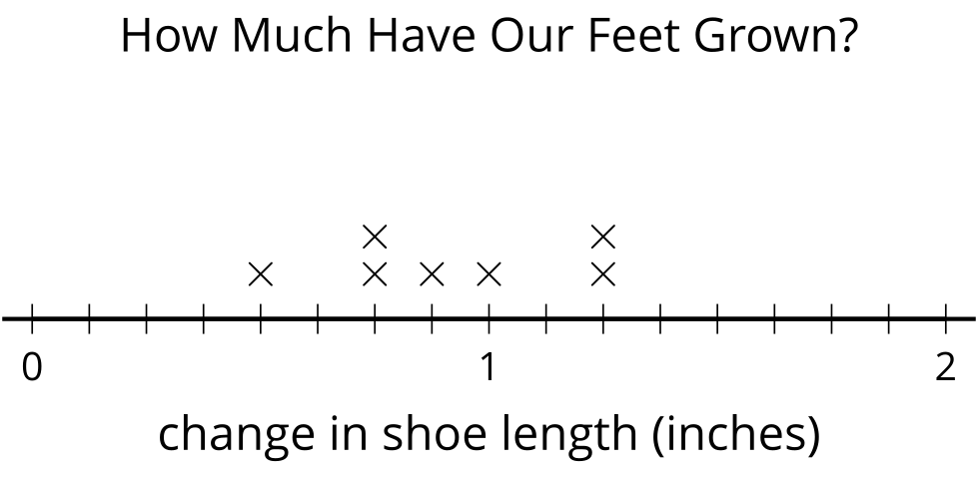
- The line plot shows only seven points. Whose information is missing? Add the three missing points to the line plot.
- If Han’s shoe length now is $9\frac{1}{8}$ inches, what was his shoe length in third grade?
- If Priya’s shoe length was $7\frac{6}{8}$ inches last year, what’s her shoe length this year?
- Tyler made a calculation error. What he recorded, $1\frac{1}{8}$ inches, was $\frac{3}{8}$ inches off from the actual change in shoe length.
  - What could be the actual change in his shoe length? Explain or show your reasoning.
  - How does his error affect the line plot? Explain your reasoning.
© CC BY 2021 Illustrative Mathematics®

