Lesson 6: Use More, Fewer, or the Same Number to Describe Groups
- Let’s use “more”, “fewer”, and “the same number” to describe groups.

6.3: Centers: Choice Time
Choose a center.
Less, Same, More
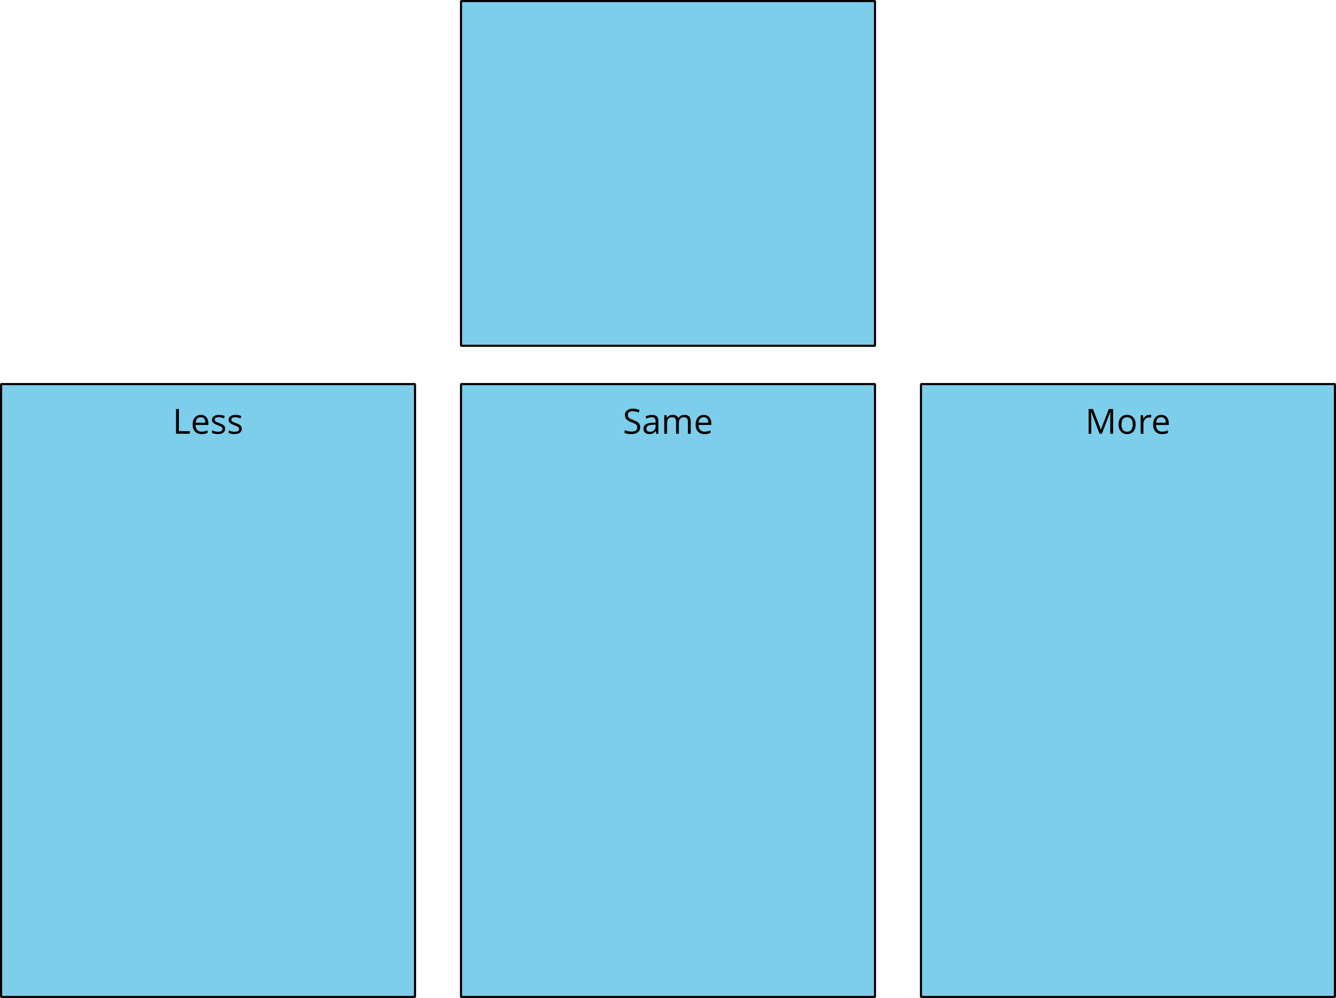
Shake and Spill
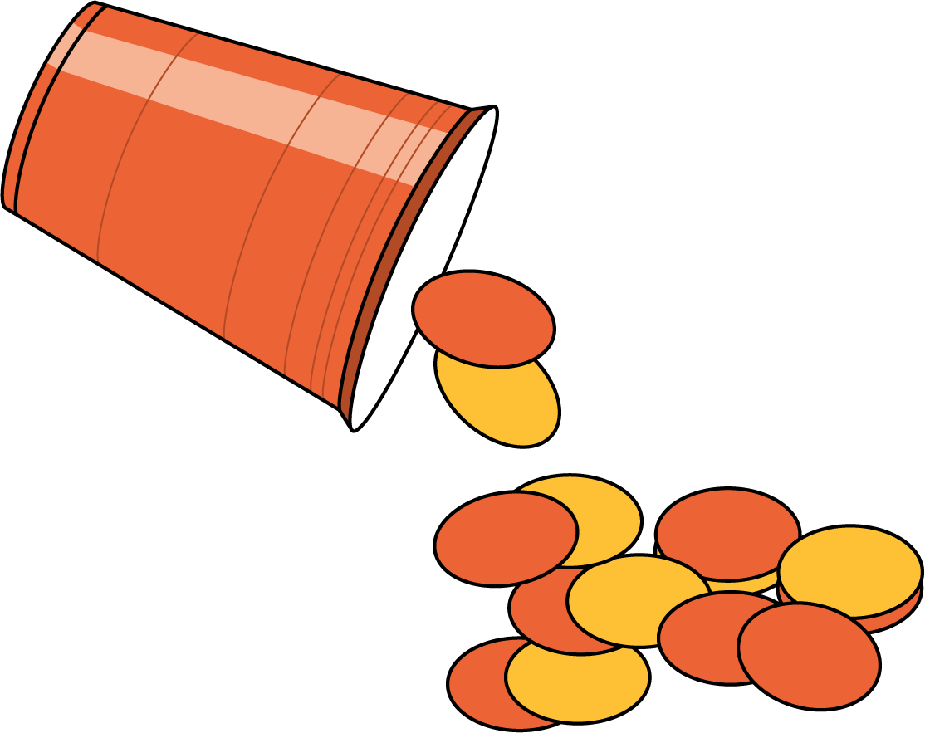
Number Race
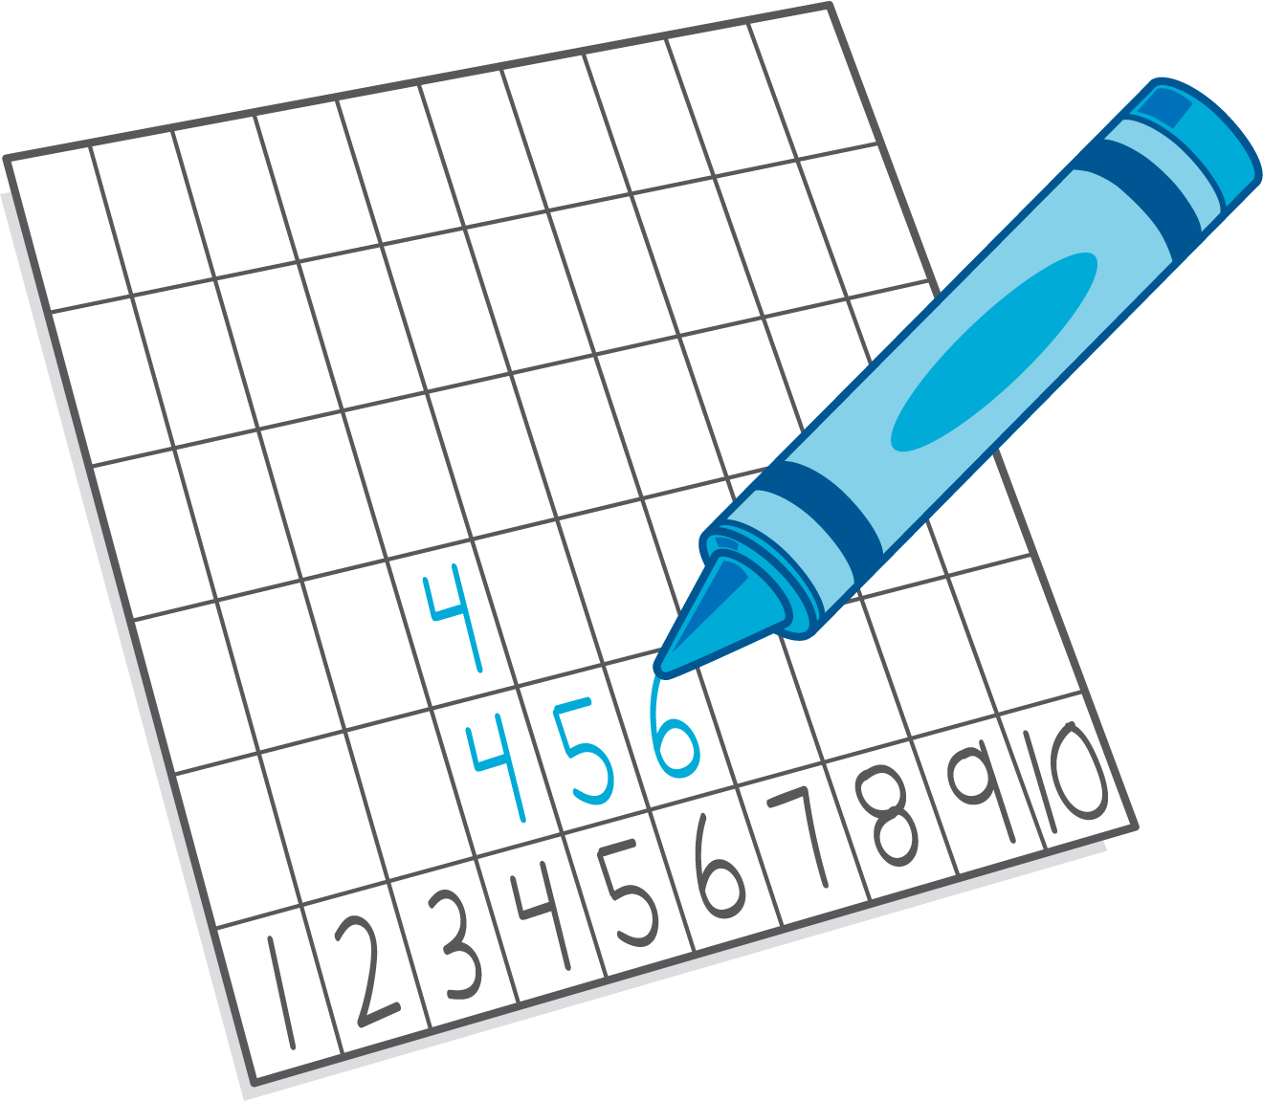
Math Fingers
Pattern Blocks
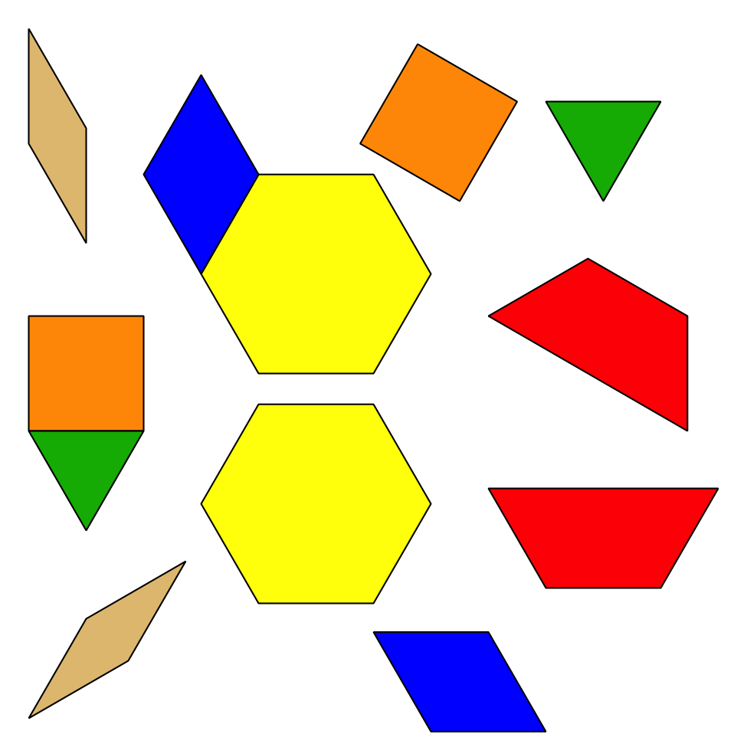
Picture Books
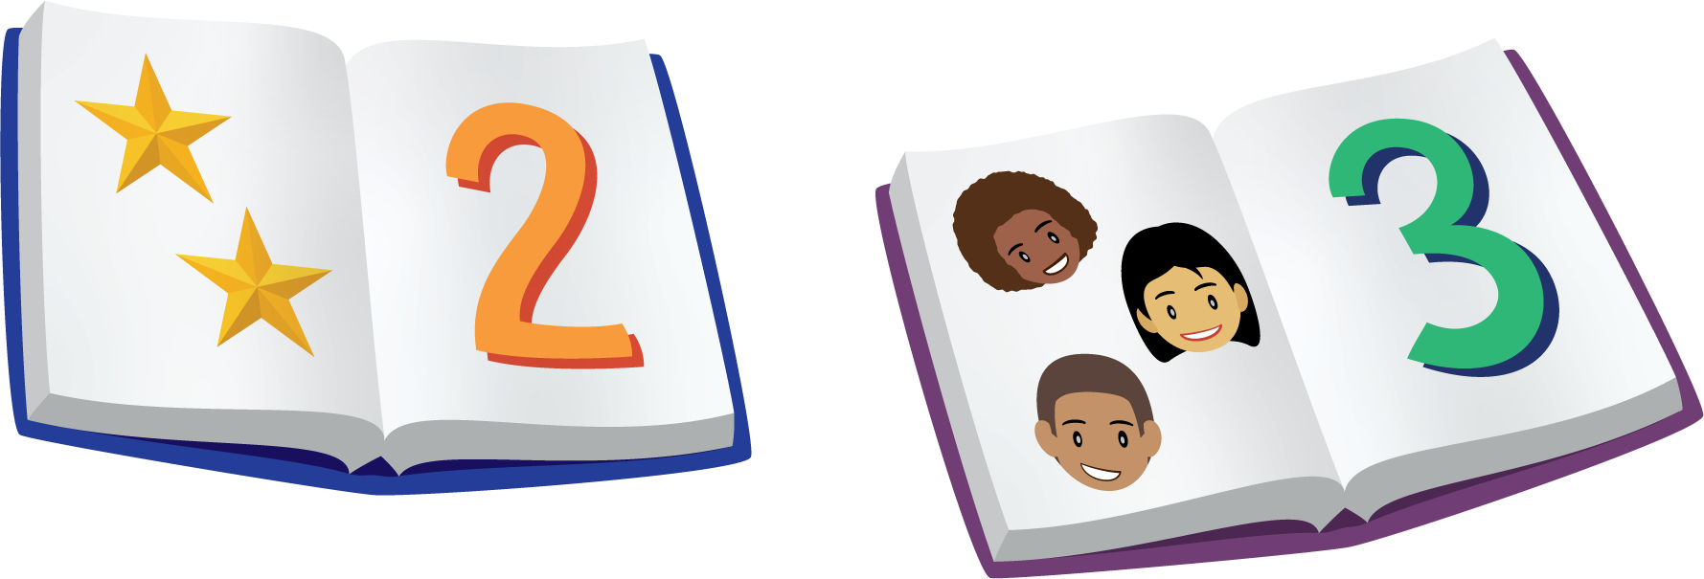

Section Summary
Section Summary
In this section, we counted many groups of objects.
We also figured out which groups had more objects and which groups had fewer objects.
Sometimes we could tell, just by looking, that there were more red counters than yellow counters.
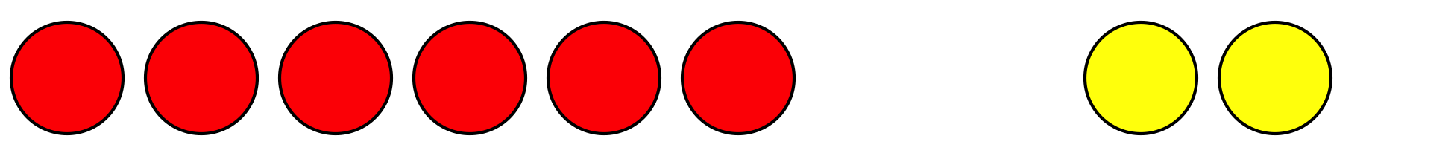
Sometimes we lined up and matched the objects to see if there were fewer red counters or yellow counters.
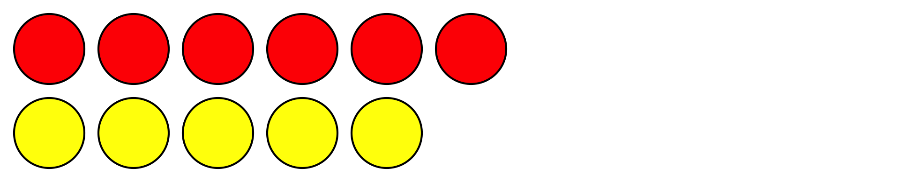
There are fewer yellow counters than red counters.
© CC BY 2021 Illustrative Mathematics®

