Unit 3 Lesson 14: Shapes in Art

WU Notice and Wonder: Shapes in Art (Warm up)

Student Task Statement
What do you notice?
What do you wonder?
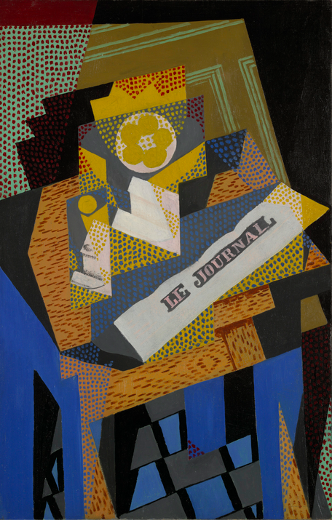

1 Find Shapes in Art

Student Task Statement

2 Make Art with Shapes

Student Task Statement

3 Centers: Choice Time

Student Task Statement
Choose a center.
Match Mine
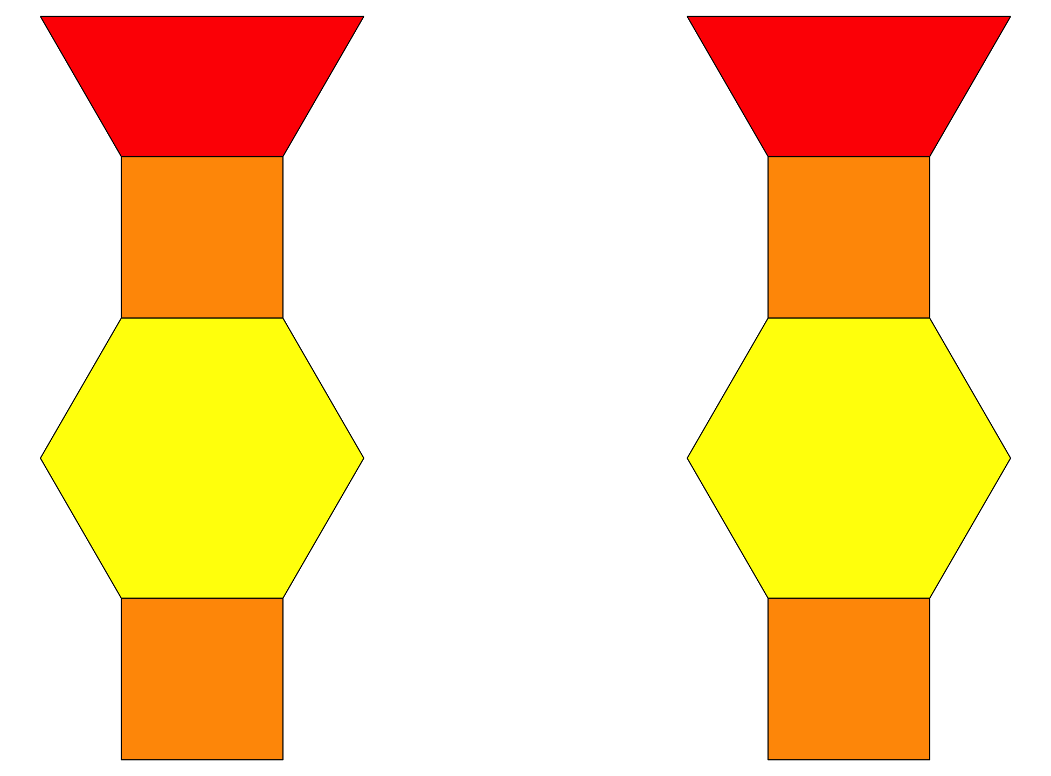
Geoblocks
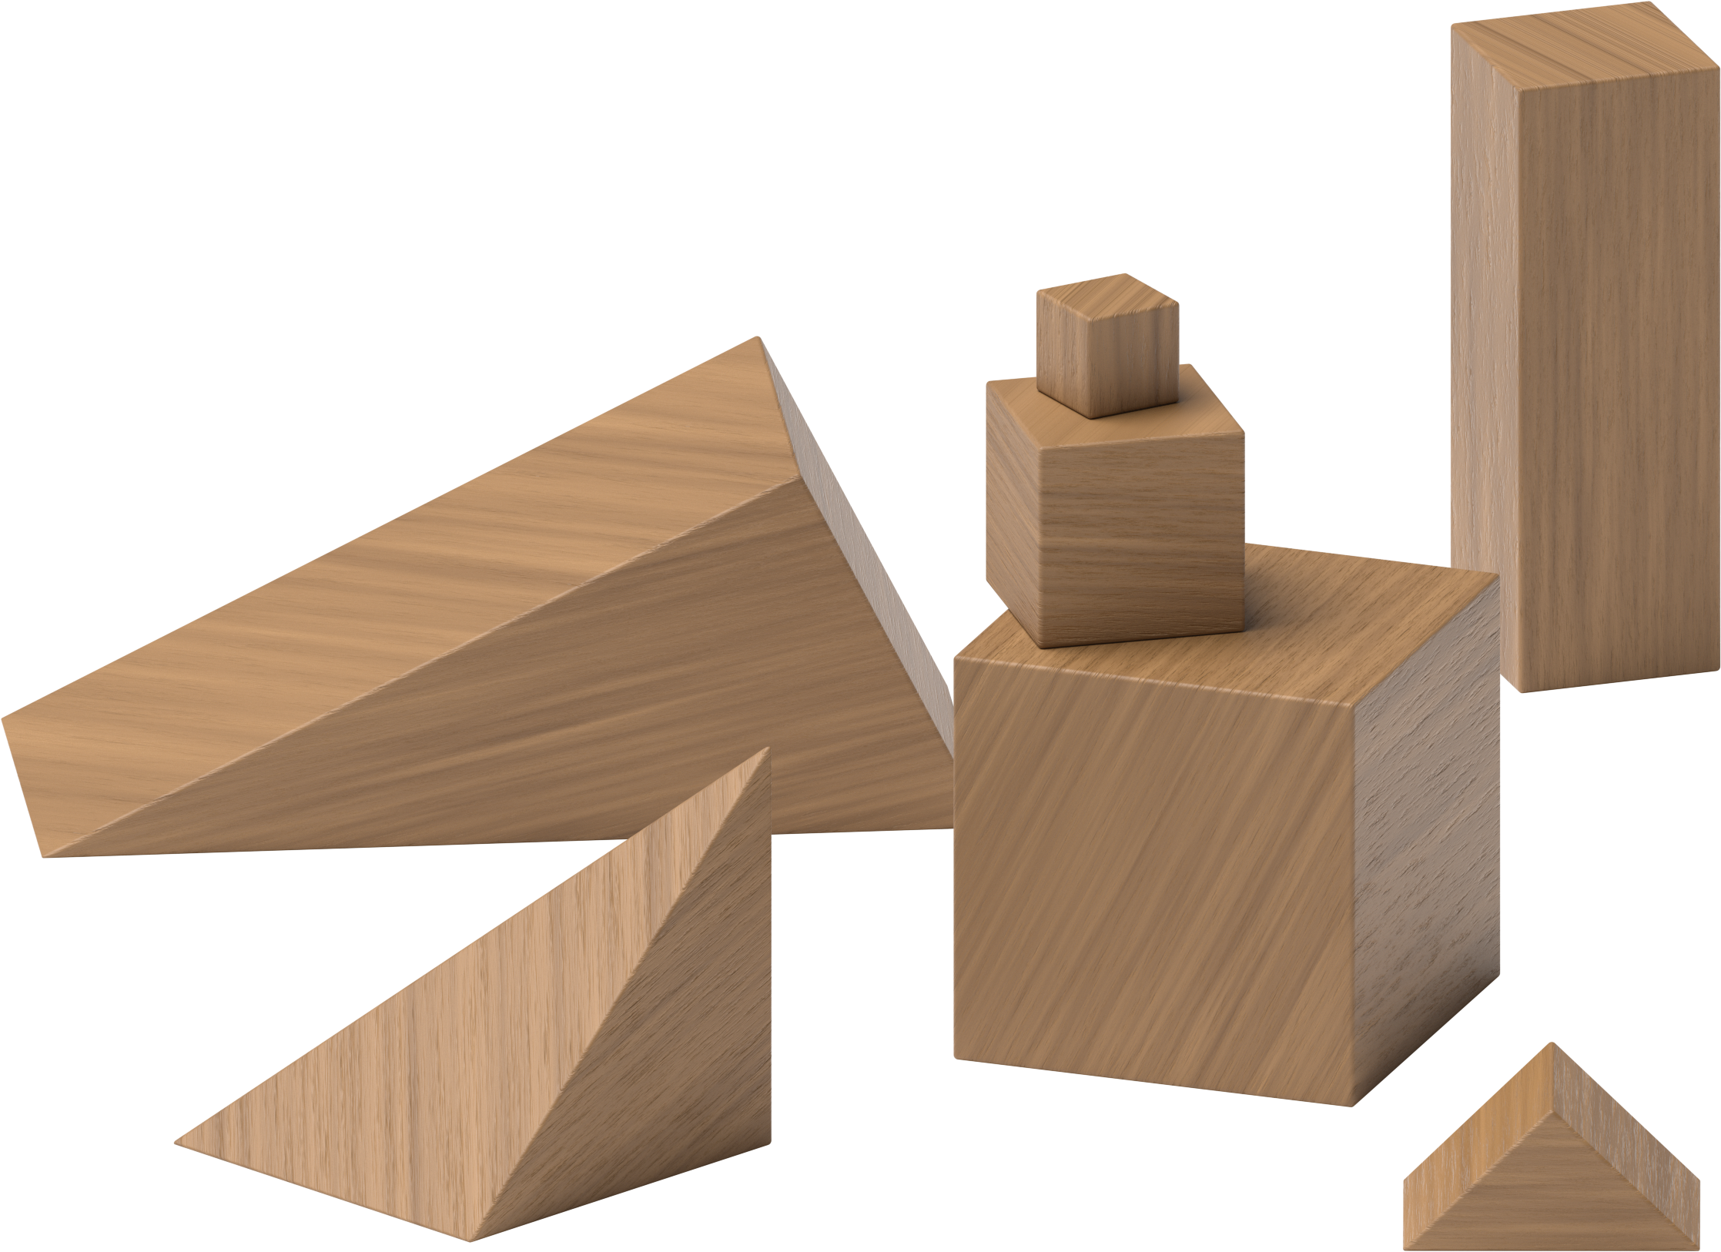
Build Shapes
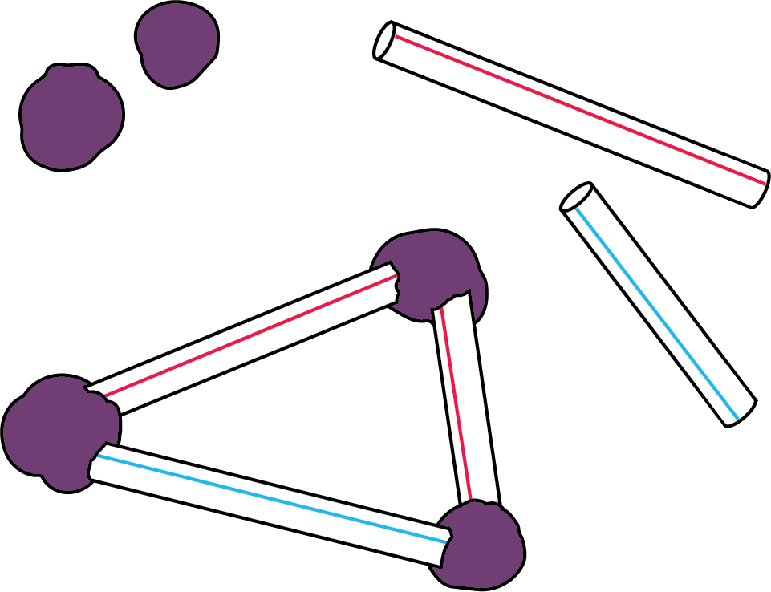
Pattern Blocks
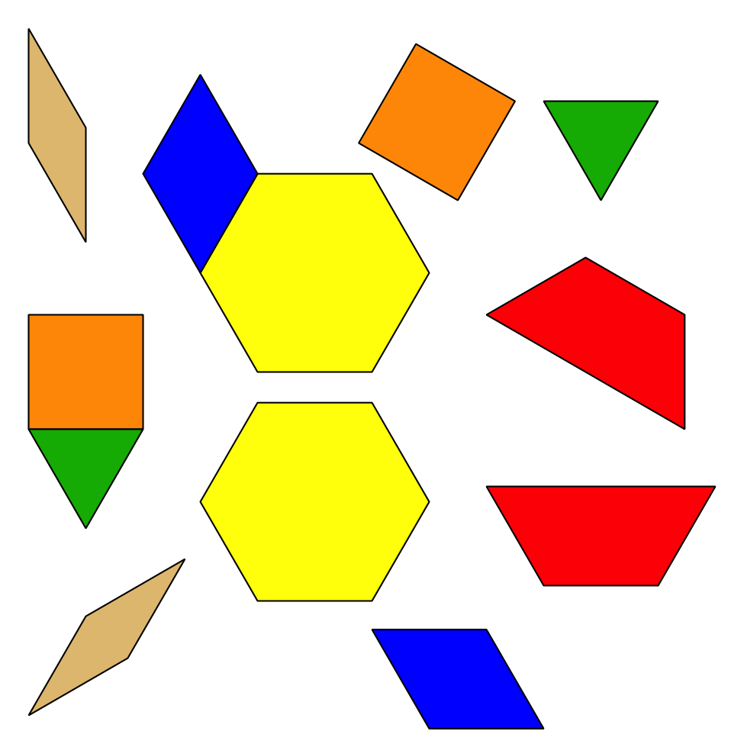
Less, Same, More
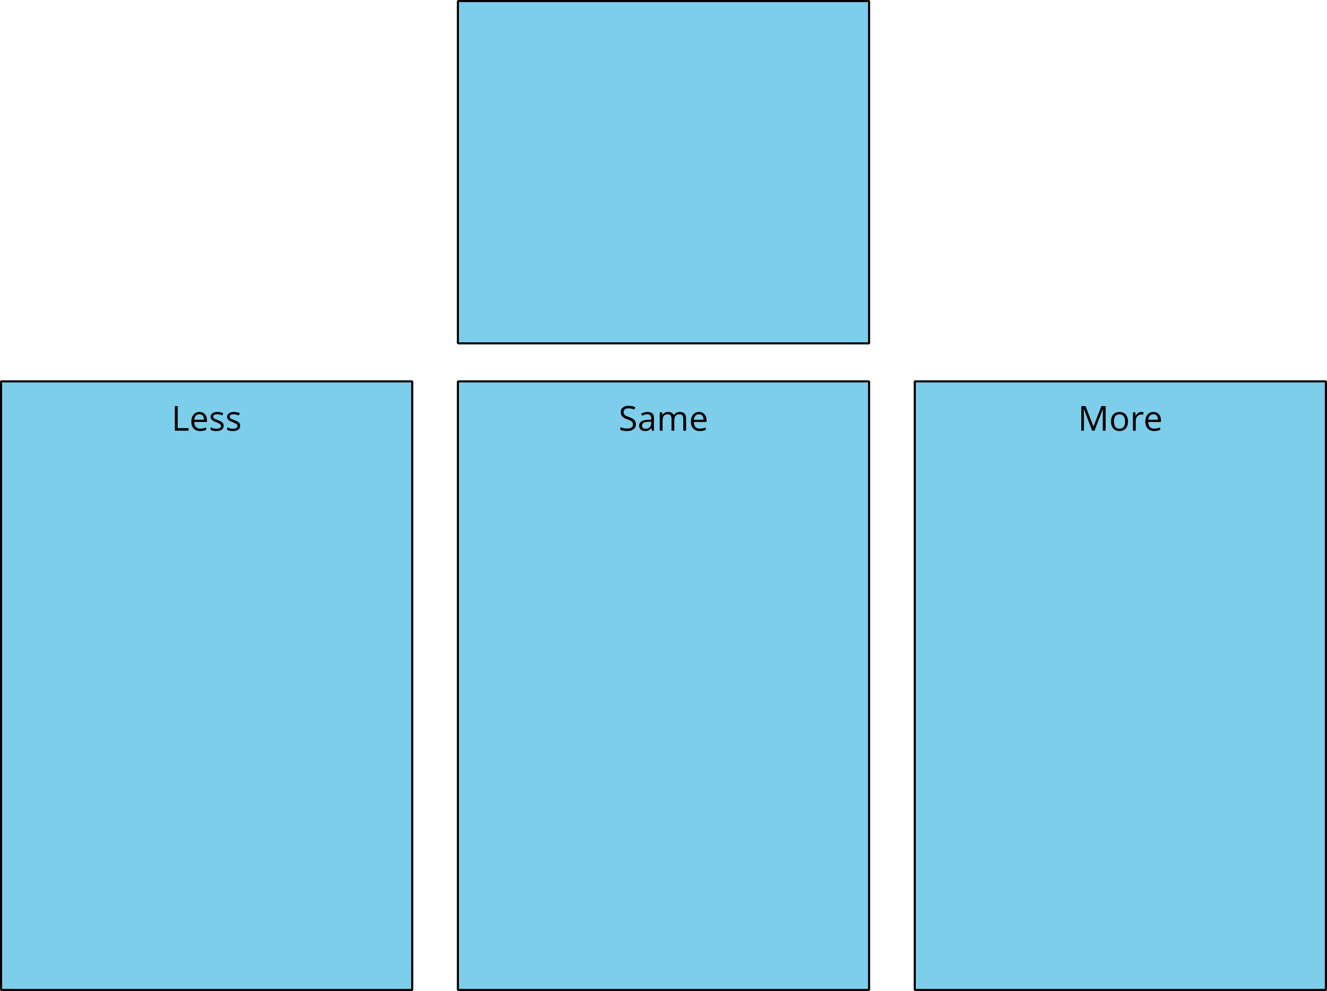
© CC BY 2021 Illustrative Mathematics®

