Unit 2 Lesson 16: Writing Equations for Lines

1 Coordinates and Lengths in the Coordinate Plane (Warm up)

Student Task Statement
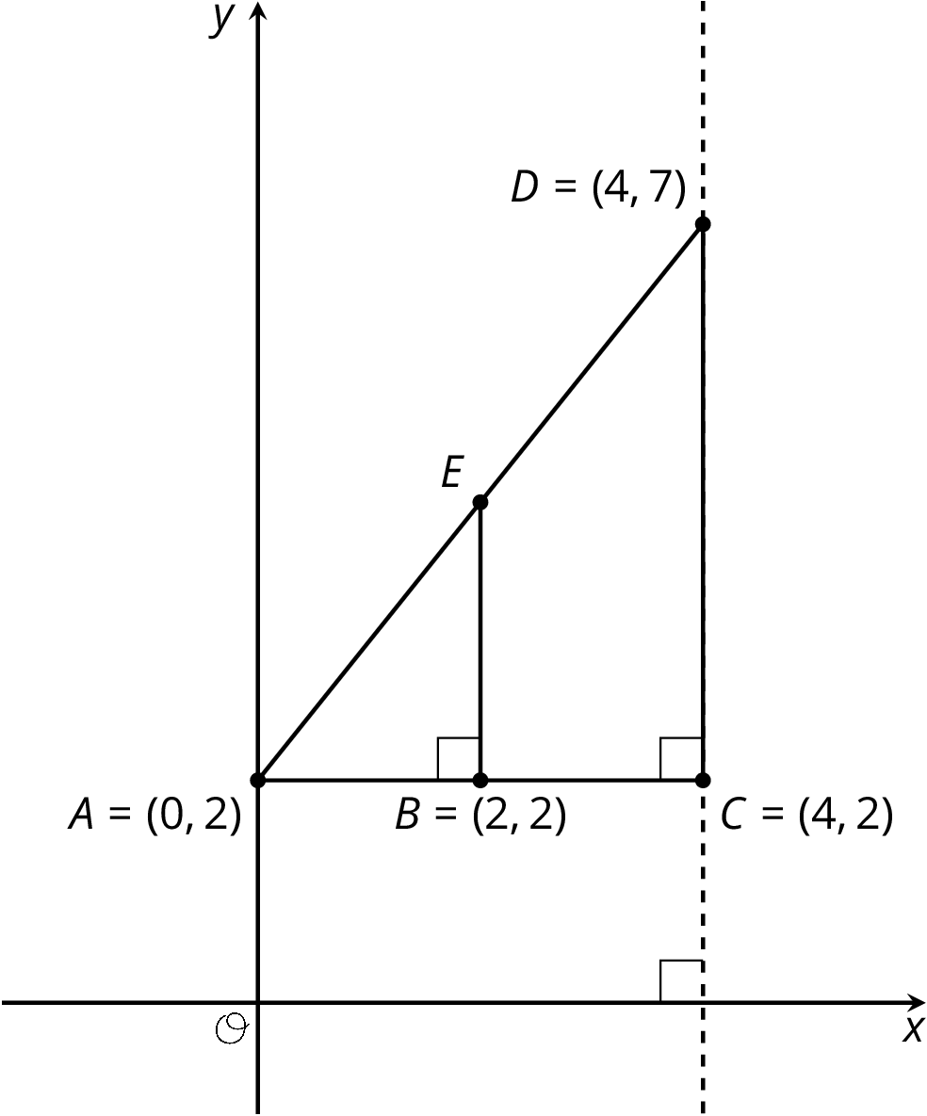
Find each of the following and explain your reasoning:
- The length of segment $BE$.
- The coordinates of $E$.

2 What We Mean by an Equation of a Line

Student Task Statement
Line $j$ is shown in the coordinate plane.
- What are the coordinates of $B$ and $D$?
- Is point $\left(20,15\right)$ on line $j$? Explain how you know.
- Is point $\left(100,75\right)$ on line $j$? Explain how you know.
- Is point $\left(90,68\right)$ on line $j$? Explain how you know.
- Suppose you know the $x$- and $y$-coordinates of a point. Write a rule that would allow you to test whether the point is on line $j$.
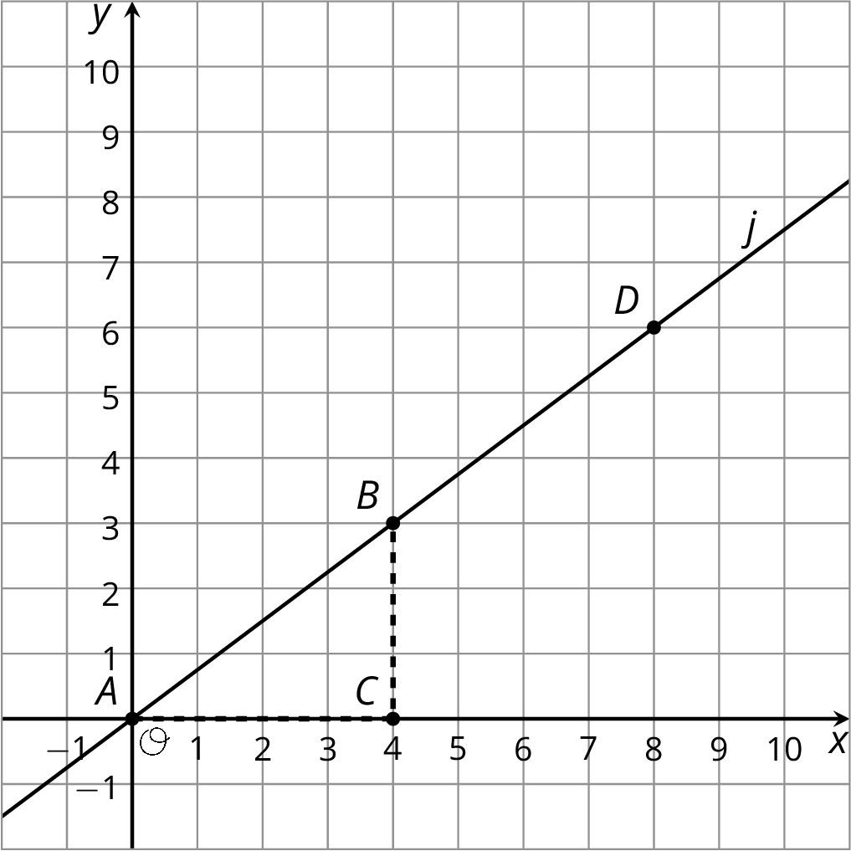

Activity Synthesis
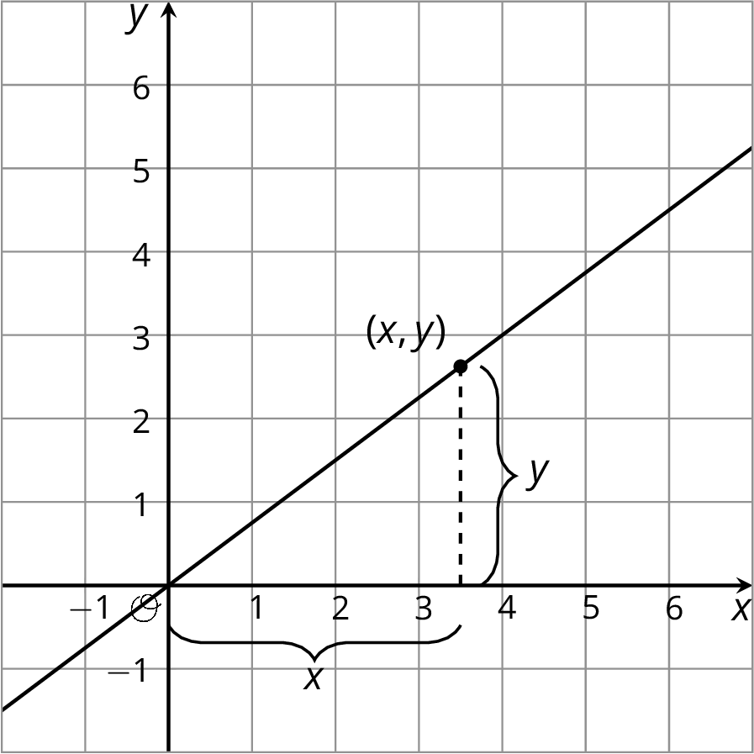

3 Writing Relationships from Slope Triangles

Student Task Statement
Here are two diagrams:
- Complete each diagram so that all vertical and horizontal segments have expressions for their lengths.
- Use what you know about similar triangles to find an equation for the quotient of the vertical and horizontal side lengths of $△DFE$ in each diagram.
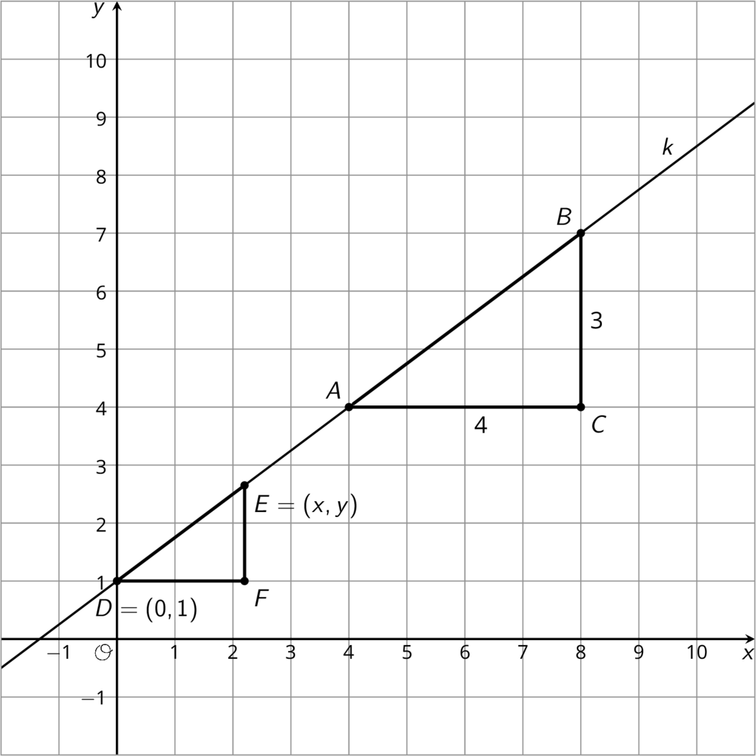
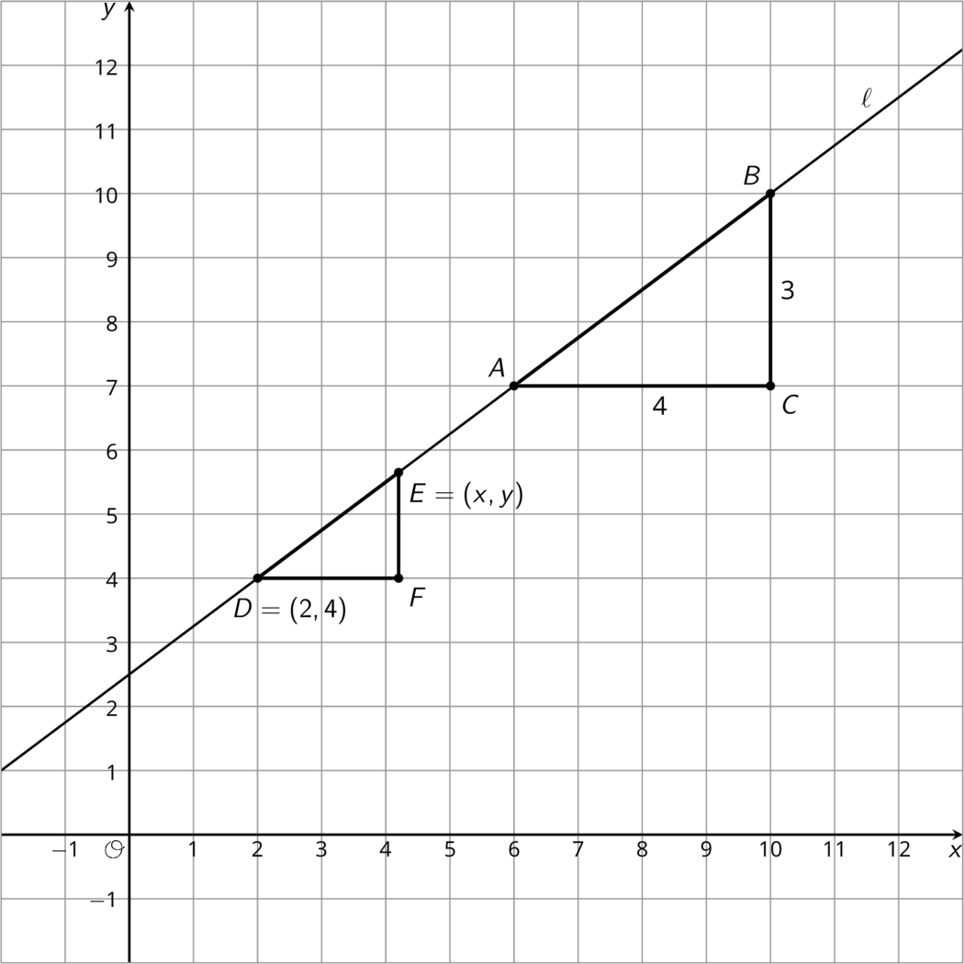

Images for Activity Synthesis
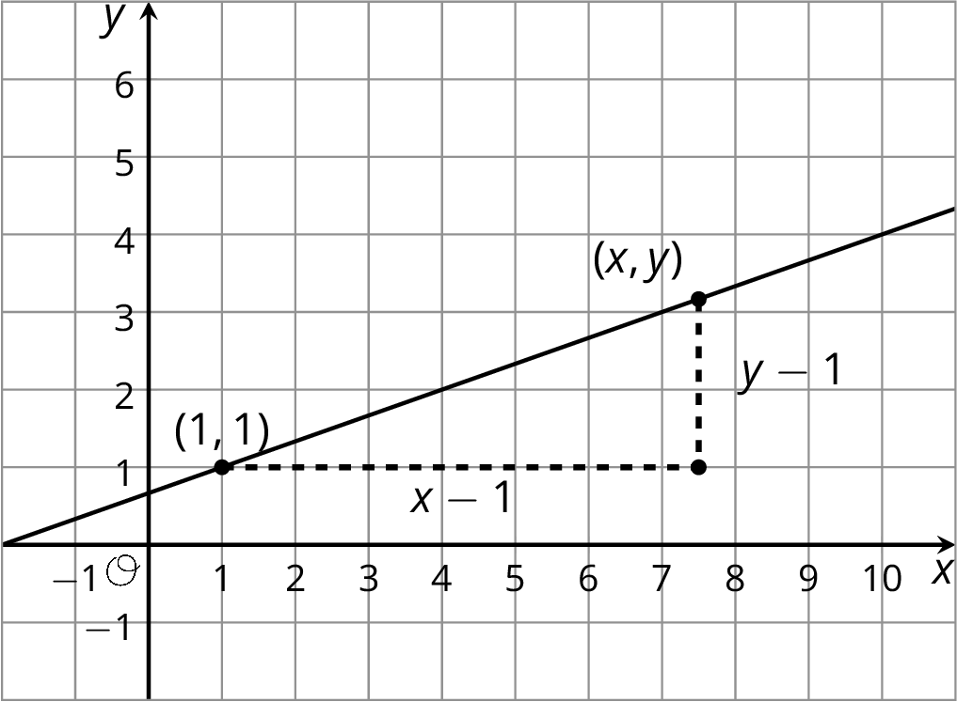
© CC BY Open Up Resources. Adaptations CC BY IM.

