Lesson 4: Groups that Look Alike
- Let’s find groups that have more, fewer, or the same number.

4.1: Which Has More?
Priya and her family are sitting down at the table for dinner.
There are 4 people sitting at the table.
There are 6 spoons.
Are there enough spoons for each person to get one?
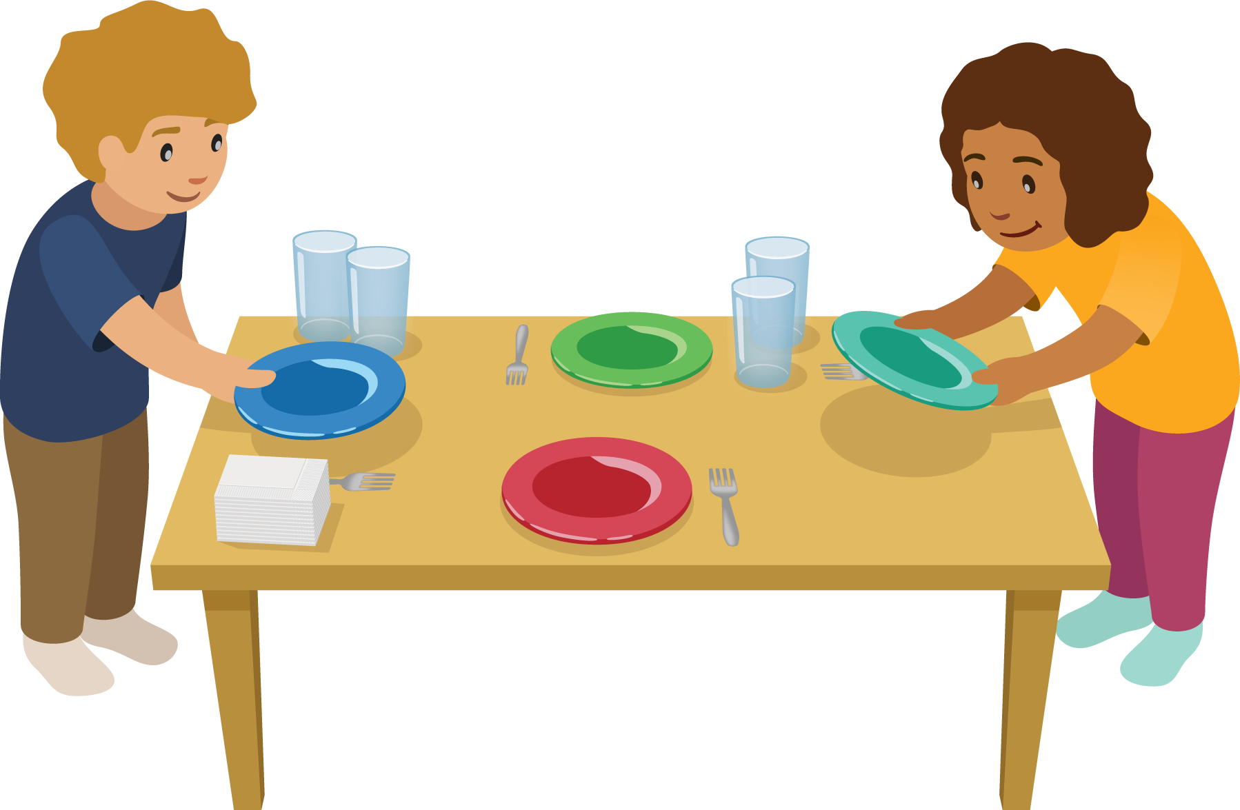

4.3: Centers: Choice Time
Choose a center.
Number Race
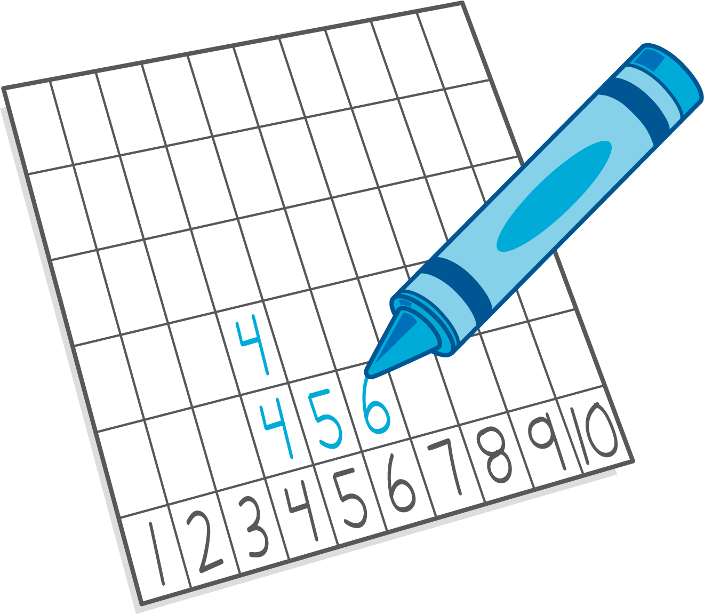
Shake and Spill
Math Fingers
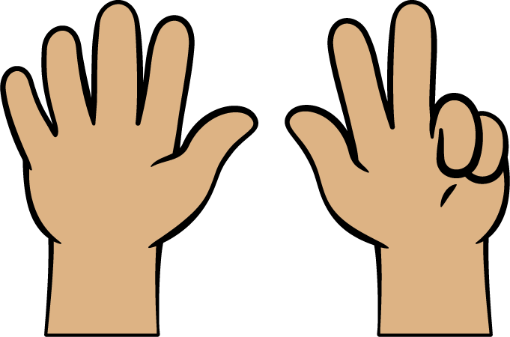
Pattern Blocks
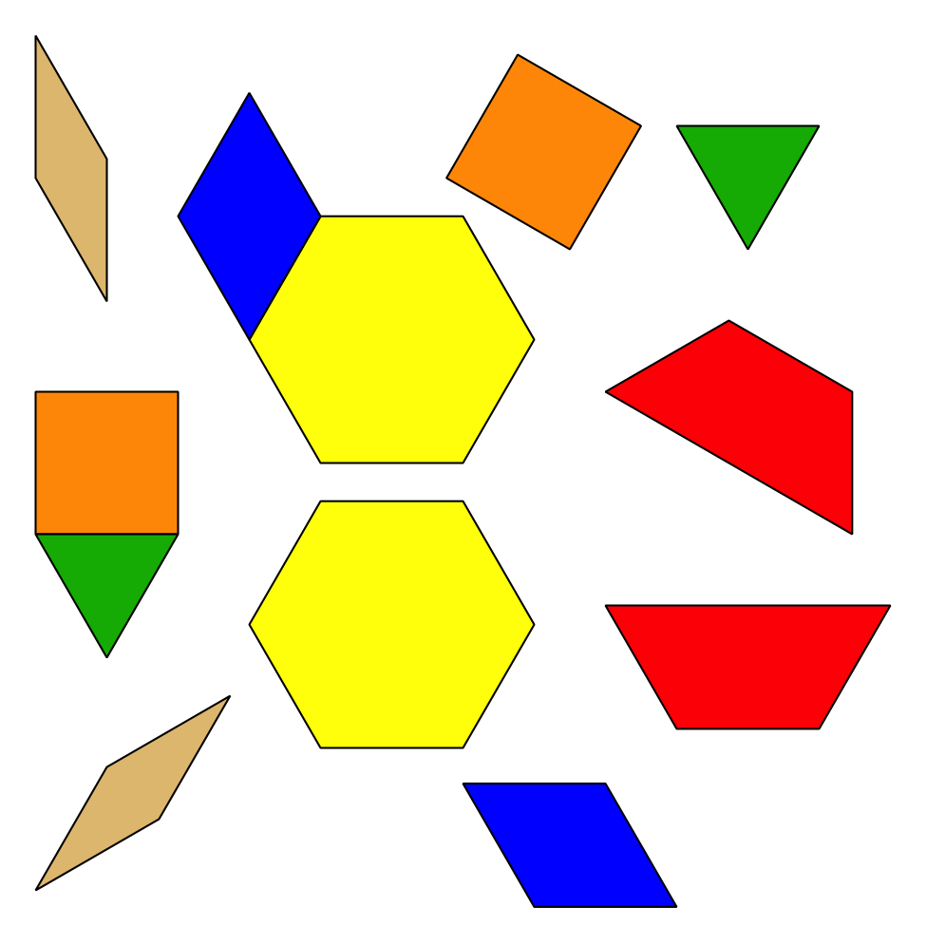
Picture Books
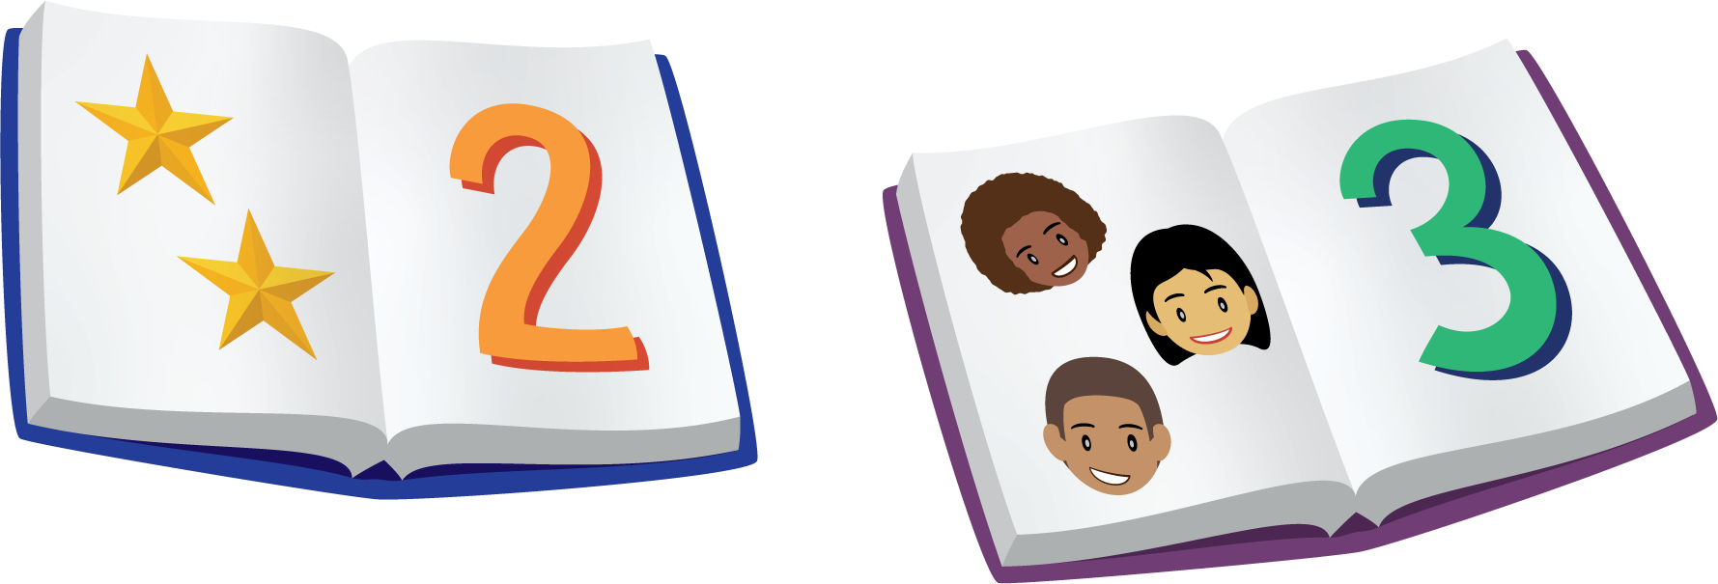
© CC BY 2021 Illustrative Mathematics®

