Lesson 13 Practice Problems
- For each trigonometric function, indicate the amplitude and midline.
  - $y=2sin\left(θ\right)$
  - $y=cos\left(θ\right)−5$
  - $y=1.4sin\left(θ\right)+3.5$
- Here is a graph of the equation $y=2sin\left(θ\right)−3$.
  - Indicate the midline on the graph.
  - Use the graph to find the amplitude of this sine equation.
- 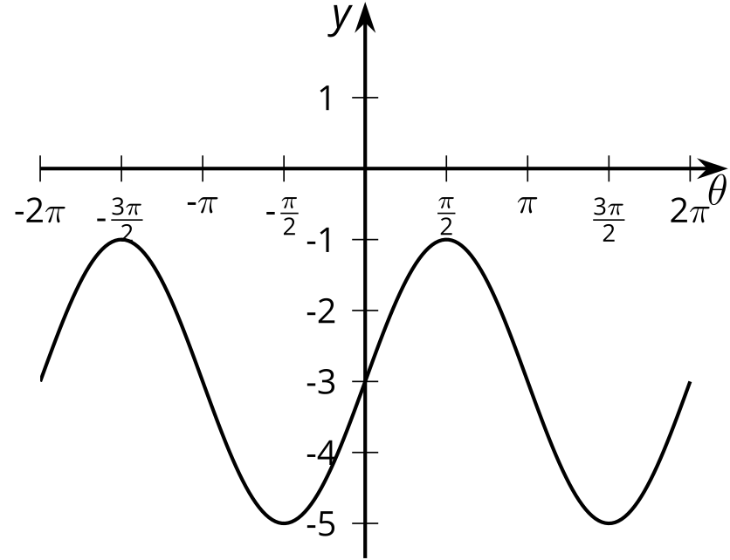
- Select all trigonometric functions with an amplitude of 3.
  - $y=3sin\left(θ\right)−1$
  - $y=sin\left(θ\right)+3$
  - $y=3cos\left(θ\right)+2$
  - $y=cos\left(θ\right)−3$
  - $y=3sin\left(θ\right)$
  - $y=cos\left(θ−3\right)$
- The center of a windmill is 20 feet off the ground and the blades are 10 feet long.
- 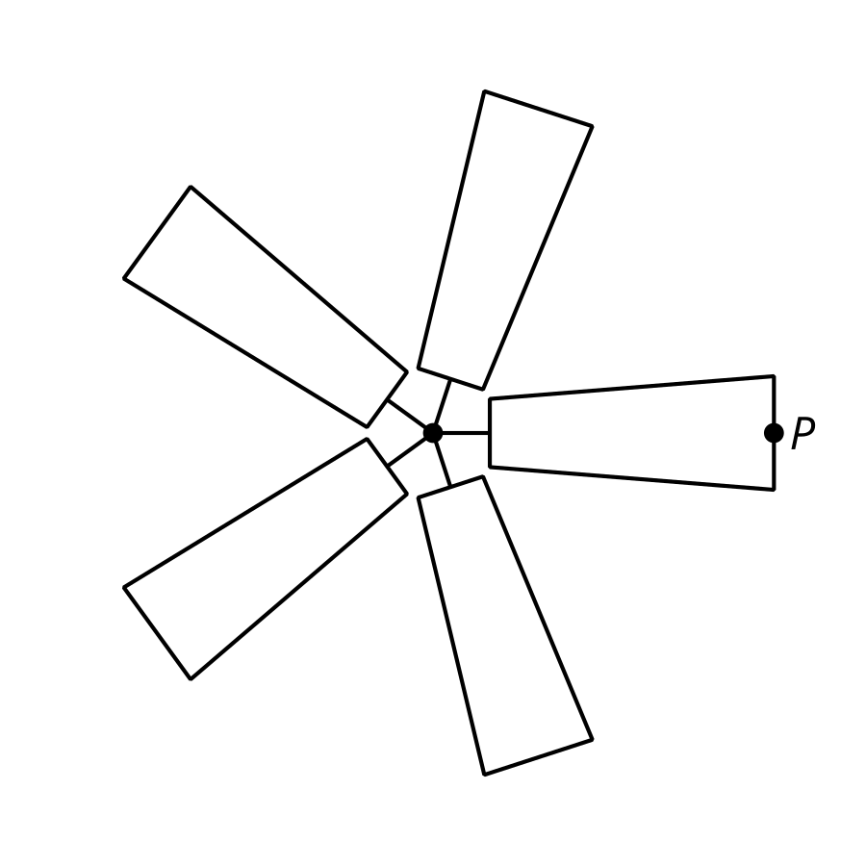
- ​​​​​​
- rotation angle  of windmill | - vertical position  of $P$ in feet
- $\frac{π}{6}$
- $\frac{π}{3}$
- $\frac{π}{2}$
- $π$
- $\frac{3π}{2}$
  - Fill out the table showing the vertical position of $P$ after the windmill has rotated through the given angle.
  - Write an equation for the function $f$ that describes the relationship between the angle of rotation $θ$ and the vertical position of the point $P$, $f\left(θ\right)$, in feet.
- The measure of angle $θ$, in radians, satisfies $sin\left(θ\right)<0$. If $θ$ is between 0 and $2π$ what can you say about the measure of $θ$?
- (From Unit 6, Lesson 9.)
- Which rotations, with center $O$, take $P$ to $Q$? Select all that apply.
- 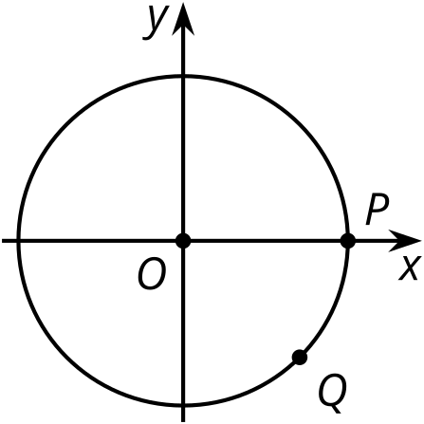
  - $\frac{3π}{4}$ radians
  - $\frac{15π}{4}$ radians
  - $\frac{7π}{4}$ radians
  - $\frac{11π}{4}$ radians
  - $\frac{23π}{4}$ radians
- (From Unit 6, Lesson 10.)
- The picture shows two points $P$ and $Q$ on the unit circle.
- Explain why the tangent of $P$ and $Q$ is 2.
- 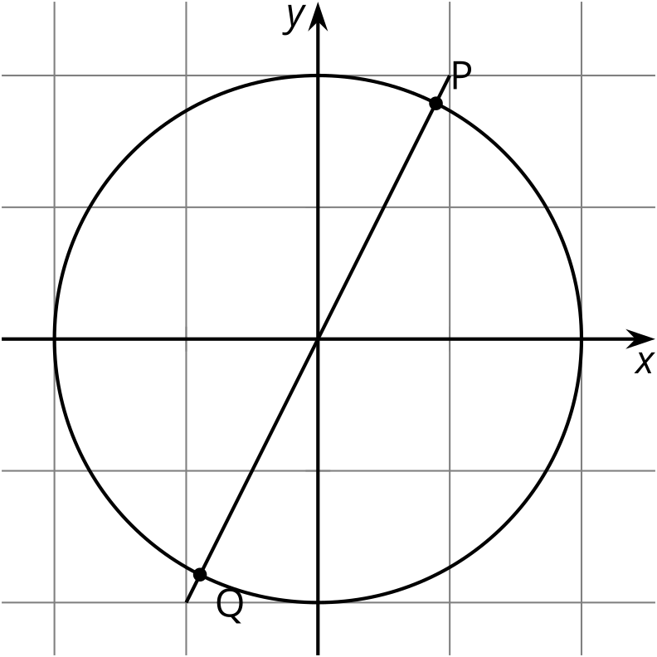
- (From Unit 6, Lesson 12.)
© CC BY 2019 by Illustrative Mathematics®

