Lesson 4: Using Function Notation to Describe Rules (Part 1)
- Let’s look at some rules that describe functions and write some, too.

4.1: Notice and Wonder: Two Functions
What do you notice? What do you wonder?
$x$ | $f\left(x\right)=10−2x$
1 | 8
1.5 | 7
5 | 0
-2 | 14

$x$ | $g\left(x\right)=x^{3}$
-2 | -8
0 | 0
1 | 1
3 | 27

4.2: Four Functions
Here are descriptions and equations that represent four functions.
$f\left(x\right)=3x−7$
$g\left(x\right)=3\left(x−7\right)$
$h\left(x\right)=\frac{x}{3}−7$
$k\left(x\right)=\frac{x−7}{3}$
A. To get the output, subtract 7 from the input, then divide the result by 3.
B. To get the output, subtract 7 from the input, then multiply the result by 3.
C. To get the output, multiply the input by 3, then subtract 7 from the result.
D. To get the output, divide the input by 3, and then subtract 7 from the result.
- Match each equation with a verbal description that represents the same function. Record your results.
- For one of the functions, when the input is 6, the output is -3. Which is that function: $f,g$, $h$, or $k$? Explain how you know.
- Which function value—$f\left(x\right),g\left(x\right),h\left(x\right)$, or $k\left(x\right)$—is the greatest when the input is 0? What about when the input is 10?

Are you ready for more?
Mai says $f\left(x\right)$ is always greater than $g\left(x\right)$ for the same value of $x$. Is this true? Explain how you know.

4.3: Rules for Area and Perimeter
- A square that has a side length of 9 cm has an area of 81 cm². The relationship between the side length and the area of the square is a function.
  - Complete the table with the area for each given side length.
  - Then, write a rule for a function, $A$, that gives the area of the square in cm² when the side length is $s$ cm. Use function notation.
- side length (cm) | - area (cm²)
  - 1
  - 2
  - 4
  - 6
  - $s$
  - What does $A\left(2\right)$ represent in this situation? What is its value?
  - On the coordinate plane, sketch a graph of this function.
  - 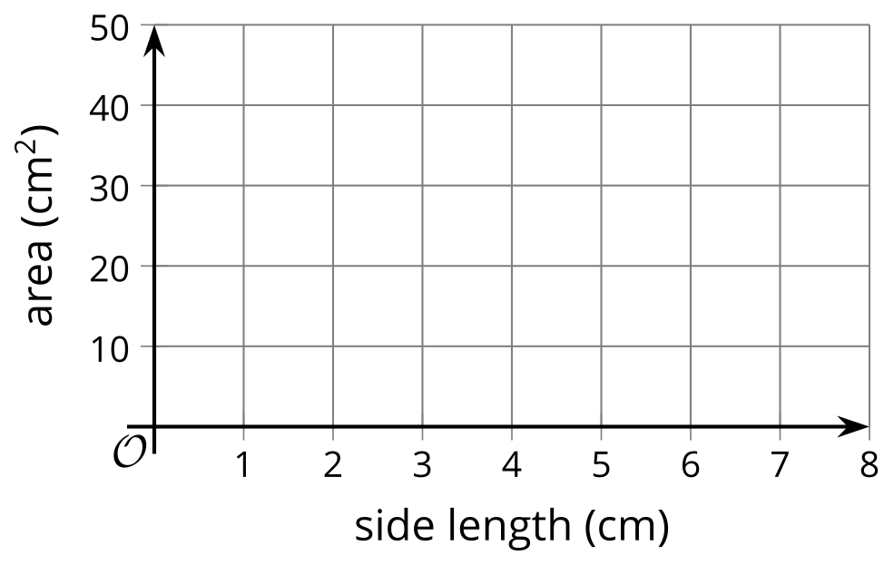
- A roll of paper that is 3 feet wide can be cut to any length.
  - If we cut a length of 2.5 feet, what is the perimeter of the paper?
  - 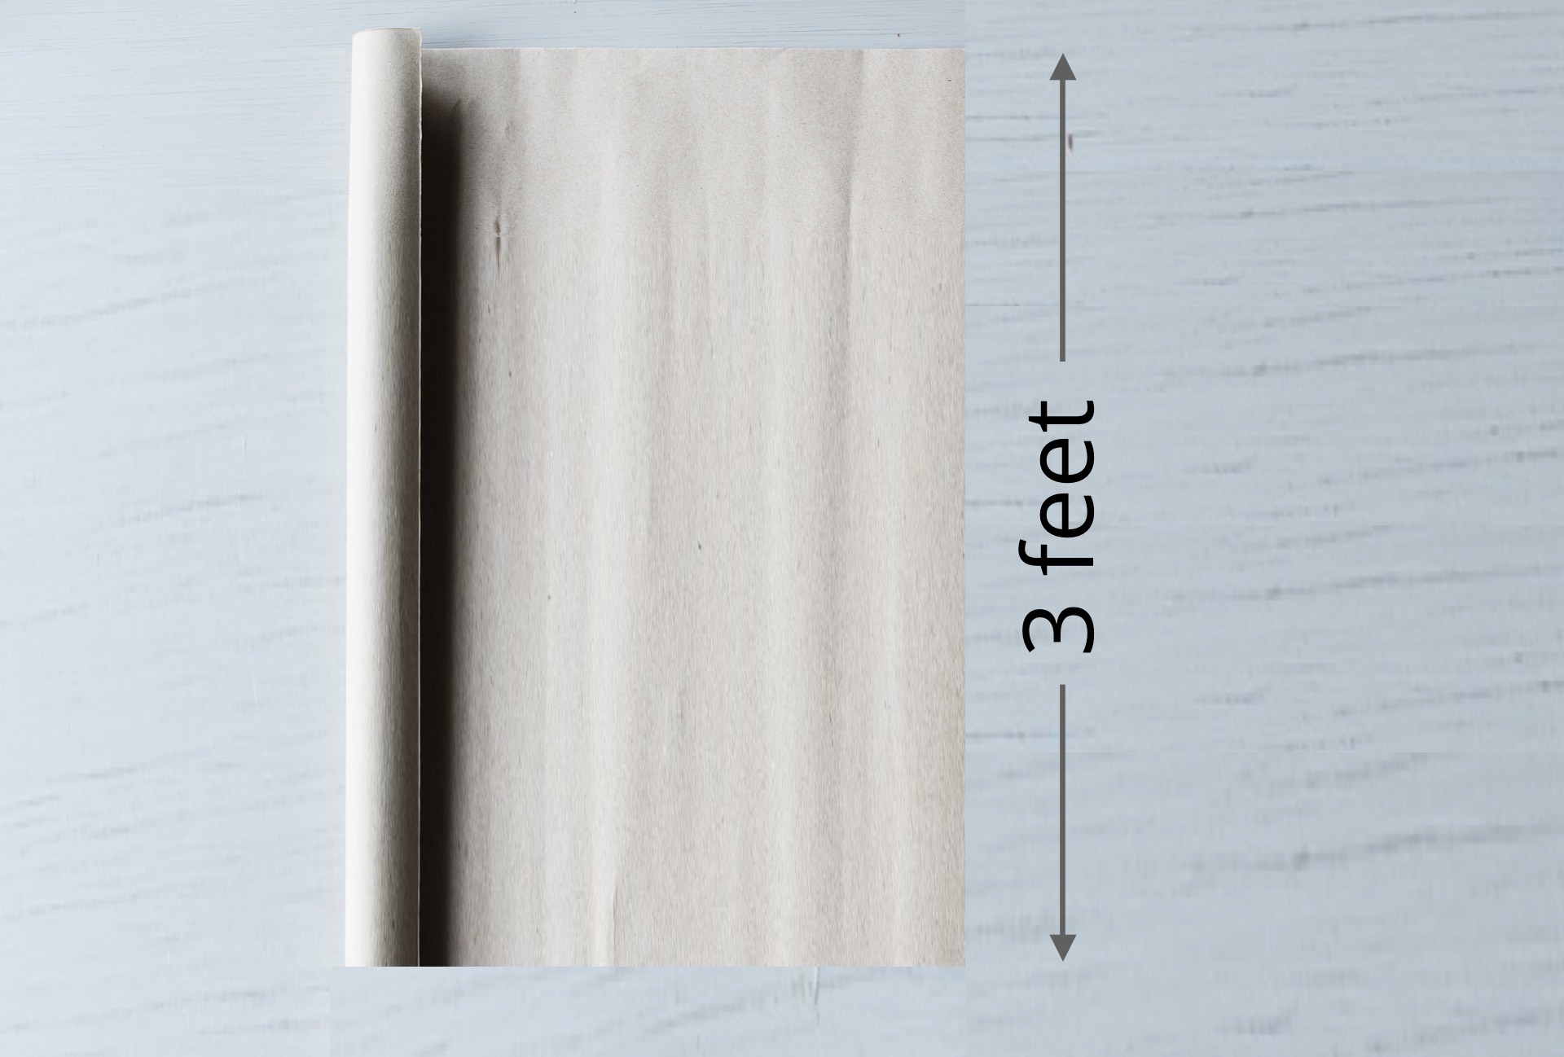
  - Complete the table with the perimeter for each given side length.
  - Then, write a rule for a function, $P$, that gives the perimeter of the paper in feet when the side length in feet is $ℓ$. Use function notation.
- side length (feet) | - perimeter (feet)
  - 1
  - 2
  - 6.3
  - 11
  - $ℓ$
  - What does $P\left(11\right)$ represent in this situation? What is its value?
  - On the coordinate plane, sketch a graph of this function.
  - 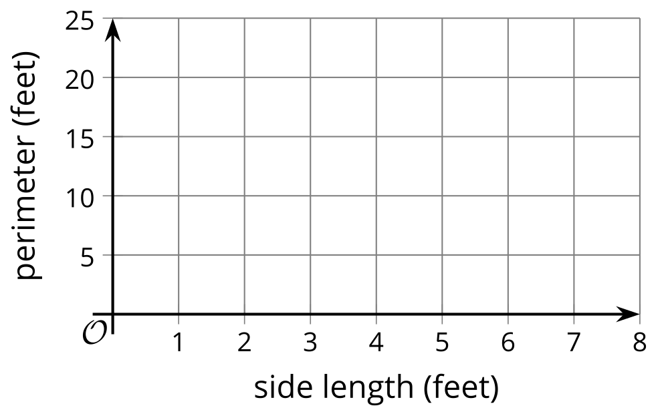

Lesson 4 Summary
Some functions are defined by rules that specify how to compute the output from the input. These rules can be verbal descriptions or expressions and equations. For example:
Rules in words:
- To get the output of function $f$, add 2 to the input, then multiply the result by 5.
- To get the output of function $m$, multiply the input by $\frac{1}{2}$ and subtract the result from 3.
Rules in function notation:
- $f\left(x\right)=\left(x+2\right)⋅5$ or $5\left(x+2\right)$
- $m\left(x\right)=3−\frac{1}{2}x$
Some functions that relate two quantities in a situation can also be defined by rules and can therefore be expressed algebraically, using function notation.
Suppose function $c$ gives the cost of buying $n$ pounds of apples at $1.49 per pound. We can write the rule $c\left(n\right)=1.49n$ to define function $c$.
To see how the cost changes when $n$ changes, we can create a table of values.
pounds of apples, $n$ | cost in dollars, $c\left(n\right)$
0 | 0
1 | 1.49
2 | 2.98
3 | 4.47
$n$ | $1.49n$
Plotting the pairs of values in the table gives us a graphical representation of $c$.
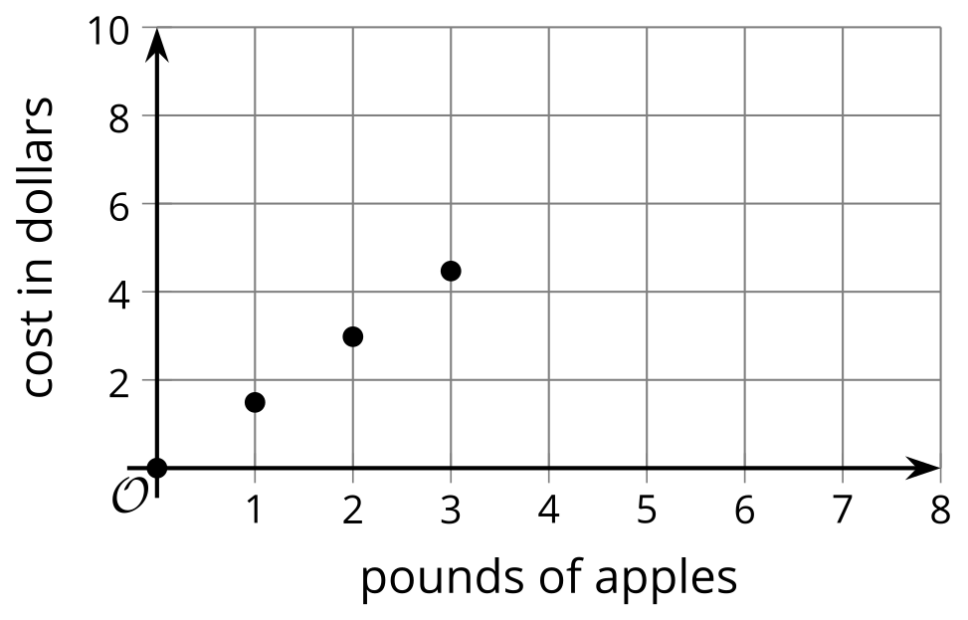
© CC BY 2019 by Illustrative Mathematics®

