Unit 5 Lesson 13: Analyze Addition Mistakes

WU Estimation Exploration: Many Places (Warm up)

Student Task Statement
$1,​987.89+658.54$
Record an estimate that is:
too low | about right | too high

1 Compare Calculations

Student Task Statement
- Find the value of $621.45+72.3$. Explain or show your reasoning.
- Elena and Andre found the value of $621.45+72.3$. Who do you agree with? Explain or show your reasoning.
- 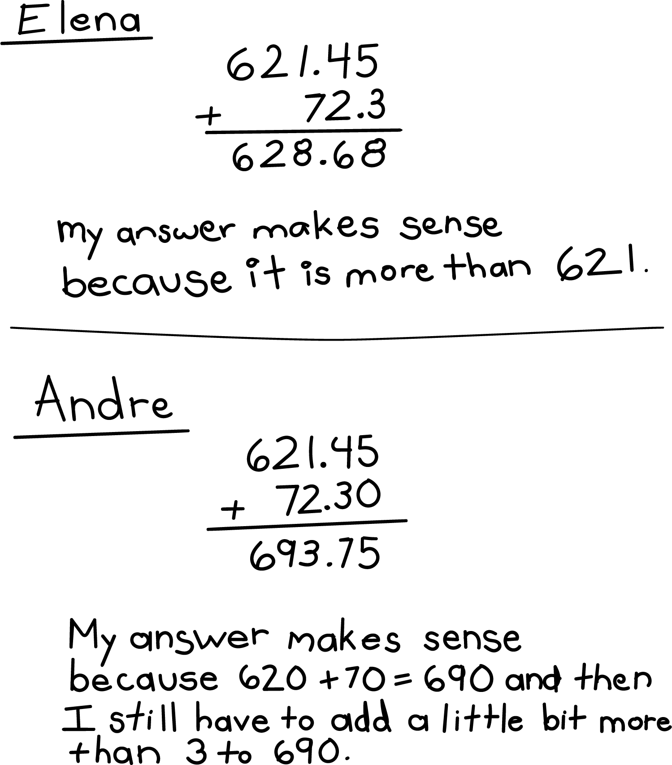

2 Same Digits, Different Sums

Student Task Statement
Find the value of each expression. Explain or show your reasoning.
- $2.63+7.74$
- $26.3+774$
- $46.3+31.42$
- $463+3.14$
© CC BY 2021 Illustrative Mathematics®

