Unit 5 Lesson 12: Order Numbers

WU Number Talk: Subtract Tens (Warm up)

Student Task Statement
Find the value of each expression mentally.
- $80−50$
- $87−50$
- $76−40$
- $66−30$

1 Who is Out of Order?

Student Task Statement
Kiran and Andre put a list of numbers in order from least to greatest.
Kiran
207, 217, 272, 269, 290
Andre
207, 217, 269, 272, 290
Andre disagreed with Kiran, so he used a number line to justify his answer.
Who do you agree with? Why?
Be prepared to explain your thinking. Use what you know about place value or the number line to justify your reasoning.

2 Order Numbers

Student Task Statement
- Estimate the location of 839, 765, 788, 815, and 719 on the number line. Mark each number with a point. Label the point with the number it represents.
- Order the numbers from least to greatest.
- _______, _______, _______, _______, _______
- Estimate the location of 199, 245, 173, 218, and 137 on the number line. Mark each number with a point. Label the point with the number it represents.
- Order the numbers from greatest to least.
- _______, _______, _______, _______, _______
- Order the numbers from least to greatest.
- 545, 454, 405, 504, and 445
- _______, _______, _______, _______, _______
- Explain or show your thinking. Use the number line if it helps.
- Was it more helpful for you to put the numbers in order first or put them on the number line first? Explain.
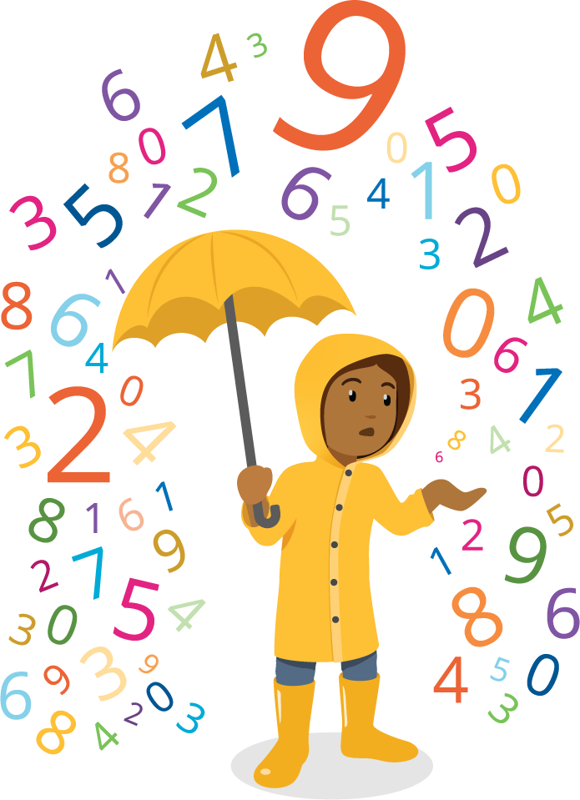
© CC BY 2021 Illustrative Mathematics®

