Unit 5 Lesson 20: Evaluating Functions over Equal Intervals

1 Finding Slopes (Warm up)

Student Task Statement
- Find the slope of each line.
  - The line that passes through $(2,2)$ and $(3,6)$.
  - The graph of $f(x)=\text{-}2+\frac{1}{3}x$.
- Show on the graph where each slope can be seen.
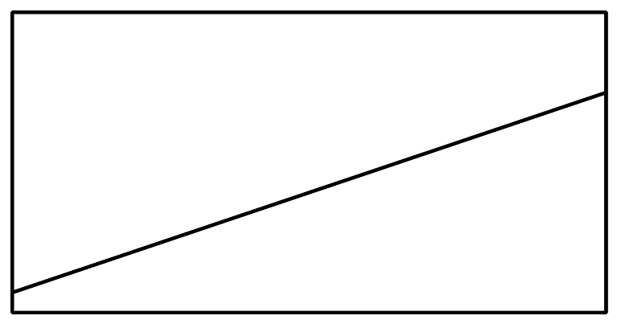

2 Incrementing by One

Student Task Statement
- For the function $f(x)=3x+4$, evaluate:
  - $f(0)$ and $f(1)$
  - $f(100)$ and $f(101)$
  - $f(\text{-}10)$ and $f(\text{-}9)$
  - $f(0.5)$ and $f(1.5)$
- What do all those pairs of numbers you found have in common?
- Write an expression for $f(w)$ and $f(w+1)$.
- What would you expect to be the result of subtracting $f(w)$ from $f(w+1)$?
- Subtract $f(w)$ from $f(w+1)$. If you don’t get the answer you predicted, work with a partner to check your algebra.
- For the function $g(x)=2^{x}$, evaluate:
  - $g(3)$ and $g(4)$
  - $g(0)$ and $g(1)$
  - $g(\text{-}1)$ and $g(\text{-}2)$
  - $g(10)$ and $g(11)$
- What do all those pairs of numbers you found have in common?
- Write an expression for $g(u)$ and $g(u+1)$.
- What would you expect to be the result of dividing $g(u+1)$ by $g(u)$?
- Divide $g(u+1)$ by $g(u)$. If you don’t get the answer you predicted, work with a partner to check your algebra.

3 Rewriting Expressions

Student Task Statement
- Evaluate:
  - $\frac{3^{5}}{3^{4}}$
  - $\frac{3^{1}}{3^{0}}$
  - $\frac{3^{\text{-}1}}{3^{\text{-}2}}$
  - $\frac{3^{100}}{3^{99}}$
  - $\frac{3^{x+1}}{3^{x}}$
- Solve for $m$:
  - $\frac{2^{m}}{2^{7}}=2$
  - $\frac{2^{100}}{2^{m}}=2$
  - $\frac{2^{m}}{2^{x}}=2$
- Write an equivalent expression using as few terms as possible:
  - $3(x+1)+4−(3x+4)$
  - $2(x+1)+5−(2x+5)$
  - $2(x+2)+5−(2(x+1)+5)$
  - $\text{-}5(x+1)+3−(\text{-}5x+3)$
  - $\frac{5^{x+1}}{5^{x}}$
  - $\frac{7^{x+4}}{7^{x}}$
© CC BY 2019 by Illustrative Mathematics®

