Lesson 4: Making the Moves
Let’s draw and describe translations, rotations, and reflections.

4.1: Reflection Quick Image
Here is an incomplete image. Your teacher will display the completed image twice, for a few seconds each time. Your job is to complete the image on your copy.
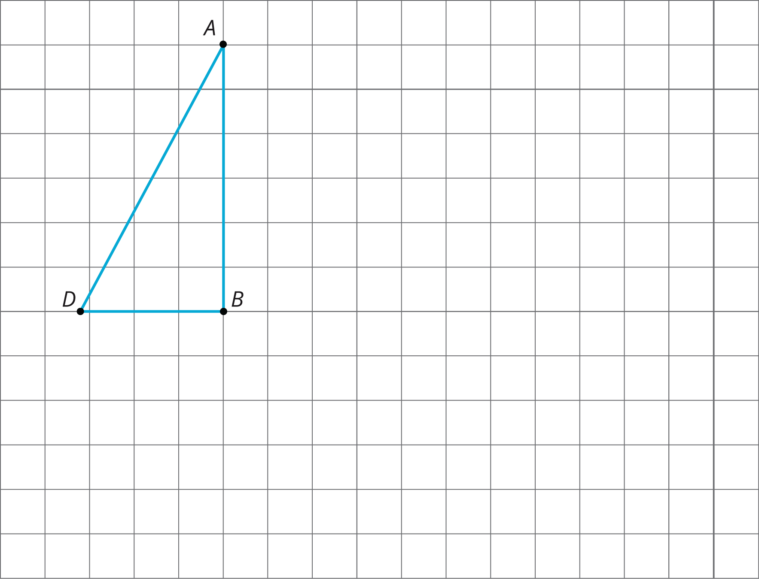

4.2: Make That Move
Your partner will describe the image of this triangle after a certain transformation. Sketch it here.
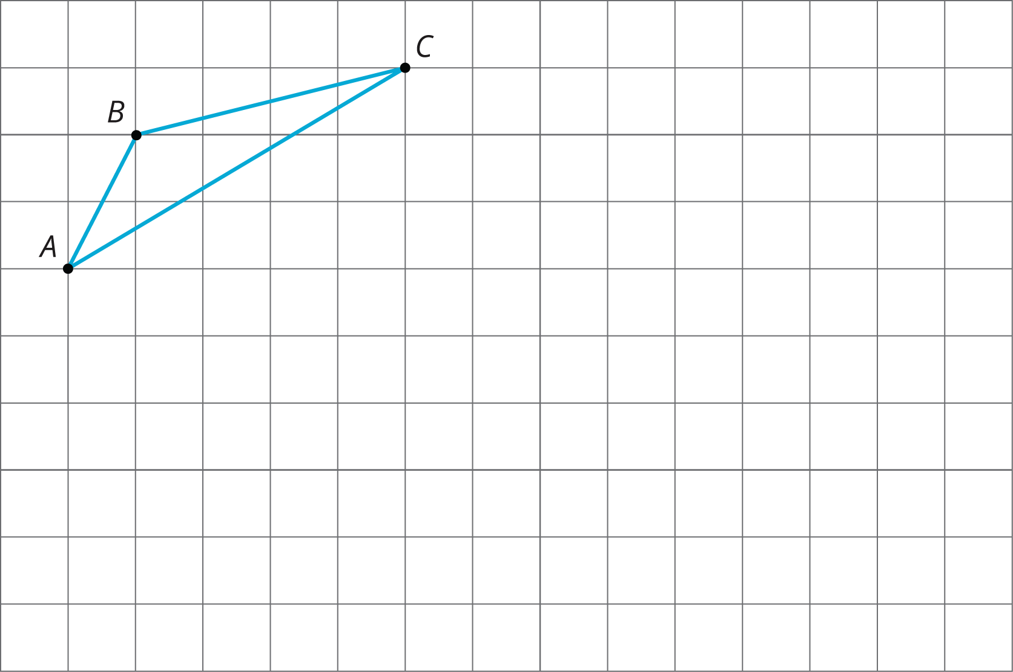

4.3: A to B to C
Here are some figures on an isometric grid.
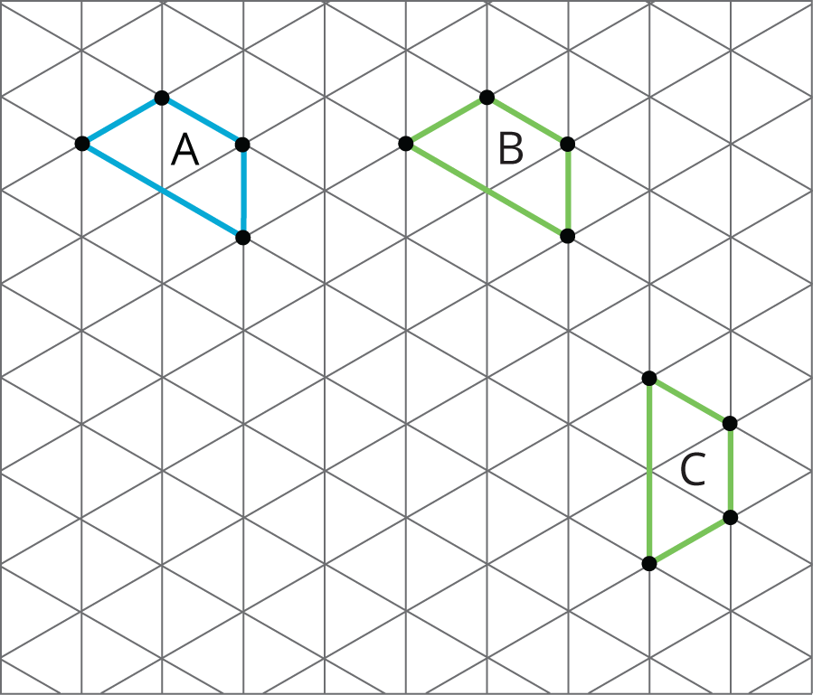
- Name a transformation that takes Figure $A$ to Figure $B$. Name a transformation that takes Figure $B$ to Figure $C$.
- What is one sequence of transformations that takes Figure $A$ to Figure $C$? Explain how you know.

Are you ready for more?
Experiment with some other ways to take Figure $A$ to Figure $C$. For example, can you do it with. . .
- No rotations?
- No reflections?
- No translations?

Lesson 4 Summary
A move, or combination of moves, is called a transformation. When we do one or more moves in a row, we often call that a sequence of transformations. To distinguish the original figure from its image, points in the image are sometimes labeled with the same letters as the original figure, but with the symbol $​^{′}$ attached, as in $A^{′}$ (pronounced “A prime”).
- A translation can be described by two points. If a translation moves point $A$ to point $A^{′}$, it moves the entire figure the same distance and direction as the distance and direction from $A$ to $A^{′}$. The distance and direction of a translation can be shown by an arrow.
- For example, here is a translation of quadrilateral $ABCD$ that moves $A$ to $A^{′}$.
- 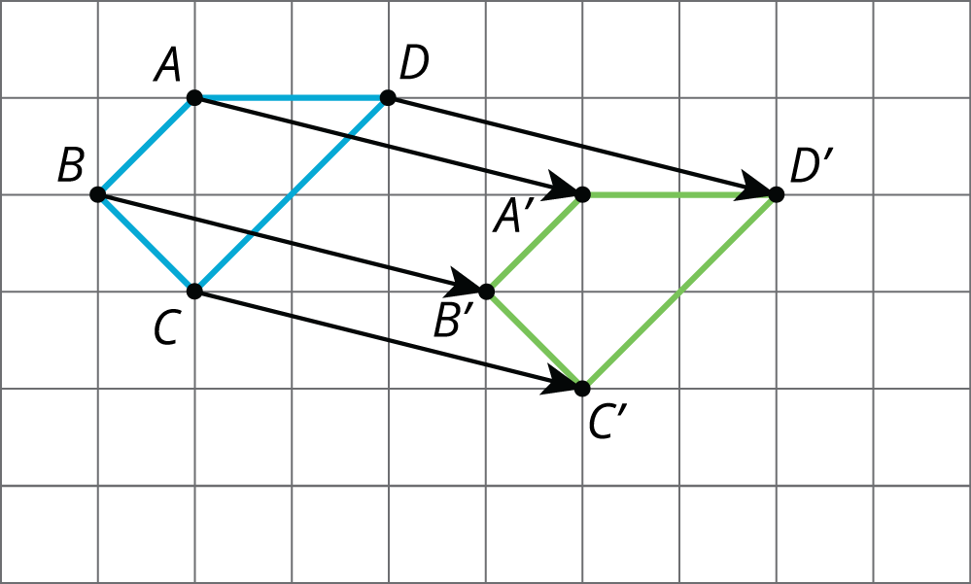
- A rotation can be described by an angle and a center. The direction of the angle can be clockwise or counterclockwise.
- For example, hexagon $ABCDEF$ is rotated ${90}^{∘}$ counterclockwise using center $P$.
- 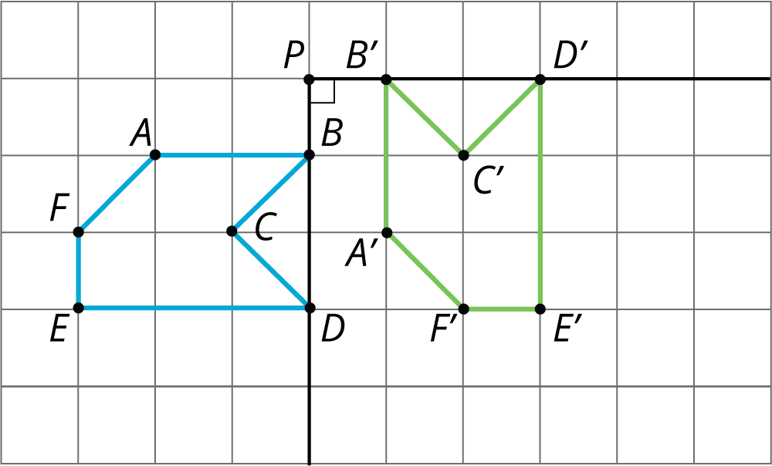
- A reflection can be described by a line of reflection (the “mirror”). Each point is reflected directly across the line so that it is just as far from the mirror line, but is on the opposite side.
- For example, pentagon $ABCDE$ is reflected across line $m$.
- 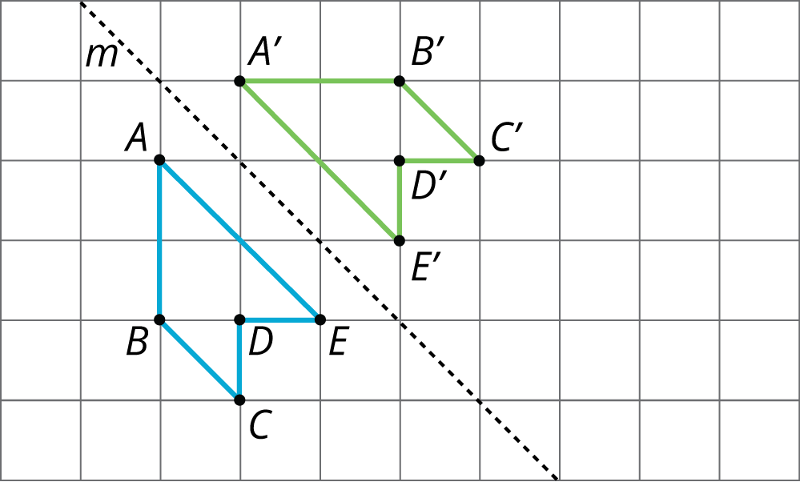
© CC BY Open Up Resources. Adaptations CC BY IM.

