Lesson 13: Applying Circumference
Let’s use $π$ to solve problems.

13.1: What Do We Know? What Can We Estimate?
Here are some pictures of circular objects, with measurement tools shown. The measurement tool on each picture reads as follows:
- Wagon wheel: 3 feet
- Plane propeller: 24 inches
- Sliced Orange: 20 centimeters
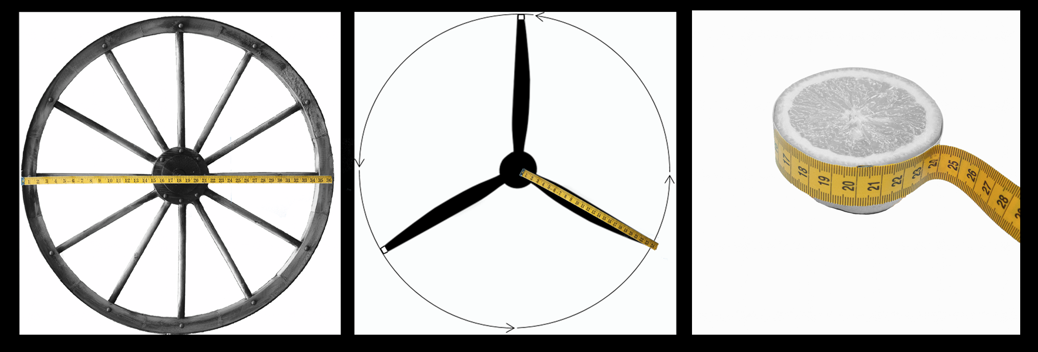
- For each picture, which measurement is shown?
- Based on this information, what measurement(s) could you estimate for each picture?

13.2: Using $π$
In the previous activity, we looked at pictures of circular objects. One measurement for each object is listed in the table.
Your teacher will assign you an approximation of $π$ to use for this activity.
- Complete the table.
- object | - radius | - diameter | - circumference
- wagon wheel |  | - 3 ft
- airplane propeller | - 24 in
- orange slice |  |  | - 20 cm
- A bug was sitting on the tip of the propeller blade when the propeller started to rotate. The bug held on for 5 rotations before flying away. How far did the bug travel before it flew off?

13.3: Around the Running Track
The field inside a running track is made up of a rectangle that is 84.39 m long and 73 m wide, together with a half-circle at each end.
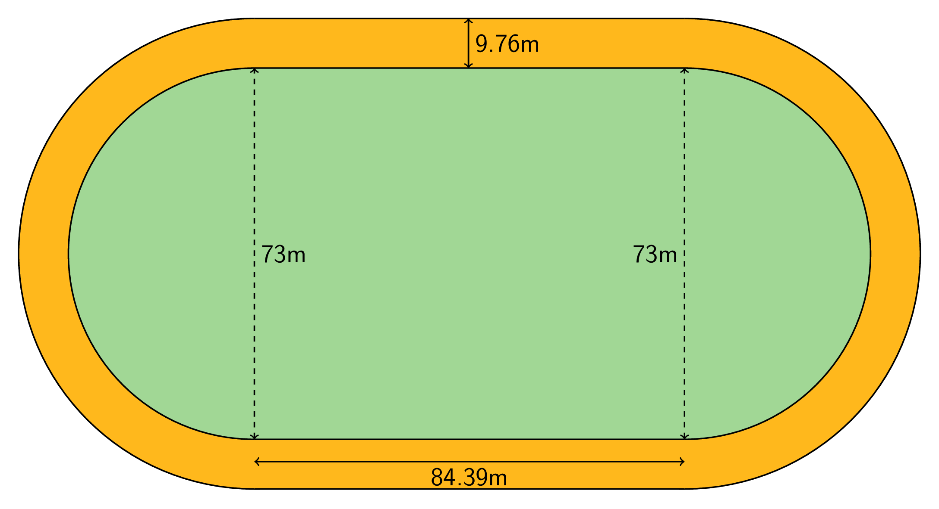
- What is the distance around the inside of the track? Explain or show your reasoning.
- The track is 9.76 m wide all the way around. What is the distance around the outside of the track? Explain or show your reasoning.

Are you ready for more?
This size running track is usually called a 400-meter track. However, if a person ran as close to the “inside” as possible on the track, they would run less than 400 meters in one lap. How far away from the inside border would someone have to run to make one lap equal exactly 400 meters?

13.4: Measuring a Picture Frame
Kiran bent some wire around a rectangle to make a picture frame. The rectangle is 8 inches by 10 inches.
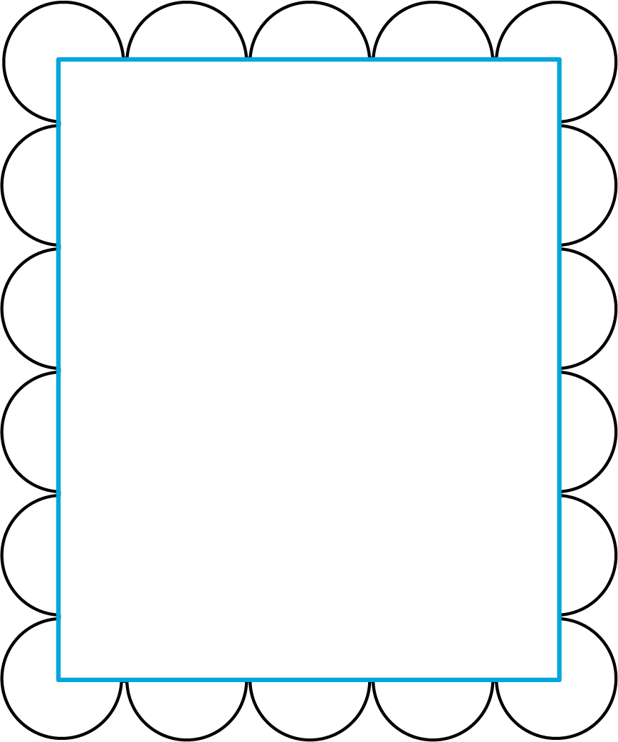
- Find the perimeter of the wire picture frame. Explain or show your reasoning.
- If the wire picture frame were stretched out to make one complete circle, what would its radius be?

Lesson 13 Summary
The circumference of a circle, $C$, is $π$ times the diameter, $d$. The diameter is twice the radius, $r$. So if we know any one of these measurements for a particular circle, we can find the others. We can write the relationships between these different measures using equations:
$d=2r$ $C=πd$ $C=2πr$
If the diameter of a car tire is 60 cm, that means the radius is 30 cm and the circumference is $60⋅π$ or about 188 cm.
If the radius of a clock is 5 in, that means the diameter is 10 in, and the circumference is $10⋅π$ or about 31 in.
If a ring has a circumference of 44 mm, that means the diameter is $44÷π$, which is about 14 mm, and the radius is about 7 mm.
© CC BY Open Up Resources. Adaptations CC BY IM.

