Lesson 5: Make Groups of More, Fewer, or the Same
- Let’s make groups of objects that have more, fewer, or the same number of objects as another group.

5.3: Center: Choice Time
Choose a center.
Less, Same, More
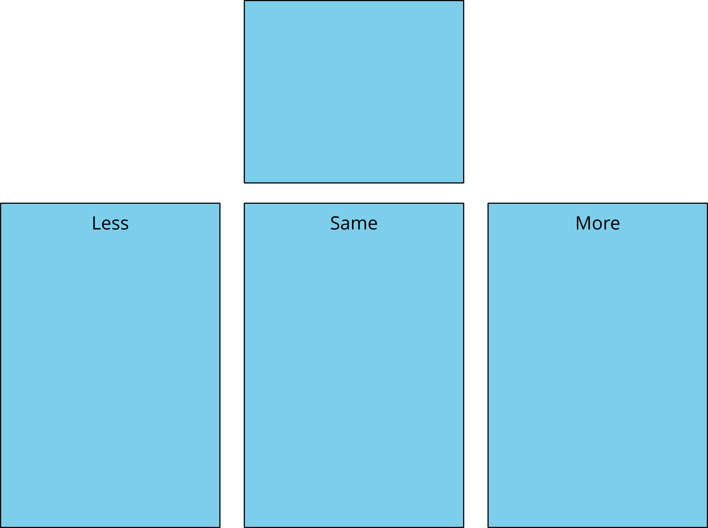
Shake and Spill
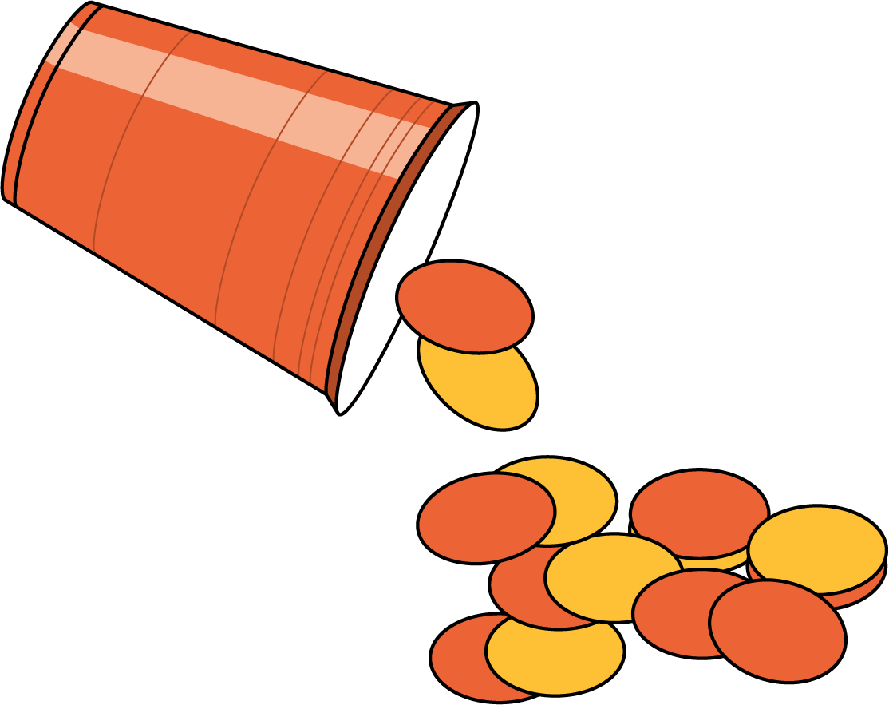
Number Race
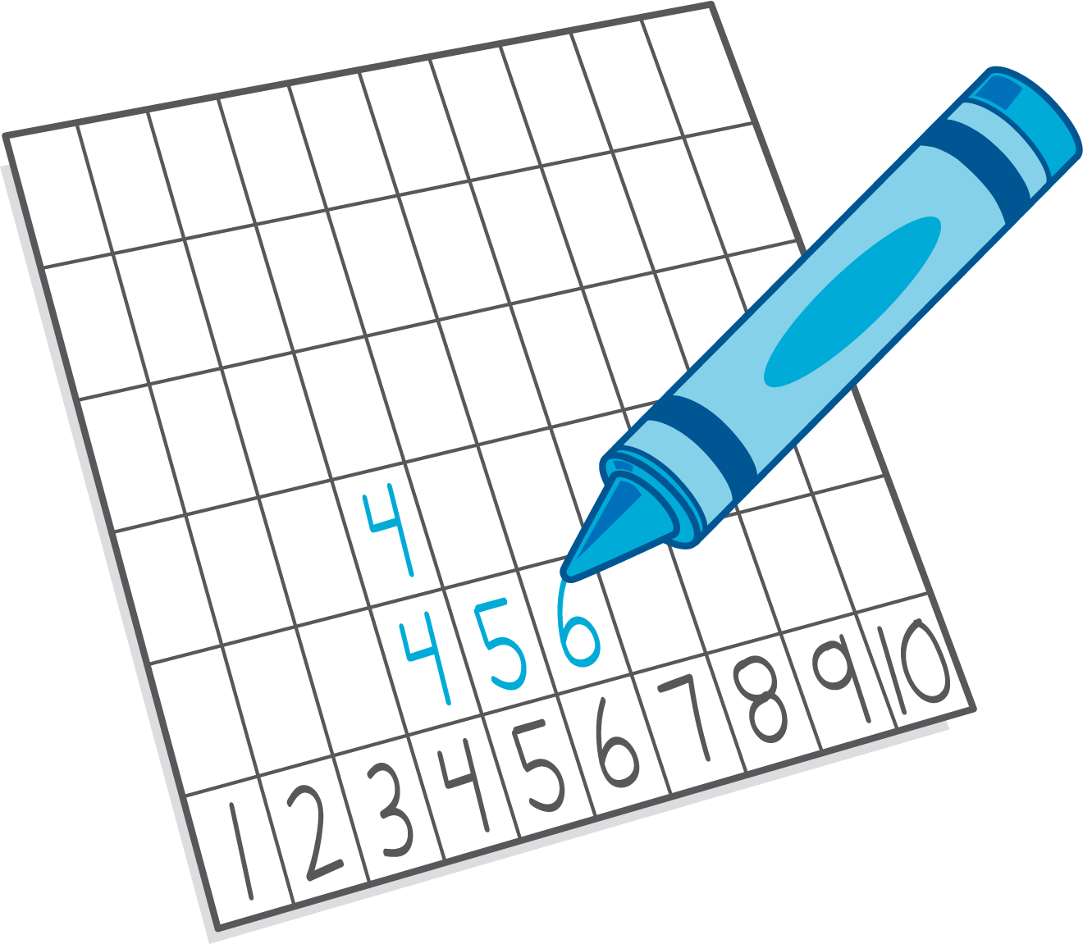
Math Fingers
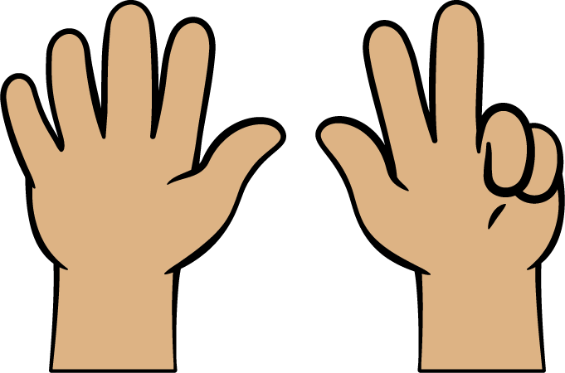
Pattern Blocks
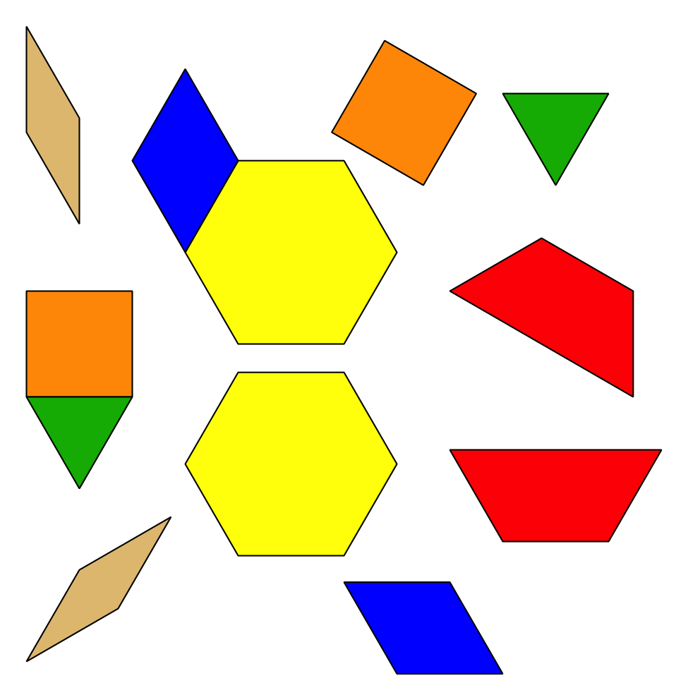
Picture Books
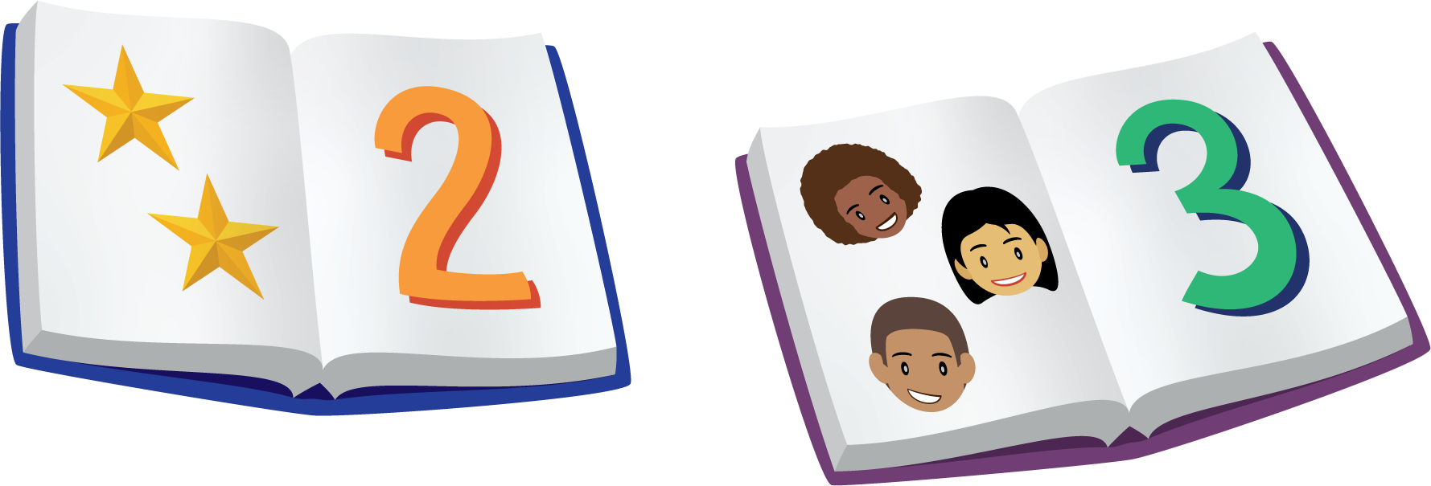
© CC BY 2021 Illustrative Mathematics®

