Unit 3 Lesson 13: Describe and Match Shapes

WU How Many Do You See: Add On and Rearrange (Warm up)

Student Task Statement
How many do you see?
How do you see them?

1 Where are the Pattern Blocks?

Student Task Statement
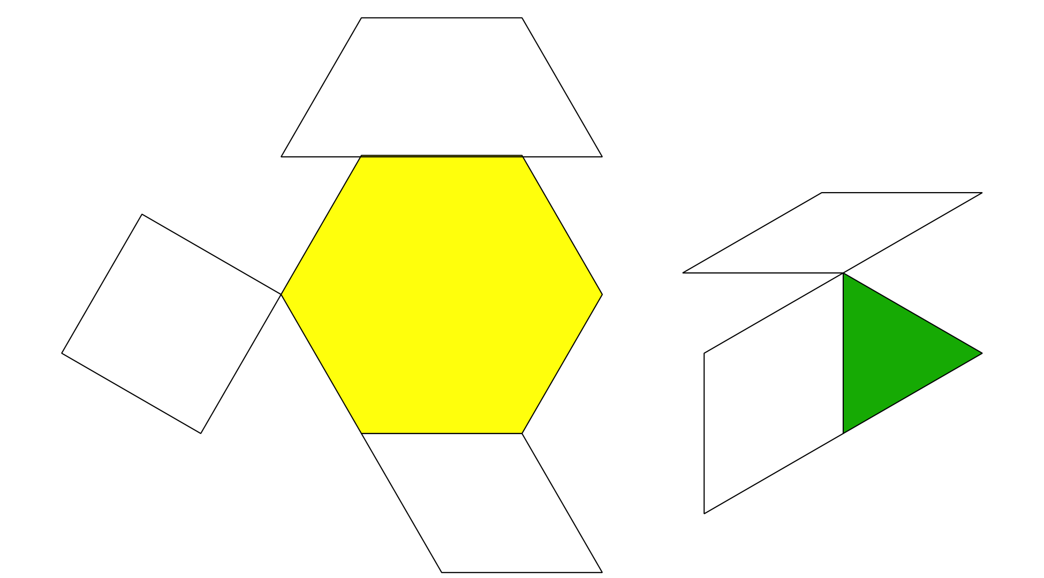
Synthesis:
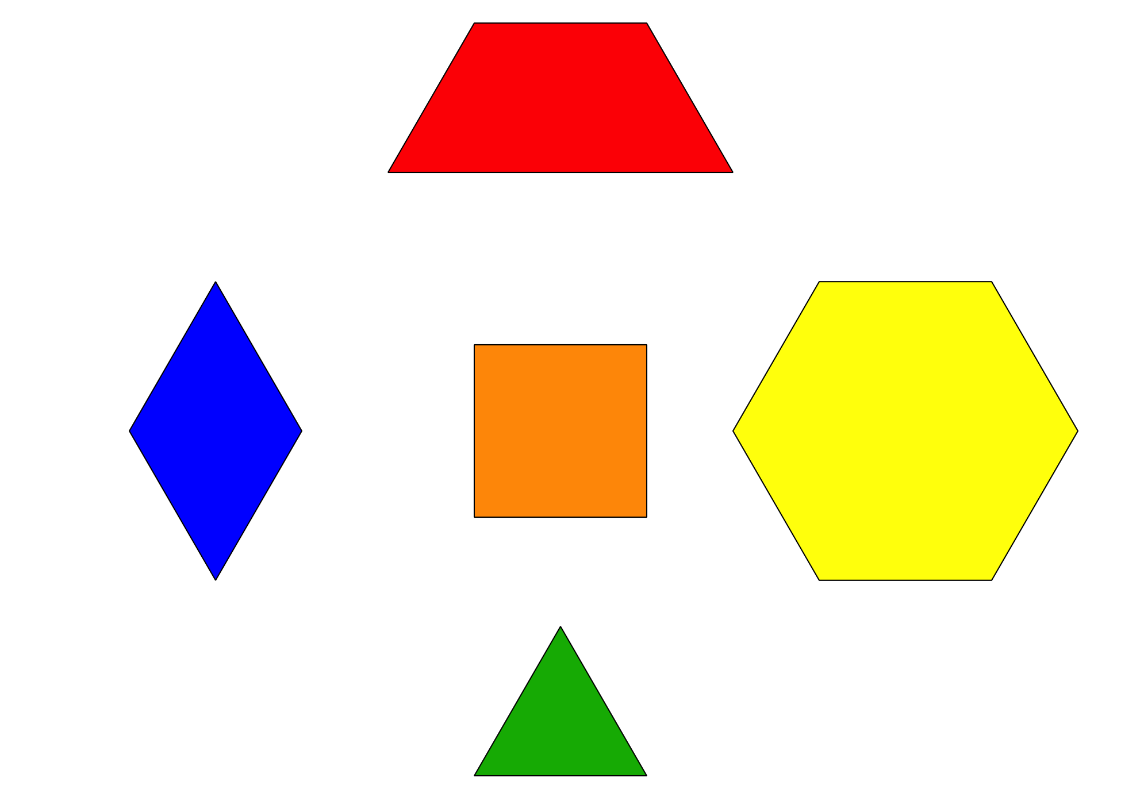

Activity Synthesis
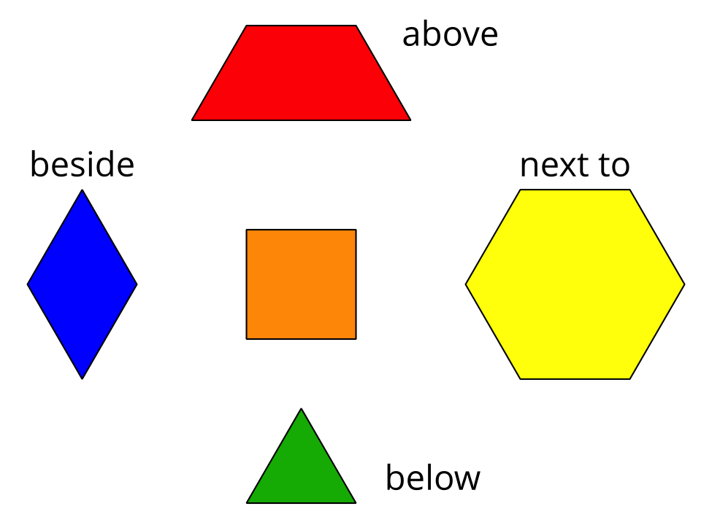

2 Introduce Match Mine, Pattern Blocks

Student Task Statement

3 Centers: Choice Time

Student Task Statement
Choose a center.
Match Mine
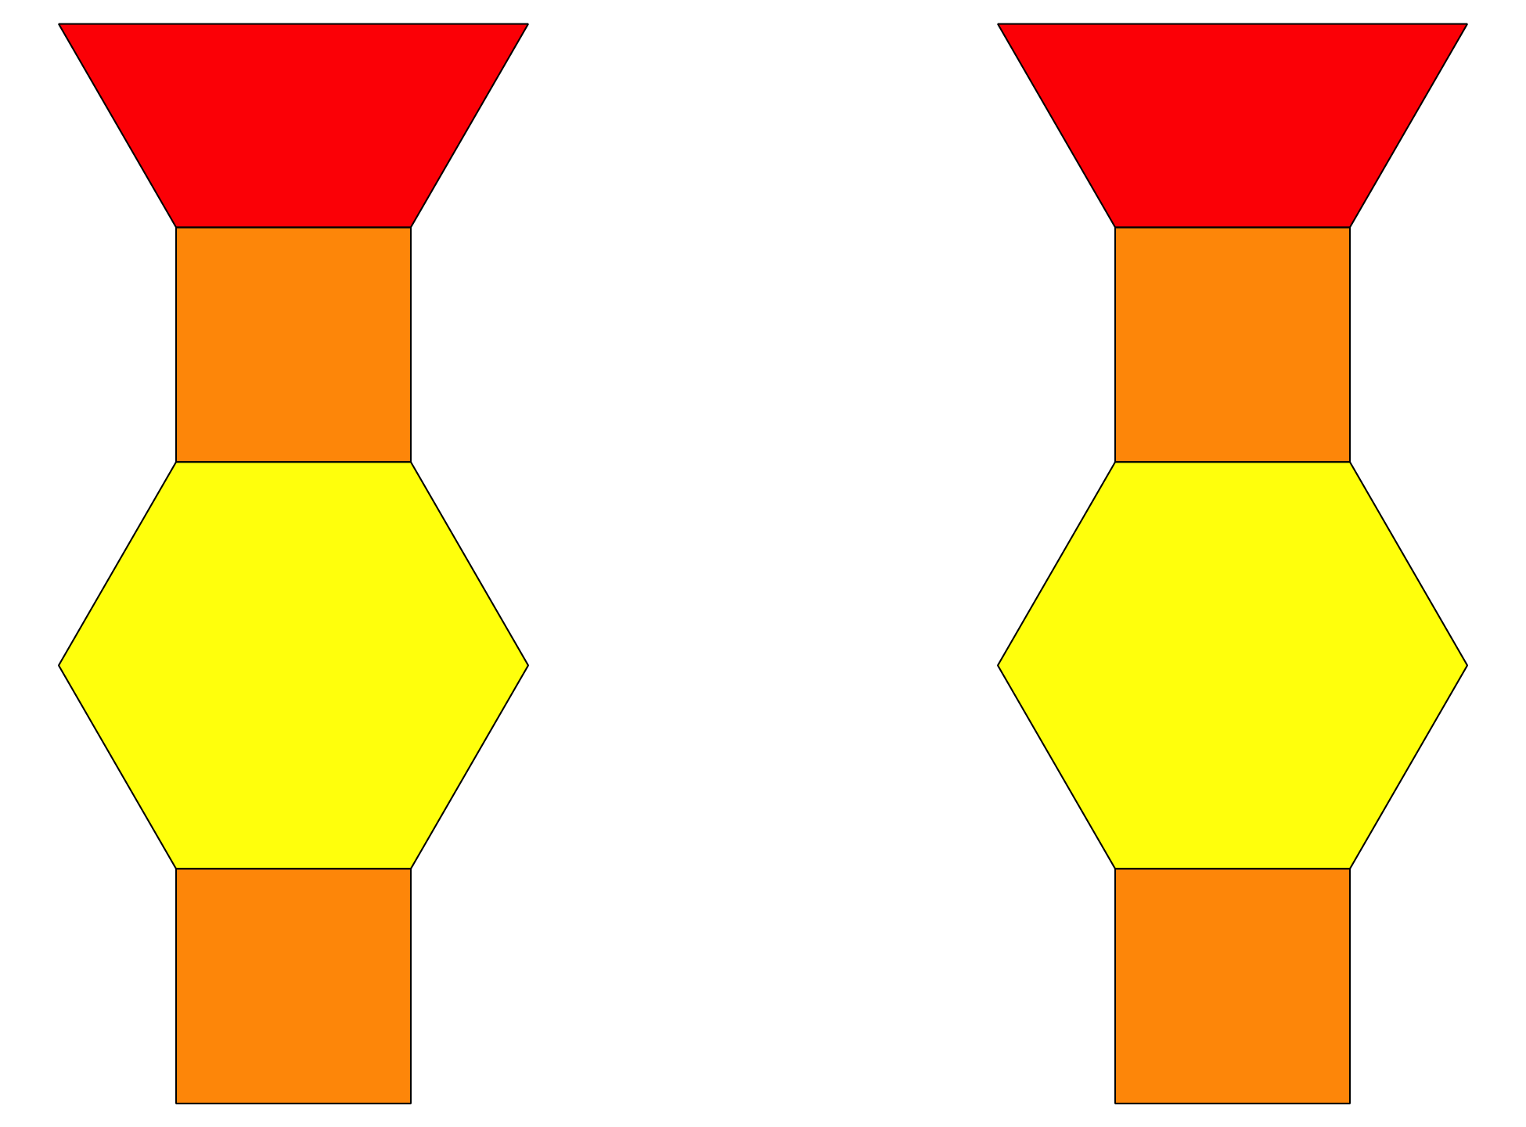
Geoblocks
Build Shapes
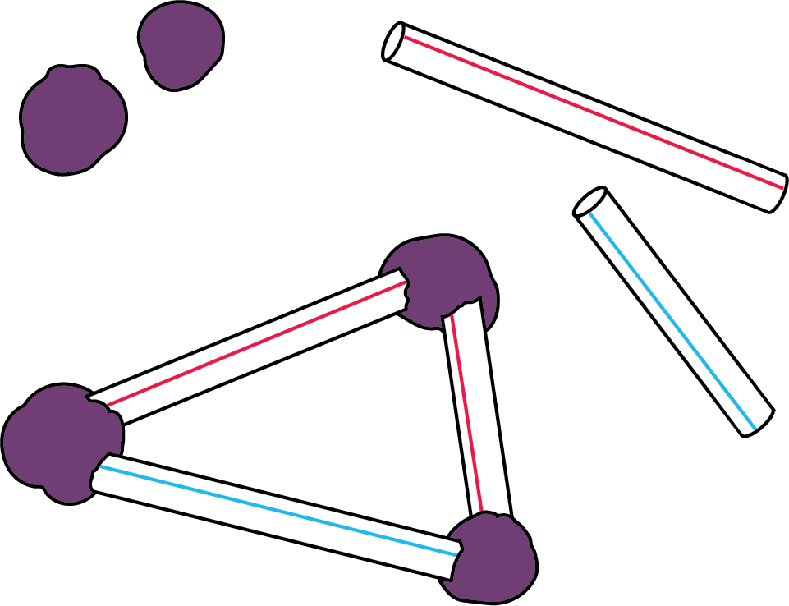
Pattern Blocks
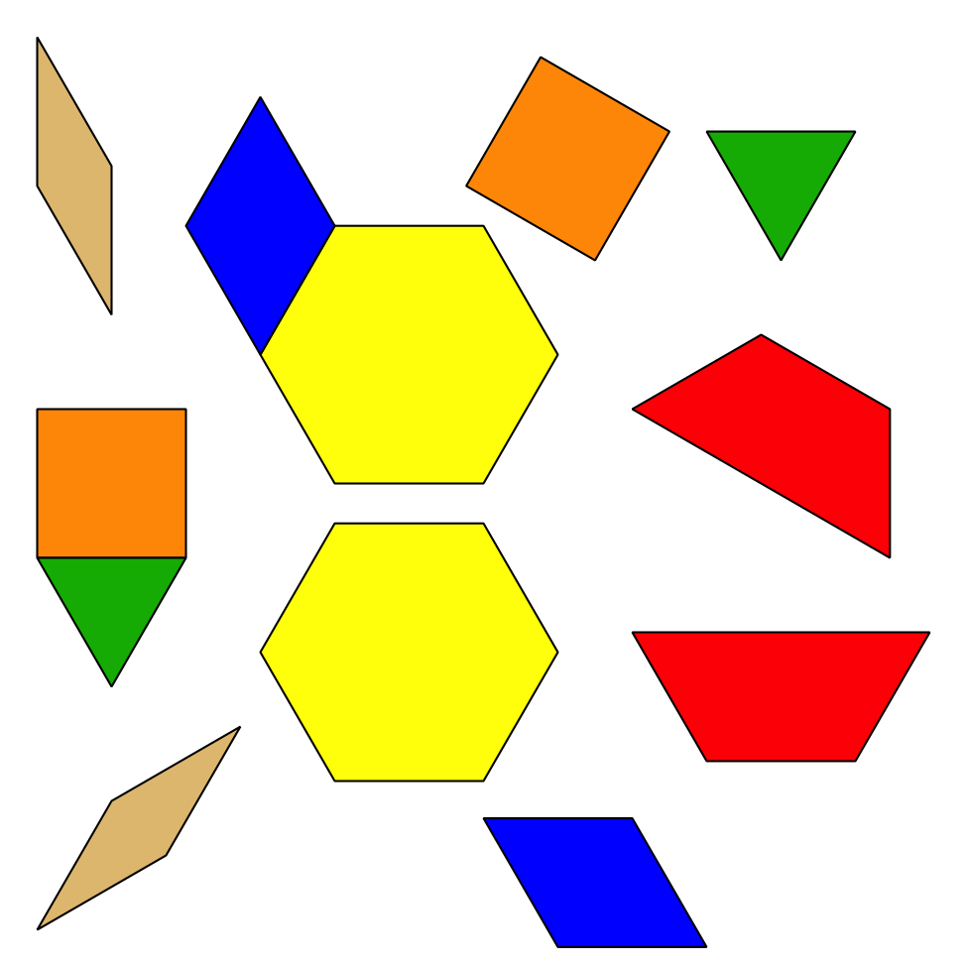
Less, Same, More
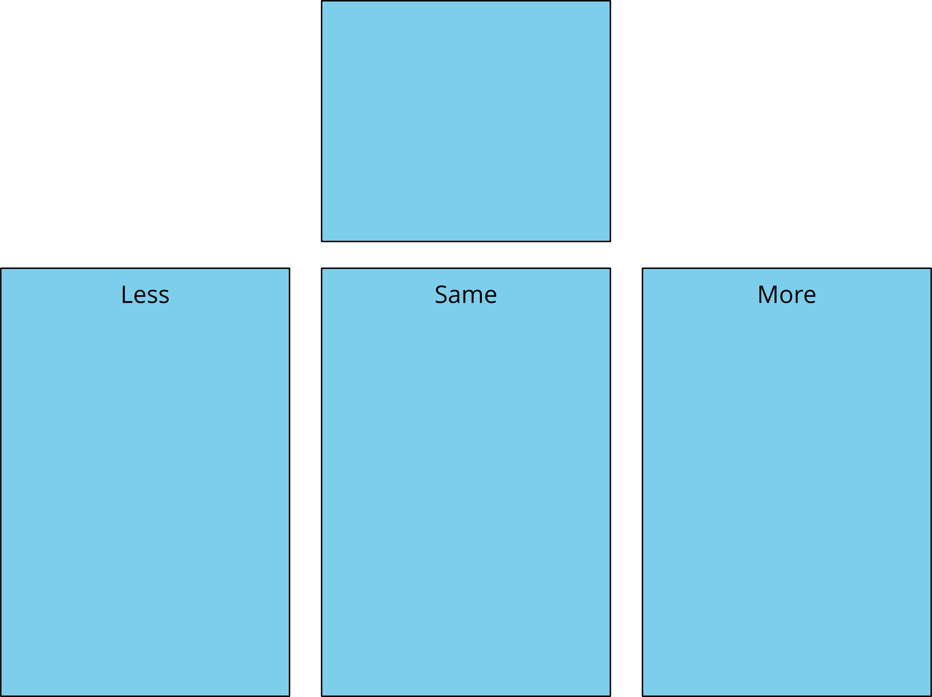
© CC BY 2021 Illustrative Mathematics®

