Lesson 14 Practice Problems
- These equations model the vertical position, in feet above the ground, of a point at the end of a windmill blade. For each function, indicate the height of the windmill and the length of the windmill blades.
  - $y=5sin\left(θ\right)+10$
  - $y=8sin\left(θ\right)+20$
  - $y=4sin\left(θ\right)+15$
- Which expression takes the same value as $cos\left(θ\right)$ when $θ=0,\frac{π}{2},π,$ and $\frac{3π}{2}$?
  - $sin\left(θ−\frac{π}{2}\right)$
  - $sin\left(θ+\frac{π}{2}\right)$
  - $sin\left(θ+π\right)$
  - $sin\left(θ−π\right)$
- Here is a graph of a trigonometric function.
- Which equation does the graph represent?
- 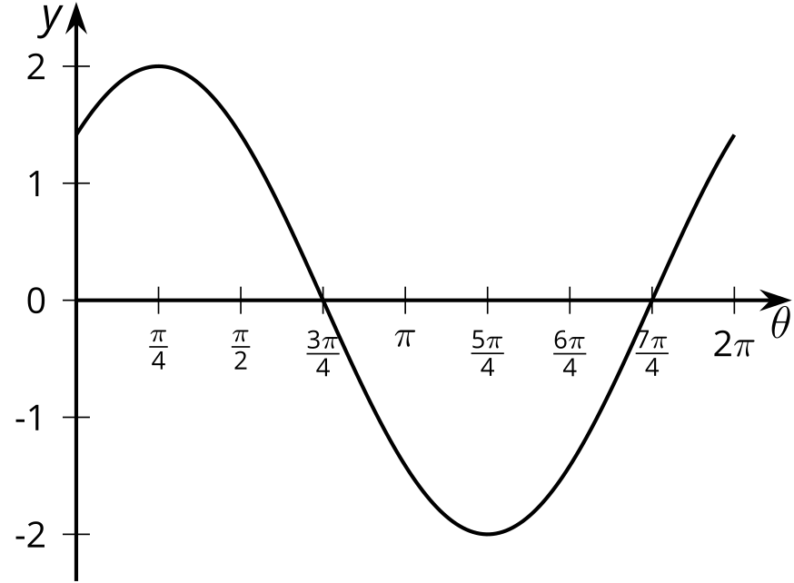
  - $y=2sin\left(θ\right)$
  - $y=2cos\left(θ+\frac{π}{4}\right)$
  - $y=2sin\left(θ−\frac{π}{4}\right)$
  - $y=2cos\left(θ−\frac{π}{4}\right)$
- The vertical position $v$ of a point at the tip of a windmill blade, in feet, is given by $v\left(θ\right)=11+2sin\left(θ+\frac{π}{2}\right)$. Here $θ$ is the angle of rotation.
  - How long is the windmill blade? Explain how you know.
  - What is the height of the windmill? Explain how you know.
  - Where is the point $P$ when $θ=0$?

  - Explain how to use a unit circle to find a point $P$ with $x$-coordinate $cos\left(\frac{23π}{24}\right)$.
  - Use a unit circle to estimate the value of $cos\left(\frac{23π}{24}\right)$.
- (From Unit 6, Lesson 5.)

  - What are some ways in which the tangent function is similar to sine and cosine?
  - What are some ways in which the tangent function is different from sine and cosine?
- (From Unit 6, Lesson 12.)
- Match the trigonometric expressions with their graphs.

- Graph 1
- 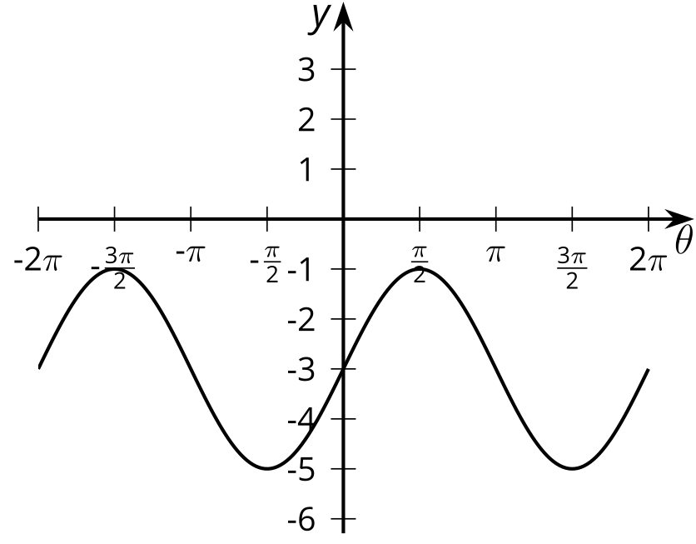

- Graph 2
- 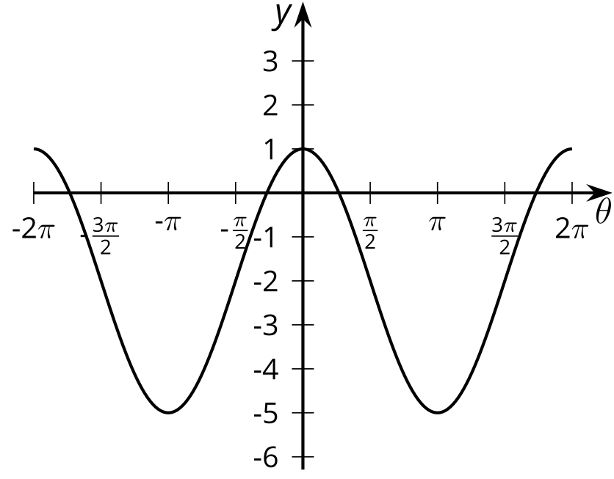

- Graph 3
- 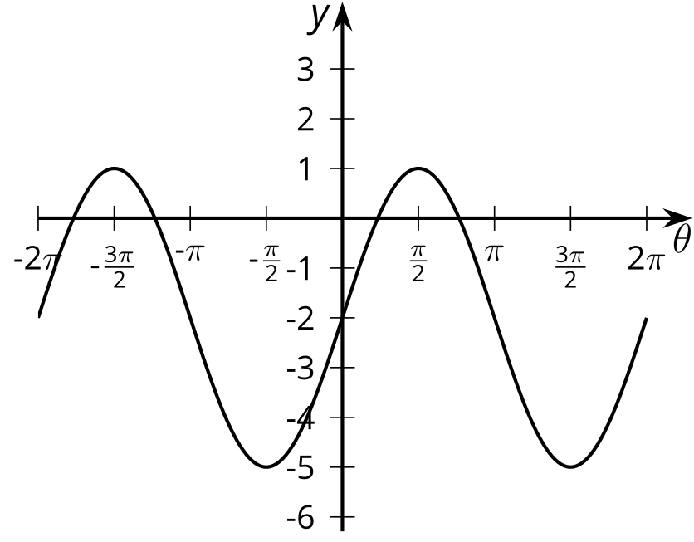

- Graph 4
- 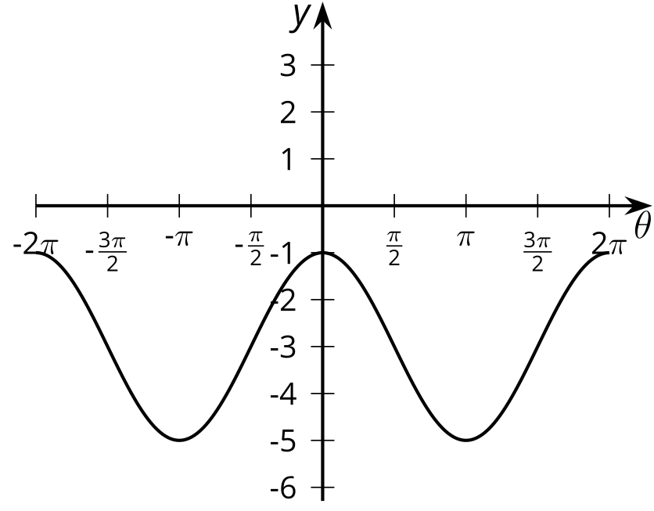
  - $3cos\left(θ\right)−2$
  - $2cos\left(θ\right)−3$
  - $3sin\left(θ\right)−2$
  - $2sin\left(θ\right)−3$
  - Graph 1
  - Graph 2
  - Graph 3
  - Graph 4
- (From Unit 6, Lesson 13.)
© CC BY 2019 by Illustrative Mathematics®

