Unit 5 Lesson 13: Center Day 2

WU How Many Do You See: Place Value (Warm up)

Student Task Statement
How many do you see and how do you see them?
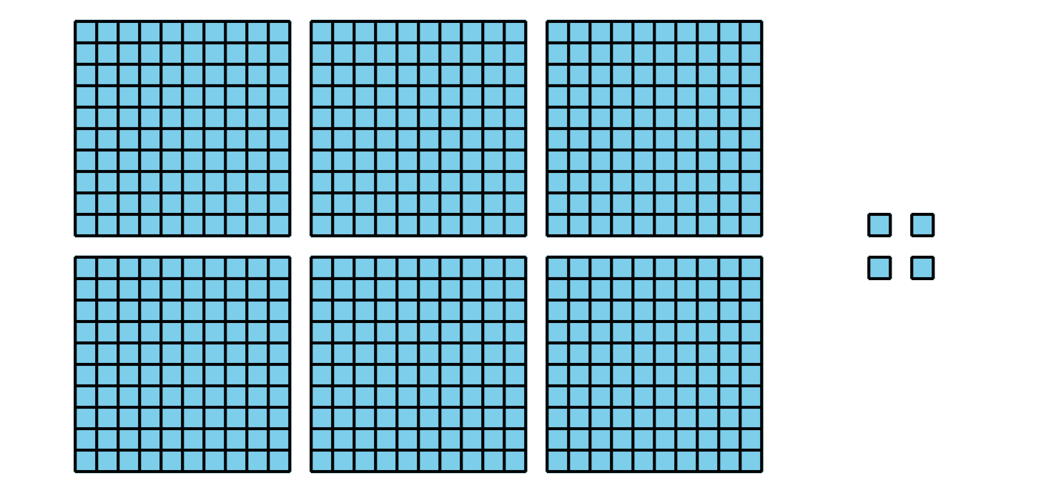
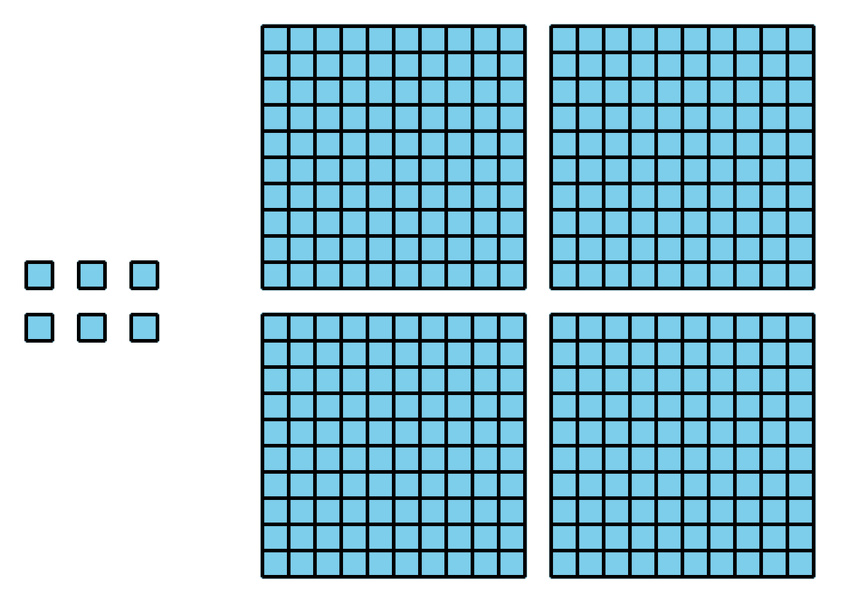
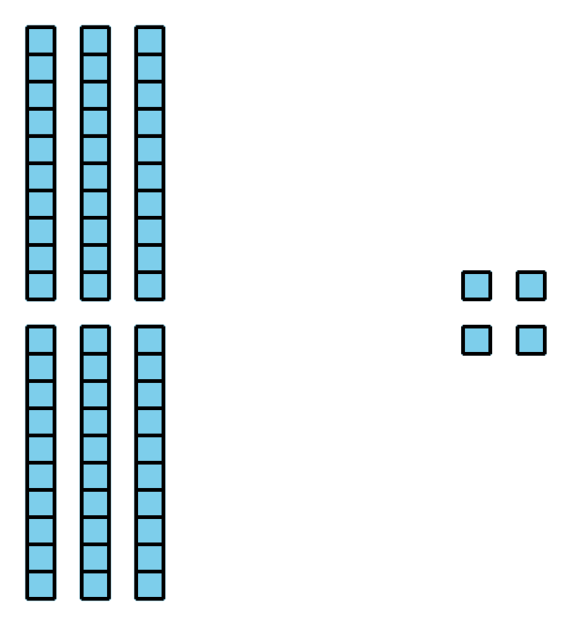

1 Introduce Get Your Numbers in Order, Three-digit Numbers

Student Task Statement

2 Centers: Choice Time

Student Task Statement
Choose a center.
Get Your Numbers in Order
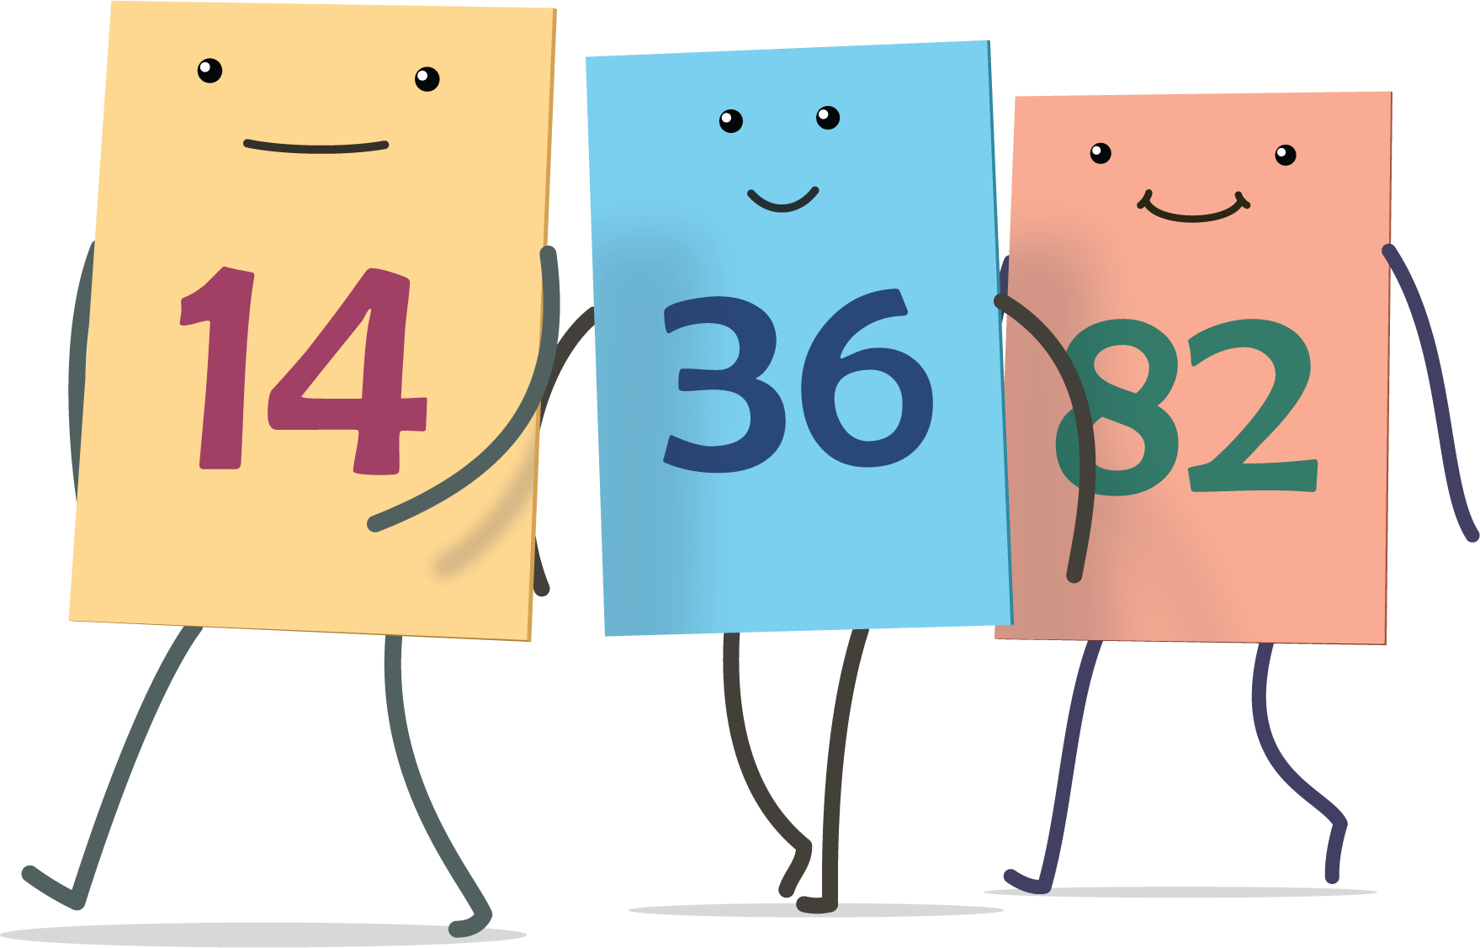
Greatest of Them All
Mystery Number
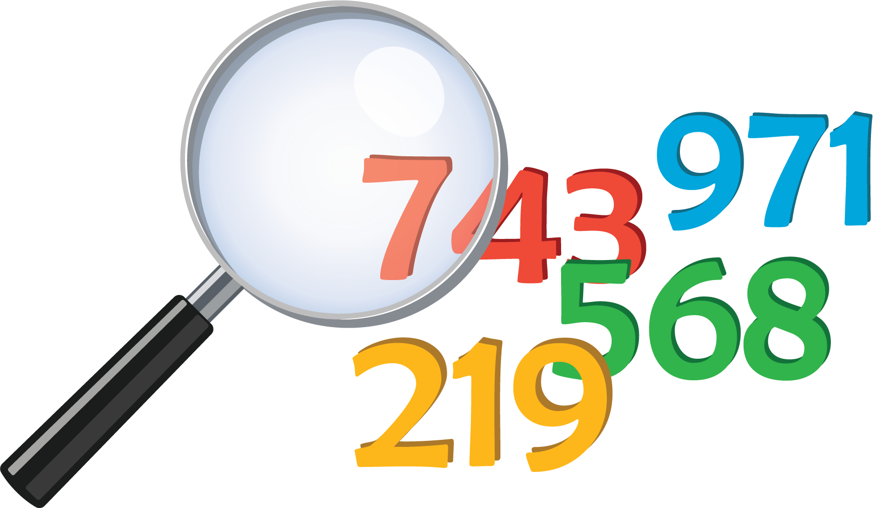
© CC BY 2021 Illustrative Mathematics®

