Unit 3 Lesson 13: Fractional Measurements on Line Plots

WU Notice and Wonder: Which Ruler? (Warm up)

Student Task Statement
What do you notice? What do you wonder?
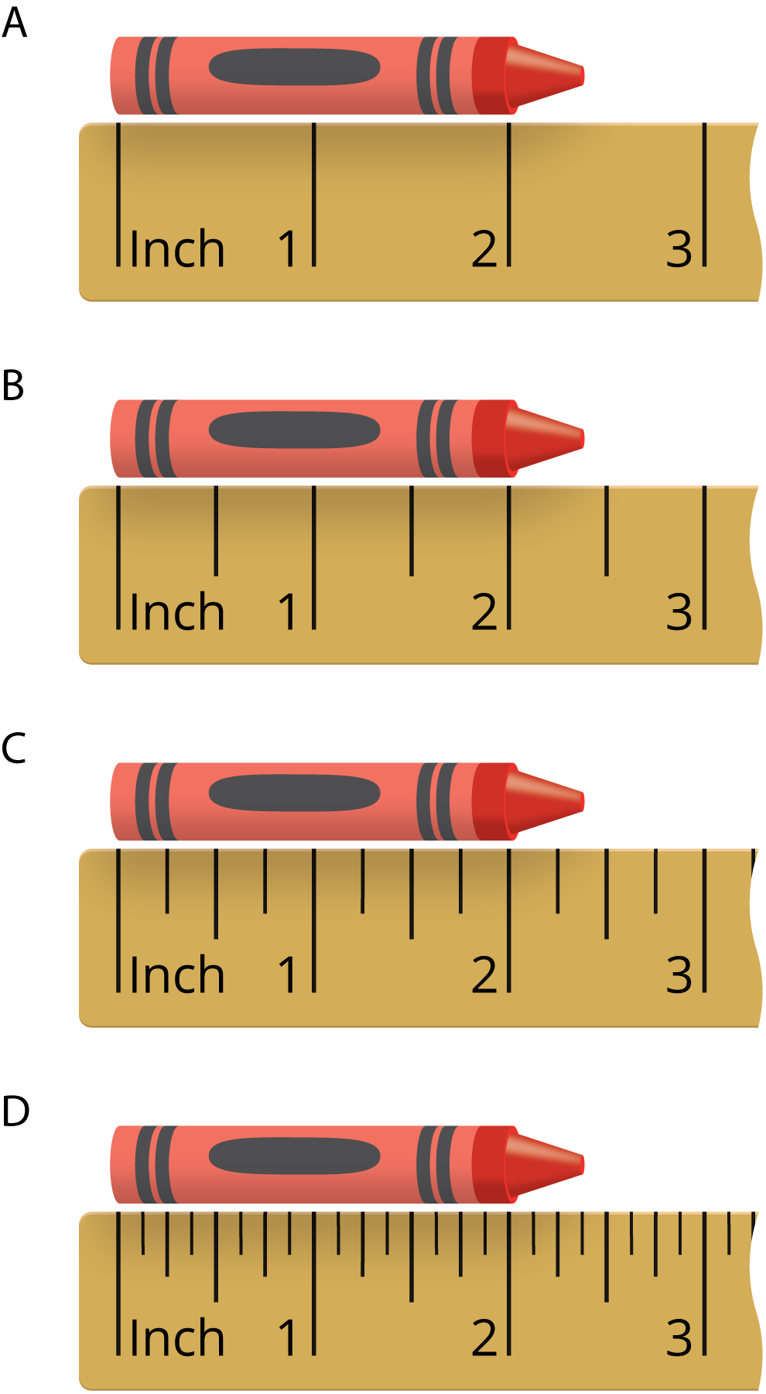

1 Measure to the Nearest $\frac{1}{4}$ and $\frac{1}{8}$ Inch (Optional)

Student Task Statement
Your teacher will give your group a set of colored pencils.
- Work with your group to measure each colored pencil to the nearest $\frac{1}{4}$ inch. Check each other’s measurements. Record each measurement in the table.
- group members | - pencil length (inches)
- Create a line plot to represent the data your group collected.
- 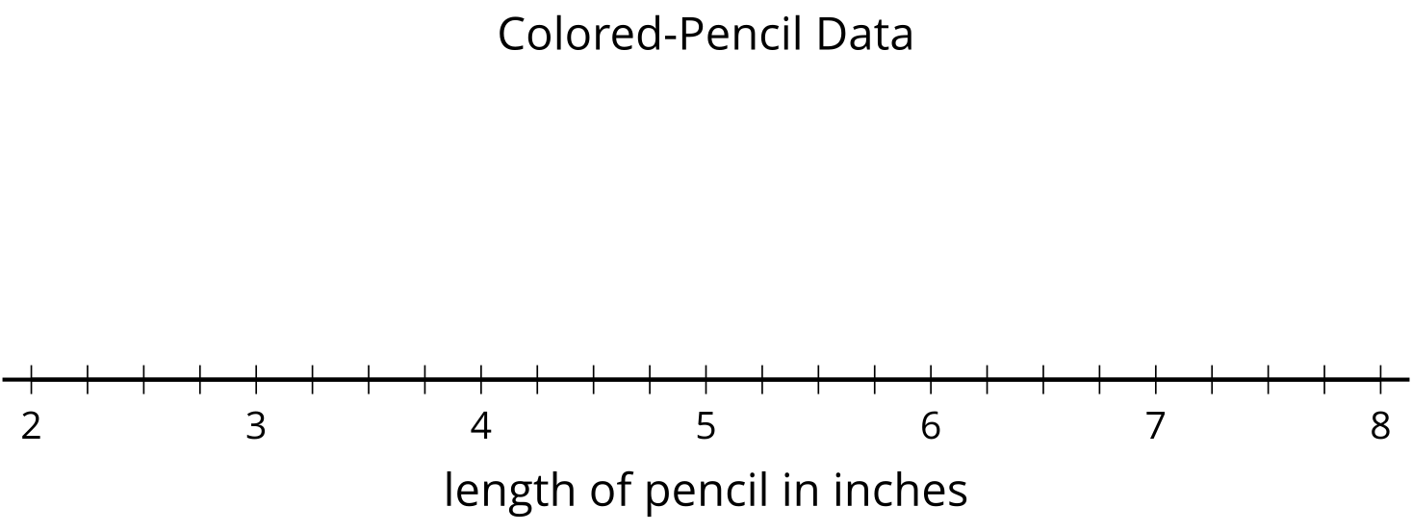
- Work with your group to measure each colored pencil to the nearest $\frac{1}{8}$ inch.
- Check one another’s measurements. Record each measurement in the table.
- group members | - pencil length (inches)
- Create a line plot to represent your new data.
- How was measuring to the nearest $\frac{1}{4}$ inch different from measuring to the nearest $\frac{1}{8}$ inch?

2 Colored-pencil Measurements

Student Task Statement
- Andre’s class measured the length of some colored pencils to the nearest $\frac{1}{4}$ inch. The data are shown here:
- $1\frac{3}{4}$ | - $2\frac{1}{4}$ | - $5\frac{1}{4}$ | - $5\frac{1}{4}$ | - $4\frac{2}{4}$ | - $4\frac{2}{4}$ | - $6\frac{1}{4}$ | - $6\frac{3}{4}$
- $6\frac{3}{4}$ | - $6\frac{3}{4}$

- 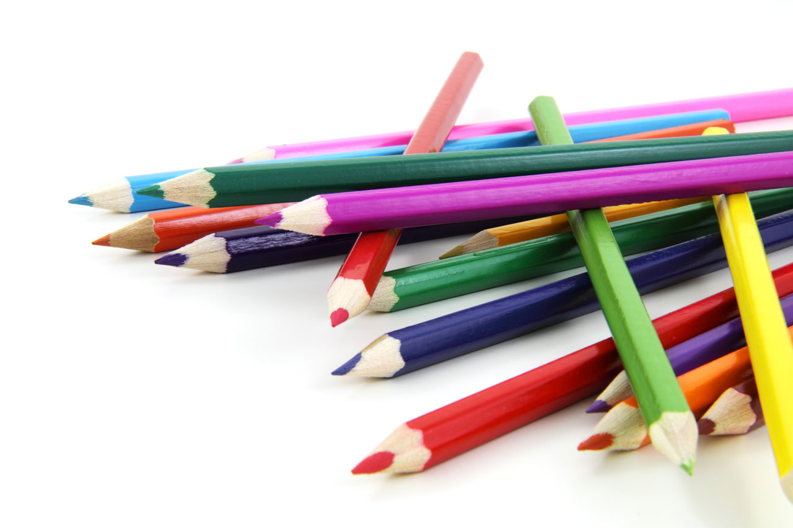
  - Plot the colored-pencil data on the line plot.
  - 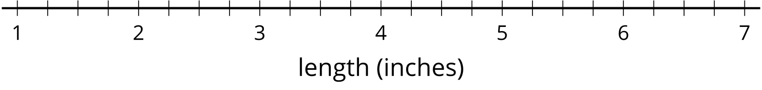
  - Which colored-pencil length is the most common in the data set?
  - Write 2 new questions that could be answered using the line plot data.
- Next, Andre’s class measured their colored pencils to the nearest $\frac{1}{8}$ inch. The data are shown here:
- $1\frac{6}{8}$ | - $2\frac{2}{8}$ | - $5\frac{2}{8}$ | - $5\frac{3}{8}$ | - $4\frac{4}{8}$ | - $4\frac{4}{8}$ | - $6\frac{6}{8}$ | - $6\frac{6}{8}$
- $6\frac{6}{8}$ | - $6\frac{3}{8}$

  - Plot the colored-pencil data on the line plot.
  - Which colored-pencil length is the most common in the line plot?
  - Why did some colored-pencil lengths change on this line plot?
  - What is the difference between the length of the longest colored pencil and the shortest colored pencil? Show your reasoning.

3 Noah's Colored Pencils

Student Task Statement
The line plot shows the data Noah collected on a set of colored pencils.
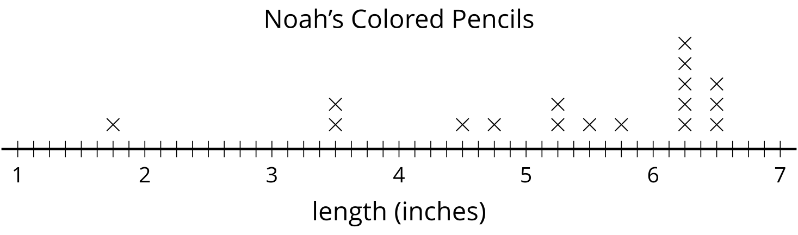
Use the line plot to tell if each of the following statements is true or false. Be prepared to explain or show how you know. For each false statement, correct it so that it is true.
- Noah measured the colored pencils to the nearest $\frac{1}{2}$ inch.
- There are five pencils that are $6\frac{1}{4}$ inches long.
- The shortest pencil is $1\frac{3}{4}$ inches long.
- The three longest pencils are exactly 5 inches longer than the shortest one.
- If Noah removed the shortest pencil from the collection, the difference between the longest and shortest pencils would be 3 inches.
If You Have Time
Noah wants to create a collection of at least 10 pencils where the difference between the longest and shortest colored pencils is no more than $1\frac{1}{2}$ inches.
Is that possible? If so, which pencils should he remove from his collection?
© CC BY 2021 Illustrative Mathematics®

