Unit 9 Lesson 12: Number Talk

WU Number Talk: A Whole Number and a Fraction (Warm up)

Student Task Statement
Find the value of each expression mentally.
- $6×\frac{1}{4}$
- $6×\frac{3}{4}$
- $18×\frac{3}{4}$
- $180×\frac{3}{4}$

1 Related Numbers, Related Expressions

Student Task Statement
- Here are two addition expressions. Think of at least two different ways to find the value of each sum mentally.
  - $15+29$
  - $30+58$
- Here are three subtraction expressions. Think of at least two different ways to find the value of each difference mentally.
  - $91−11$
  - $91−16$
  - $391−86$
- Can you write a fourth subtraction expression that uses the same strategy you used to find the value of the other differences?

2 Add One New Expression, Then Two

Student Task Statement
- Here are three division expressions. Find the value of each quotient mentally and think about how they might be related.
  - $35÷5$
  - $70÷5$
  - $210÷5$
  - ___________________
- Write a new division expression whose value can be found more easily after working through the first three.
- Here are two multiplication expressions. Analyze them and think about how they might be related.
  - $21×7$
  - $42×7$
  - ___________________
  - ___________________
- Write two new expressions. Be prepared to explain your reasoning for each expression.
- 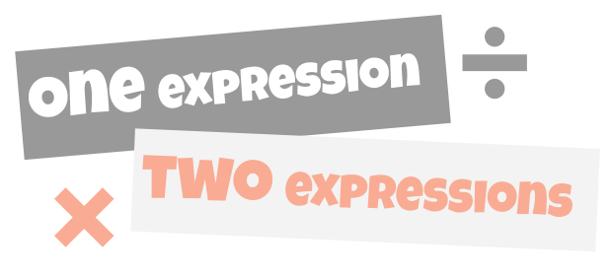

3 Add Three New Expressions (Optional)

Student Task Statement
Here are four expressions you could use to start a Number Talk activity.
$75+30$
$160−51$
$24÷8$
$3×\frac{1}{6}$
- Choose one starting expression. Think of at least two different ways to find its value mentally.
- Write three equations to create a Number Talk activity. Be prepared to explain your reasoning for writing each expression.
- ___________________ (starting expression)
- ___________________
- ___________________
- ___________________
- Create an answer key for your Number Talk. Include at least one way to find the value of each expression mentally.
© CC BY 2021 Illustrative Mathematics®

