Unit 3 Lesson 8: More about Constant Speed

1 Back on the Treadmill Again (Warm up)

Student Task Statement
While training for a race, Andre’s dad ran 12 miles in 75 minutes on a treadmill. If he runs at that rate:
- How long would it take him to run 8 miles?
- How far could he run in 30 minutes?

2 Picnics on the Rail Trail

Student Task Statement
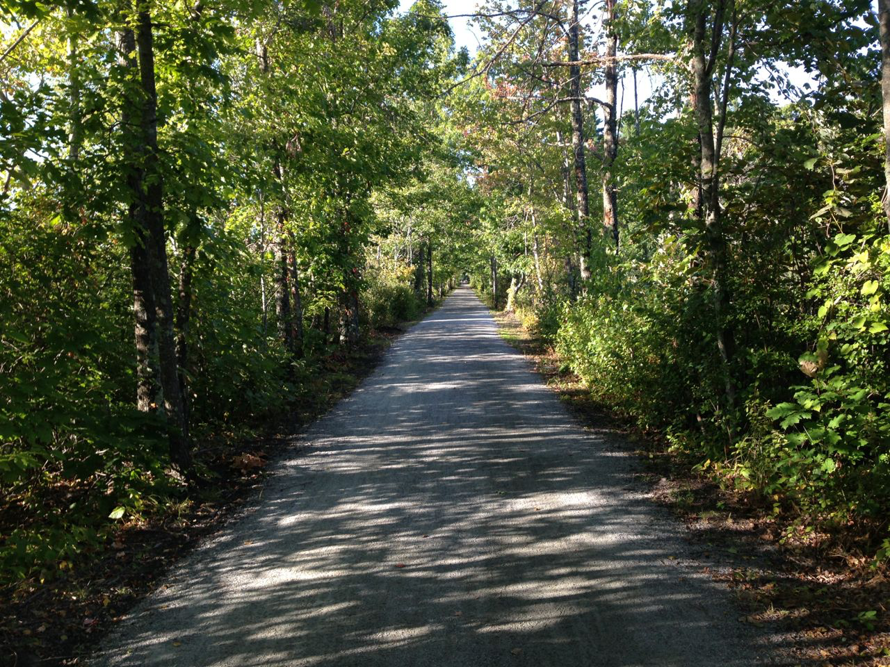
Kiran and Clare live 24 miles away from each other along a rail trail. One Saturday, the two friends started walking toward each other along the trail at 8:00 a.m. with a plan to have a picnic when they meet.
Kiran walks at a speed of 3 miles per hour while Clare walks 3.4 miles per hour.
- After one hour, how far apart will they be?
- Make a table showing how far apart the two friends are after 0 hours, 1 hour, 2 hours, and 3 hours.
- At what time will the two friends meet and have their picnic?
- Kiran says “If I walk 3 miles per hour toward you, and you walk 3.4 miles per hour toward me, it’s the same as if you stay put and I jog 6.4 miles per hour.” What do you think Kiran means by this? Is he correct?
- Several months later, they both set out at 8:00 a.m. again, this time with Kiran jogging and Clare still walking at 3.4 miles per hour. This time, they meet at 10:30 a.m. How fast was Kiran jogging?

3 Swimming and Biking (Optional)

Student Task Statement
Jada bikes 2 miles in 12 minutes. Jada’s cousin swims 1 mile in 24 minutes.
- Who is moving faster? How much faster?
- One day Jada and her cousin line up on the end of a swimming pier on the edge of a lake. At the same time, they start swimming and biking in opposite directions.
  - How far apart will they be after 15 minutes?
  - How long will it take them to be 5 miles apart?
© CC BY Open Up Resources. Adaptations CC BY IM.

