Unit 5 Lesson 10: How Well Can You Measure?

1 Estimating a Percentage (Warm up)

Student Task Statement
A student got 16 out of 21 questions correct on a quiz. Use mental estimation to answer these questions.
- Did the student answer less than or more than 80% of the questions correctly?
- Did the student answer less than or more than 75% of the questions correctly?

2 Perimeter of a Square

Student Task Statement
Your teacher will give you a picture of 9 different squares and will assign your group 3 of these squares to examine more closely.
- For each of your assigned squares, measure the length of the diagonal and the perimeter of the square in centimeters.
- Check your measurements with your group. After you come to an agreement, record your measurements in the table.
 | - diagonal (cm) | - perimeter (cm)
- square A
- square B
- square C
- square D
- square E
- square F
- square G
- square H
- square I
- Plot the diagonal and perimeter values from the table on the coordinate plane.
- 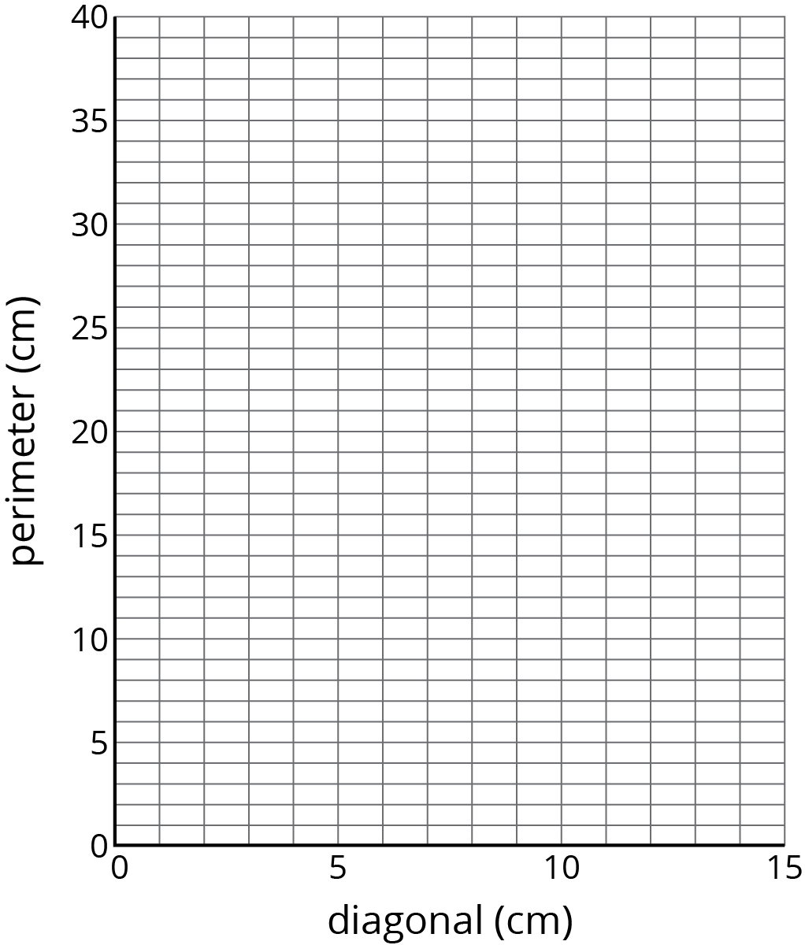
- What do you notice about the points on the graph?
- Pause here so your teacher can review your work.
- Record measurements of the other squares to complete your table.

3 Area of a Square

Images for Launch
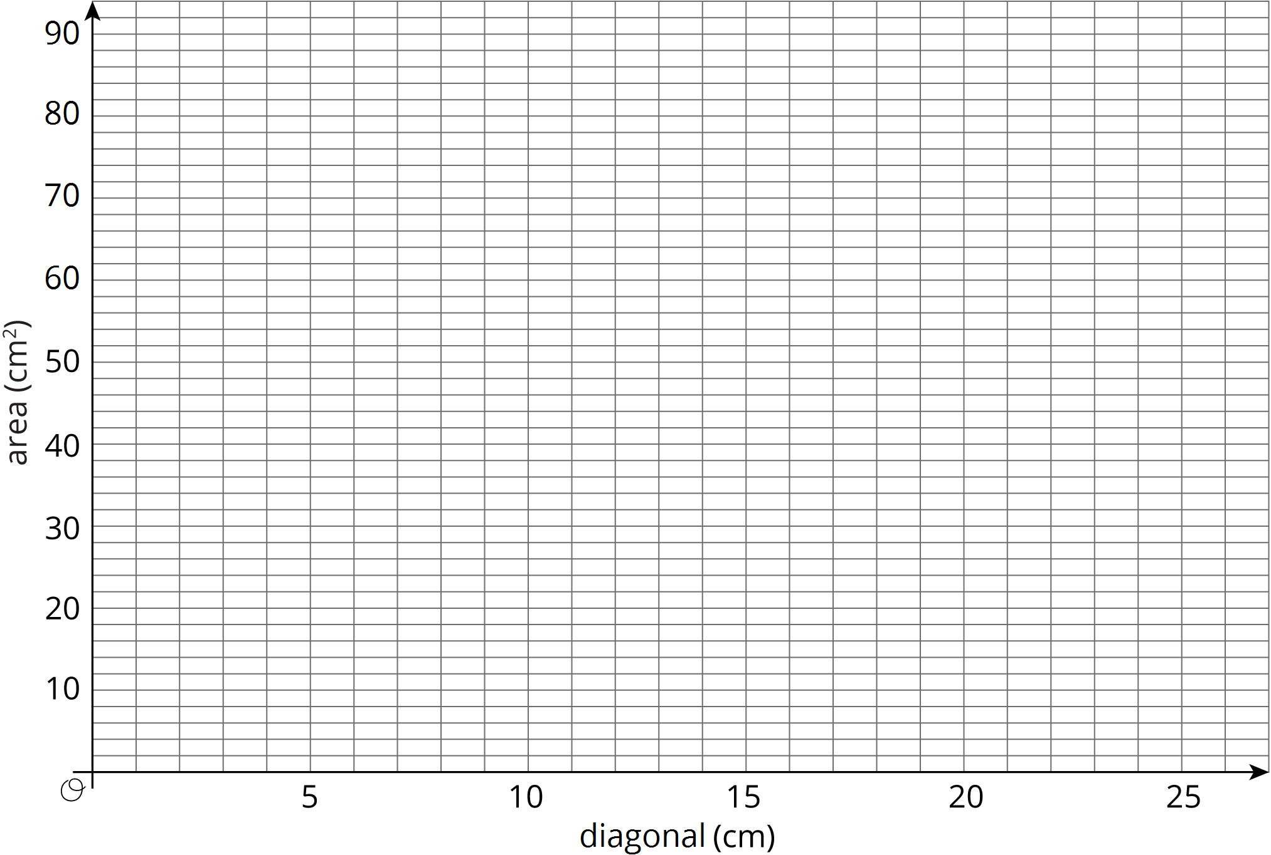

Student Task Statement
- In the table, record the length of the diagonal for each of your assigned squares from the previous activity. Next, calculate the area of each of your squares.
 | - diagonal (cm) | - area (cm²)
- square A
- square B
- square C
- square D
- square E
- square F
- square G
- square H
- square I
- Pause here so your teacher can review your work. Be prepared to share your values with the class.
- Examine the class graph of these values. What do you notice?
- How is the relationship between the diagonal and area of a square the same as the relationship between the diagonal and perimeter of a square from the previous activity? How is it different?

Activity Synthesis
© CC BY Open Up Resources. Adaptations CC BY IM.

