Unit 9 Lesson 3: Tessellating Polygons

1 Triangle Tessellations (Optional)

Student Task Statement
Your teacher will assign you one of the three triangles. You can use the picture to draw copies of the triangle on tracing paper. Your goal is to find a tessellation of the plane with copies of the triangle.
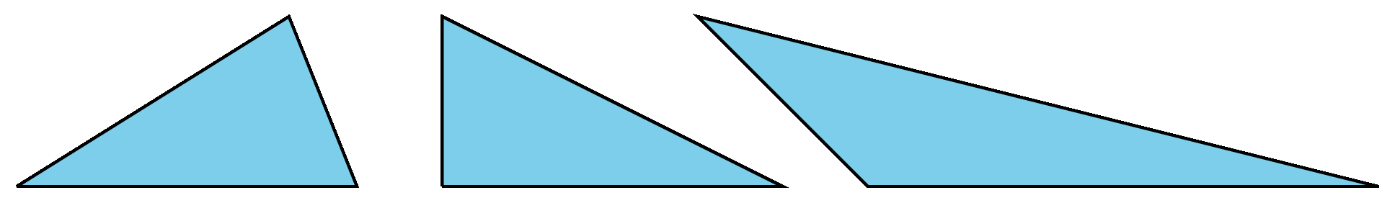

2 Quadrilateral Tessellations (Optional)

Student Task Statement
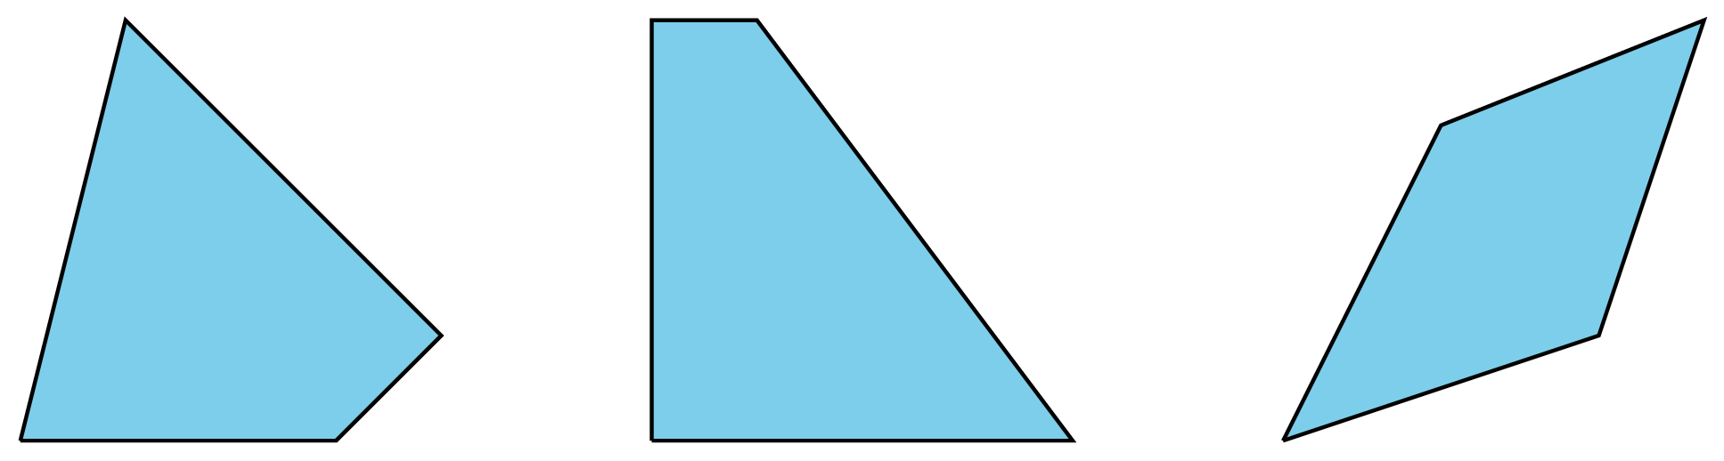
- Can you make a tessellation of the plane with copies of the trapezoid? Explain.

- Choose and trace a copy of one of the other two quadrilaterals. Next, trace images of the quadrilateral rotated 180 degrees around the midpoint of each side. What do you notice?
- Can you make a tessellation of the plane with copies of the quadrilateral from the previous problem? Explain your reasoning.

3 Pentagonal Tessellations (Optional)

Student Task Statement
- Can you tessellate the plane with copies of the pentagon? Explain why or why not. Note that the two sides making angle $A$ are congruent.
- 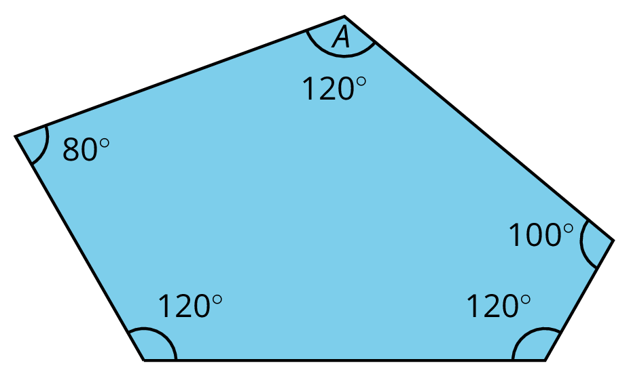
- Pause your work here.
- Take one pentagon and rotate it 120 degrees clockwise about the vertex at angle $A$, and trace the new pentagon. Next, rotate the pentagon 240 degrees clockwise about the vertex at angle $A$, and trace the new pentagon.

- Explain why the three pentagons make a full circle at the central vertex.
- Explain why the shape that the three pentagons make is a hexagon (that is, the sides that look like they are straight really are straight).
© CC BY Open Up Resources. Adaptations CC BY IM.

