Lesson 20 Practice Problems
- Solve each problem. If you get stuck, consider using the double number lines.
  - During a basketball practice, Mai attempted 40 free throws and was successful on 25% of them. How many successful free throws did she make?
  - 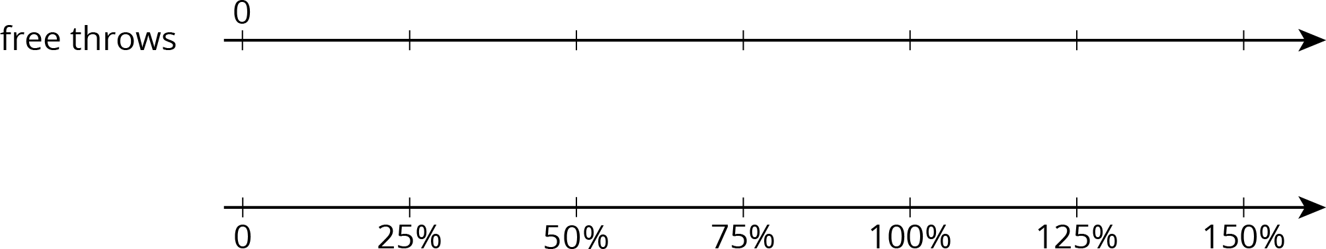
  - Yesterday, Priya successfully made 12 free throws. Today, she made 150% as many. How many successful free throws did Priya make today?
- A 16-ounce bottle of orange juice says it contains 200 milligrams of vitamin C, which is 250% of the daily recommended allowance of vitamin C for adults. What is 100% of the daily recommended allowance of vitamin C for adults?
- 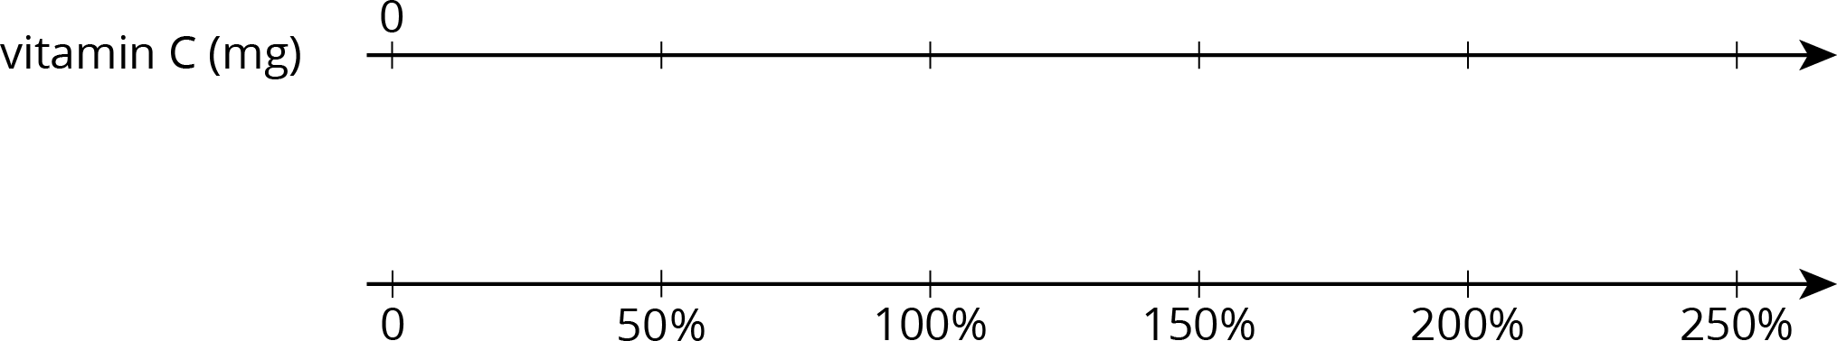

- At a school, 40% of the sixth-grade students said that hip-hop is their favorite kind of music. If 100 sixth-grade students prefer hip hop music, how many sixth-grade students are at the school? Explain or show your reasoning.
- Diego has a skateboard, scooter, bike, and go-cart. He wants to know which vehicle is the fastest. A friend records how far Diego travels on each vehicle in 5 seconds. For each vehicle, Diego travels as fast as he can along a straight, level path.
- vehicle | - distance traveled
- skateboard | - 90 feet
- scooter | - 1,020 inches
- bike | - 4,800 centimeters
- go-cart | - 0.03 kilometers
  - What is the distance each vehicle traveled in centimeters?
  - Rank the vehicles in order from fastest to slowest.
- (From Unit 2, Lesson 19.)
- It takes 10 pounds of potatoes to make 15 pounds of mashed potatoes. At this rate:
  - How many pounds of mashed potatoes can they make with 15 pounds of potatoes?
  - How many pounds of potatoes are needed to make 50 pounds of mashed potatoes?
- (From Unit 2, Lesson 18.)
© CC BY Open Up Resources. Adaptations CC BY IM.

