Unit 2 Lesson 6: Changing Scales in Scale Drawings

1 Appropriate Measurements (Warm up)

Student Task Statement
- If a student uses a ruler like this to measure the length of their foot, which choices would be appropriate measurements? Select all that apply. Be prepared to explain your reasoning.
- 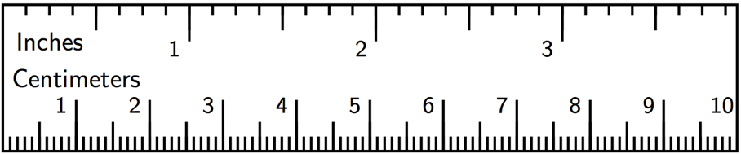
  - $9\frac{1}{4}$ inches
  - $9\frac{5}{64}$ inches
  - 23.47659 centimeters
  - 23.5 centimeters
  - 23.48 centimeters
- Here is a scale drawing of an average seventh-grade student's foot next to a scale drawing of a foot belonging to the person with the largest feet in the world. Estimate the length of the larger foot.
- 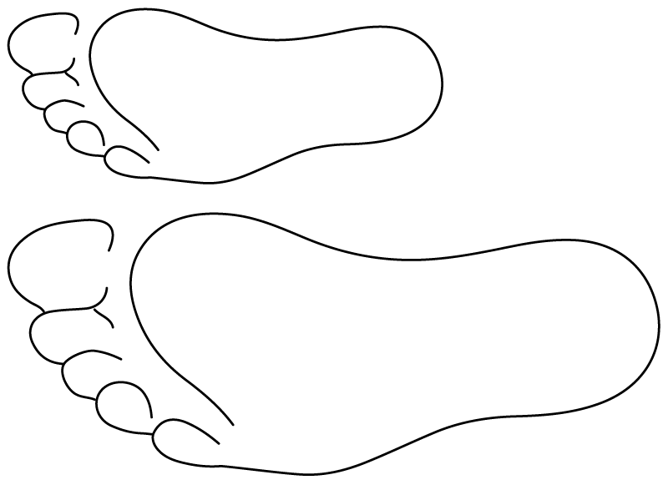

2 Same Plot, Different Drawings

Images for Launch
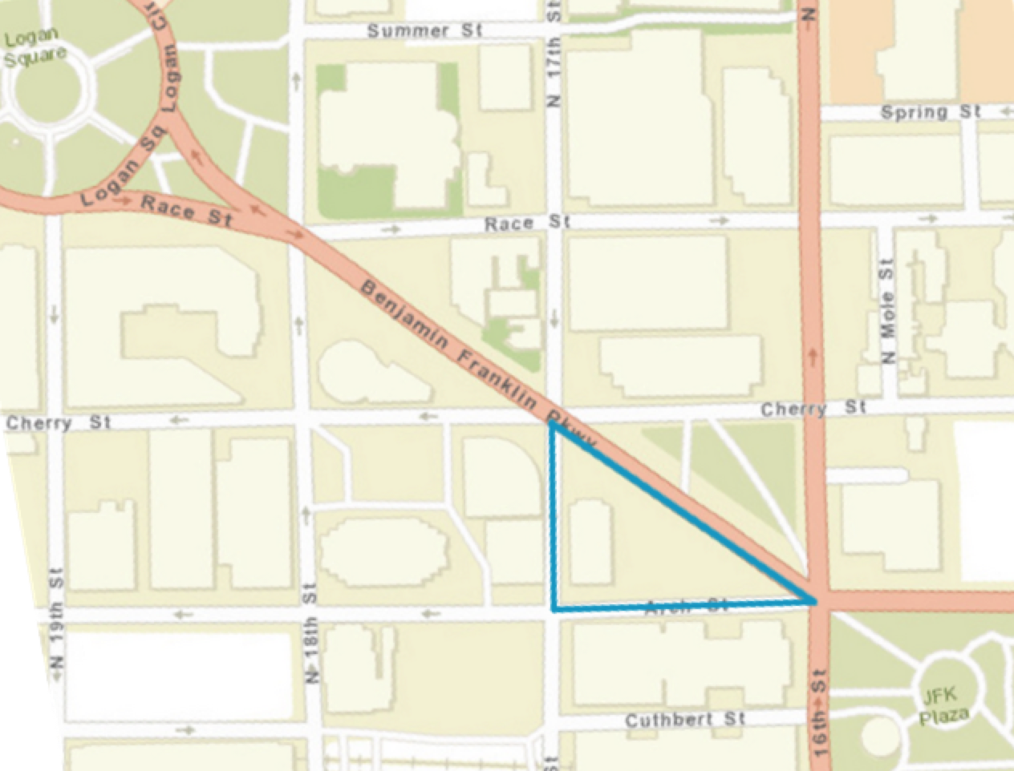

Student Task Statement
Here is a map showing a plot of land in the shape of a right triangle.
- Your teacher will assign you a scale to use. On centimeter graph paper, make a scale drawing of the plot of land. Make sure to write your scale on your drawing.
- What is the area of the triangle you drew? Explain or show your reasoning.
- How many square meters are represented by 1 square centimeter in your drawing?
- After everyone in your group is finished, order the scale drawings from largest to smallest. What do you notice about the scales when your drawings are placed in this order?

3 A New Drawing of the Playground

Student Task Statement
Here is a scale drawing of a playground.
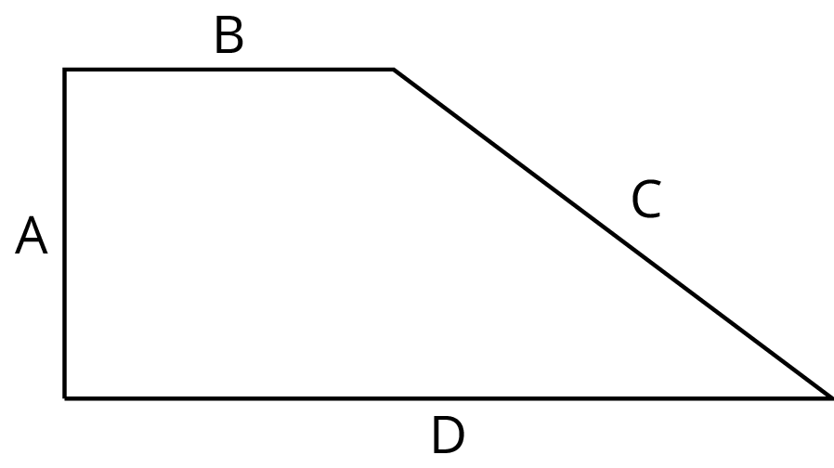
The scale is 1 centimeter to 30 meters.
- Make another scale drawing of the same playground at a scale of 1 centimeter to 20 meters.
- How do the two scale drawings compare?
© CC BY Open Up Resources. Adaptations CC BY IM.

