Lesson 3 Practice Problems
- $C$ is a circle with radius $r$. Which of the following is true? Select all that apply.
  - The diameter of $C$ is $2r$.
  - The circumference of $C$ is $πr$.
  - The circumference of $C$ is $2πr$.
  - One quarter of the circle has length $\frac{πr}{4}$.
  - One quarter of the circle has length $\frac{πr}{2}$.
- angle measure | - rotation
- 0 | - 0
- $\frac{π}{6}$
 | - $\frac{1}{8}$
 | - $\frac{1}{6}$
- $\frac{π}{2}$
- $\frac{2π}{3}$
 | - $\frac{1}{2}$
- $\frac{3π}{2}$
 | - $\frac{7}{8}$
 | - 1
- The table shows an angle measure in radians and the amount of rotation about a circle corresponding to the angle. For example, $2π$ radians corresponds to 1 full rotation. Complete the table.
- A wheel has a radius of 1 foot. After the wheel has traveled a certain distance in the counterclockwise direction, the point $P$ has returned to its original position. How many feet could the wheel have traveled? Select all that apply.
- 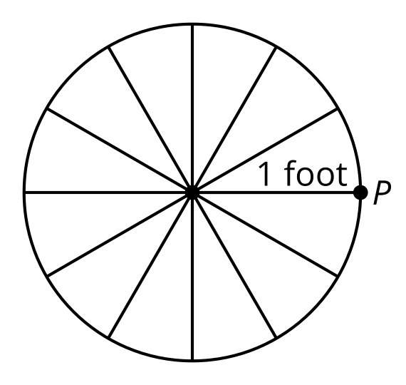
  - $\frac{π}{2}$
  - $π$
  - $2π$
  - $5π$
  - $10π$
- Here are some points labeled on the unit circle:
- 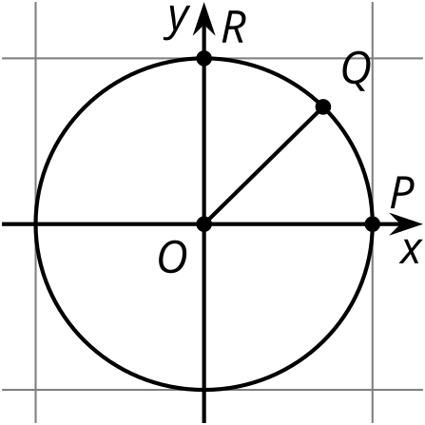
  - What is the measure in radians of angle $POR$?
  - Angle $POQ$ is halfway between 0 radians and angle $POR$. What is the measure in radians of angle $POQ$?
  - Label point $U$ on the circle so that the measure of angle $POU$ is $\frac{3π}{4}$.
  - Label point $V$ on the circle so that the measure of angle $POV$ is $\frac{3π}{2}$.

  - Mark the points on the unit circle with $x$-coordinate $\frac{4}{5}$.
  - 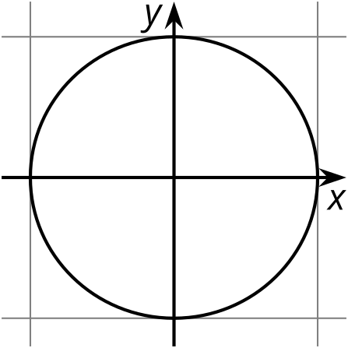
  - What are the $y$-coordinates of those points? Explain how you know.
- The point $\left(8,15\right)$ lies on a circle centered at $\left(0,0\right)$. Where does the circle intersect the $x$-axis? Where does the circle intersect the $y$-axis? Explain how you know.
- (From Unit 6, Lesson 1.)
- Triangles $ABC$ and $DEF$ are similar. Explain why $tan\left(A\right)=tan\left(D\right)$.
- 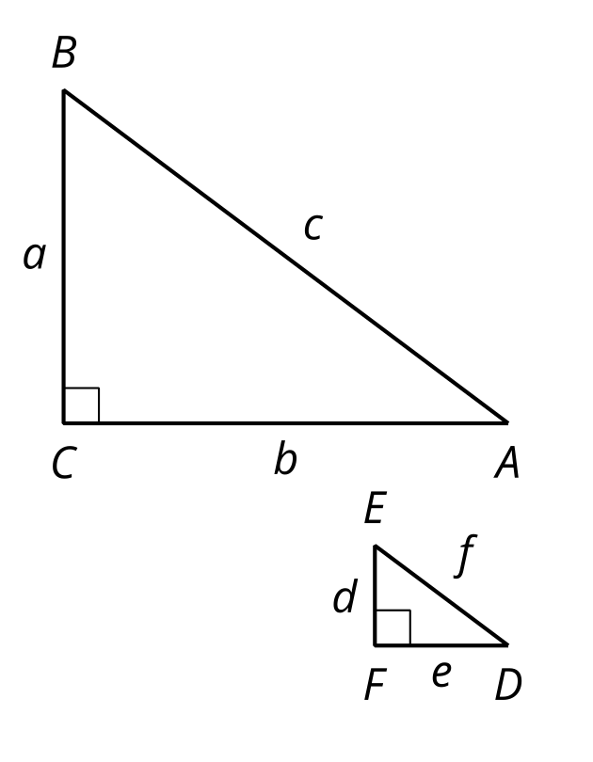
- (From Unit 6, Lesson 2.)
© CC BY 2019 by Illustrative Mathematics®

