Lesson 19 Practice Problems
- Functions $a,b,c,d,e,$ and $f$ are given below. Classify each function as linear, exponential, or neither.
  - $a\left(x\right)=3x$
  - $b\left(x\right)=3^{x}$
  - $c\left(x\right)=x^{3}$
  - $d\left(x\right)=9+3x$
  - $e\left(x\right)=9⋅3^{x}$
  - $f\left(x\right)=9⋅3x$
- Here are 4 equations defining 4 different functions, $a,b,c,$ and $d$. List them in order of increasing rate of change. That is, start with the one that grows the slowest and end with the one that grows the quickest.
- $a\left(x\right)=5x+3$
- $b\left(x\right)=3x+5$
- $c\left(x\right)=x+4$
- $d\left(x\right)=1+4x$
- Technology required. Function $f$ is defined by $f\left(x\right)=3x+5$ and function $g$ is defined by $g\left(x\right)={\left(1.1\right)}^{x}$.
  - Complete the table with values of $f\left(x\right)$ and $g\left(x\right)$. When necessary, round to 2 decimal places.
  - Which function do you think grows faster? Explain your reasoning.
  - Use technology to create graphs representing $f$ and $g$. What graphing window do you have to use to see the value of $x$ where $g$ becomes greater than $f$ for that $x$?
- $x$ | - $f\left(x\right)$ | - $g\left(x\right)$
- 1
- 5
- 10
- 20
- Functions $m$ and $n$ are given by $m\left(x\right)={\left(1.05\right)}^{x}$ and $n\left(x\right)=\frac{5}{8}x$. As $x$ increases from 0:
  - Which function reaches 30 first?
  - Which function reaches 100 first?
- The functions $f$ and $g$ are defined by $f\left(x\right)=8x+33$ and $g\left(x\right)=2⋅{\left(1.2\right)}^{x}$.
  - Which function eventually grows faster, $f$ or $g$? Explain how you know.
  - Explain why the graphs of $f$ and $g$ meet for a positive value of $x$.
- A line segment of length $ℓ$ is scaled by a factor of 1.5 to produce a segment with length $m$. The new segment is then scaled by a factor of 1.5 to give a segment of length $n$.
- What scale factor takes the segment of length $ℓ$ to the segment of length $n$? Explain your reasoning.
- (From Unit 5, Lesson 16.)
- A couple needs to get a loan of $5,000 and has to choose between three options.
  - Option A: $2\frac{1}{4}\%$ applied quarterly
  - Option B: $3\%$ applied every 4 months
  - Option C: $4\frac{1}{2}\%$ applied semi-annually
- If they make no payments for 5 years, which option will give them the least amount owed after 5 years? Use a mathematical model for each option to explain your choice.
- (From Unit 5, Lesson 17.)
- Here are graphs of five absolute value functions. Match the graph and equation that represent the same function.

- Graph 1
- 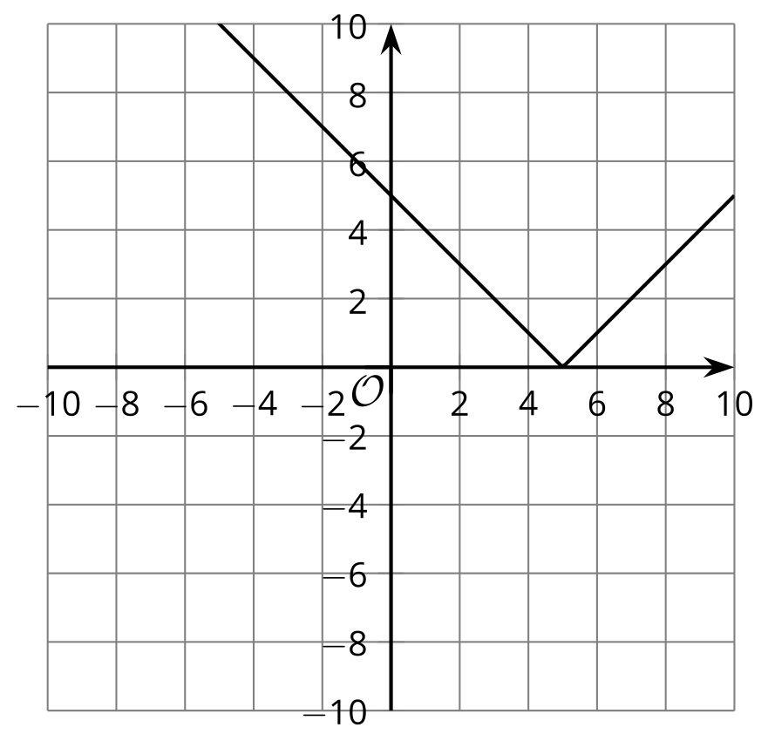

- Graph 2
- 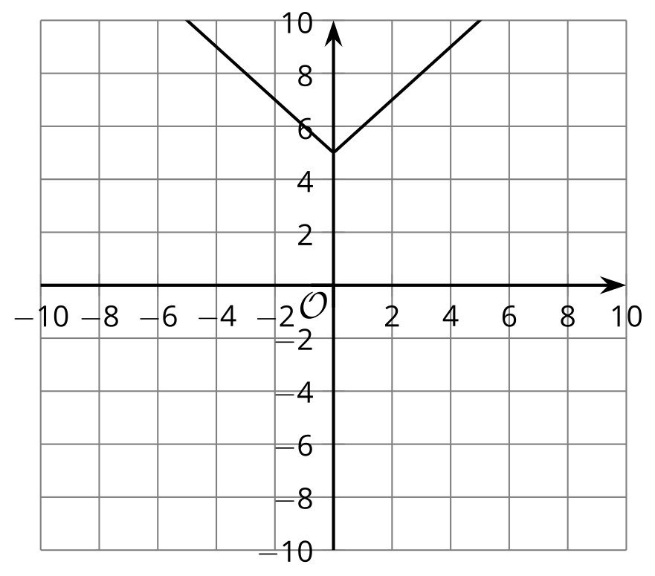

- Graph 3
- 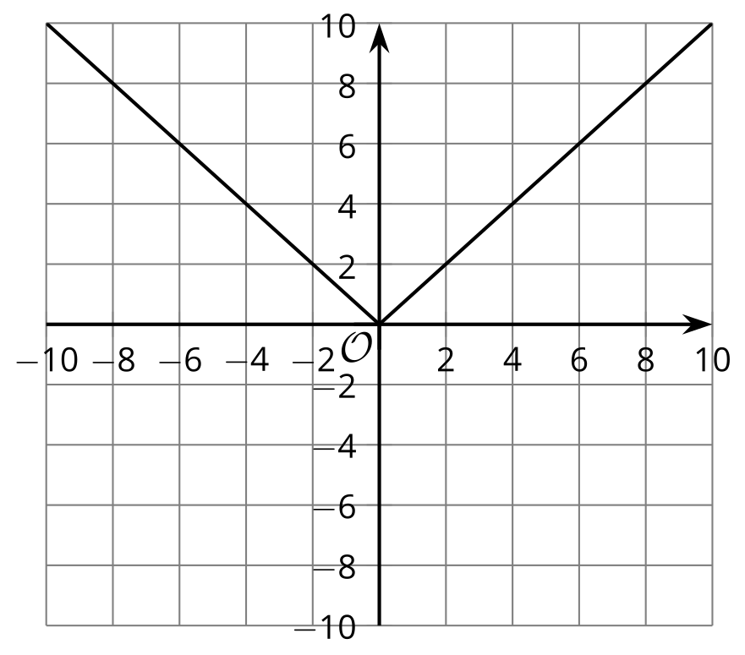

- Graph 4
- 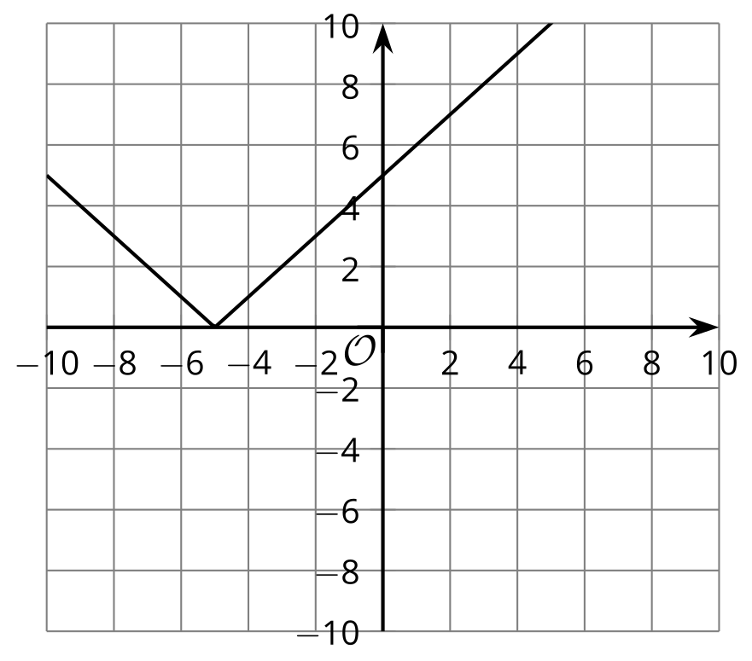

- Graph 5
- 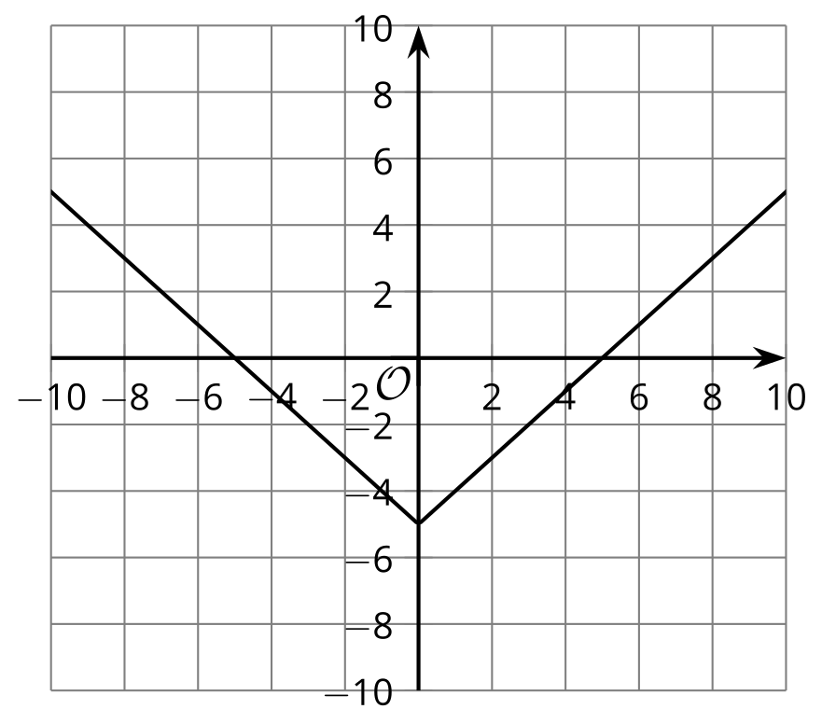

  - $f\left(x\right)=\left|x\right|$
  - $f\left(x\right)=\left|x−5\right|$
  - $f\left(x\right)=\left|x\right|−5$
  - $f\left(x\right)=\left|x+5\right|$
  - $f\left(x\right)=\left|x\right|+5$
  - Graph 1
  - Graph 2
  - Graph 3
  - Graph 4
  - Graph 5
- (From Unit 4, Lesson 14.)
© CC BY 2019 by Illustrative Mathematics®

