Unit 5 Lesson 10: Piecewise Linear Functions

1 Notice and Wonder: Lines on Dots (Warm up)

Student Task Statement
What do you notice? What do you wonder?
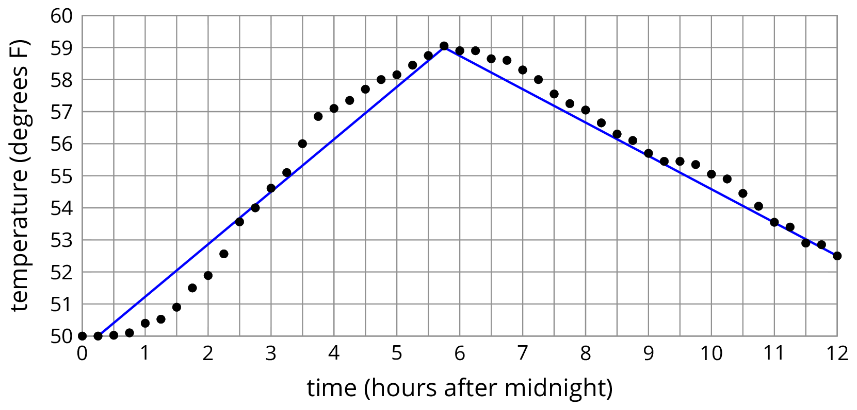

2 Modeling Recycling

Images for Launch
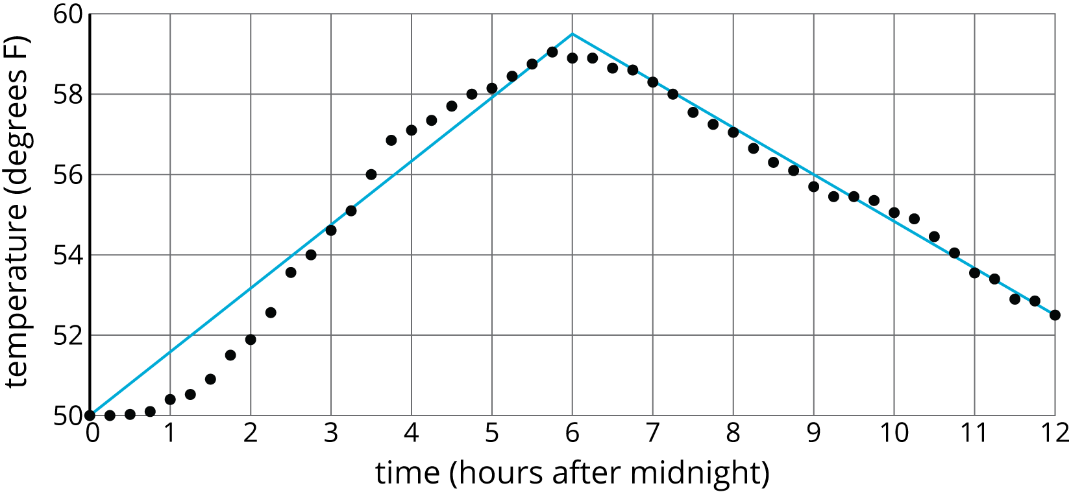
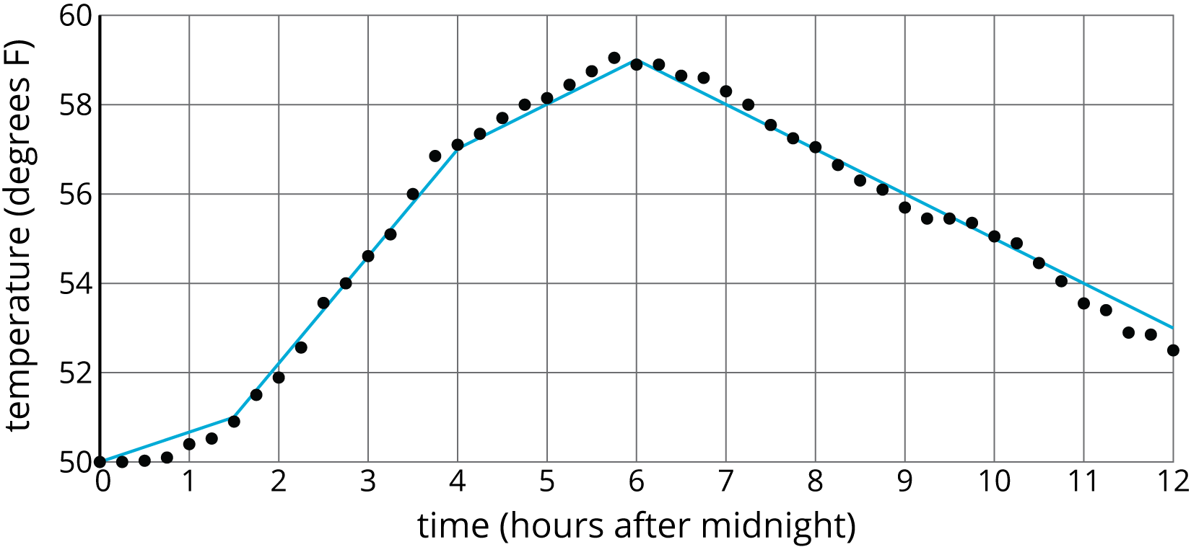

Student Task Statement
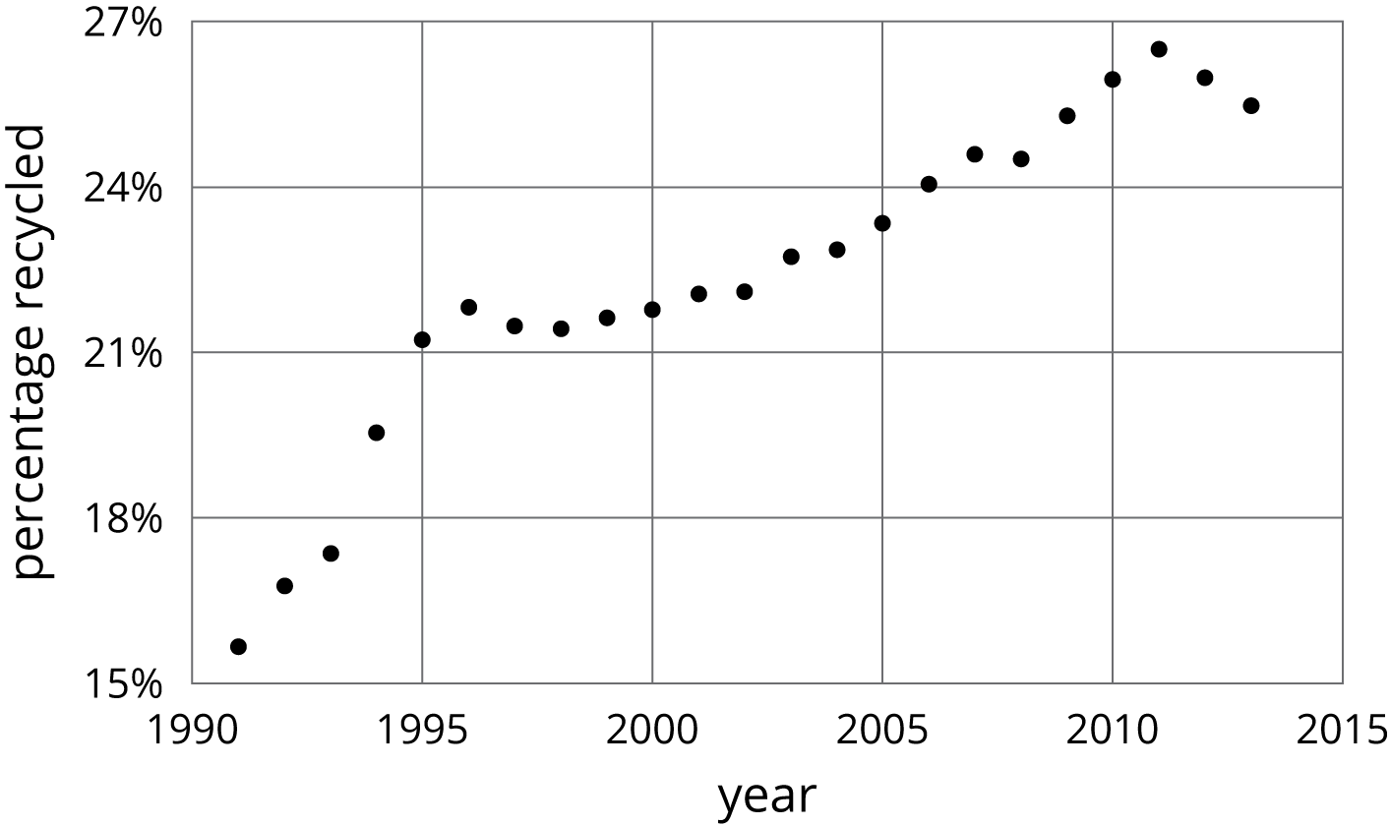
- Approximate the percentage recycled each year with a piecewise linear function by drawing between three and five line segments to approximate the graph.
- Find the slope for each piece. What do these slopes tell you?

3 Dog Bath

Student Task Statement
Elena filled up the tub and gave her dog a bath. Then she let the water out of the tub.
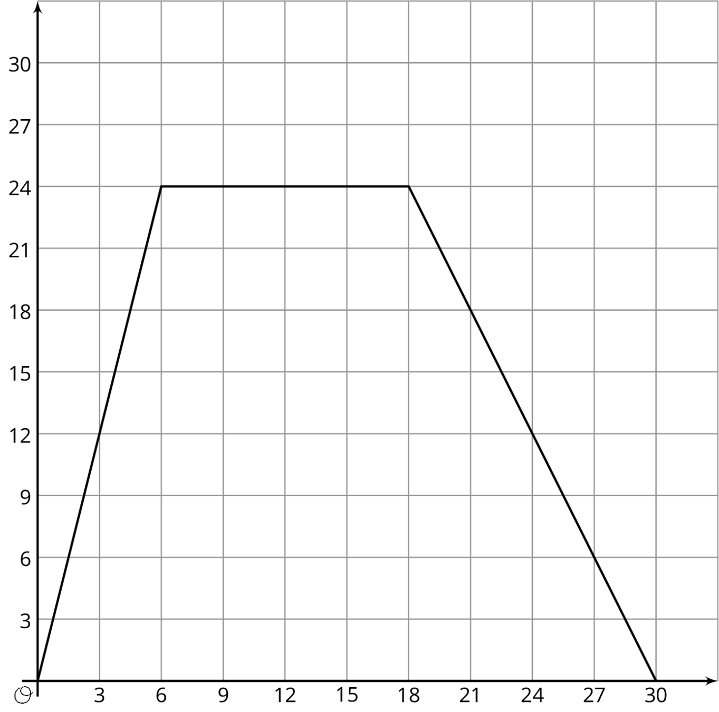
- The graph shows the amount of water in the tub, in gallons, as a function of time, in minutes. Add labels to the graph to show this.
- When did she turn off the water faucet?
- How much water was in the tub when she bathed her dog?
- How long did it take for the tub to drain completely?
- At what rate did the faucet fill the tub?
- At what rate did the water drain from the tub?

4 Distance and Speed (Optional)

Student Task Statement
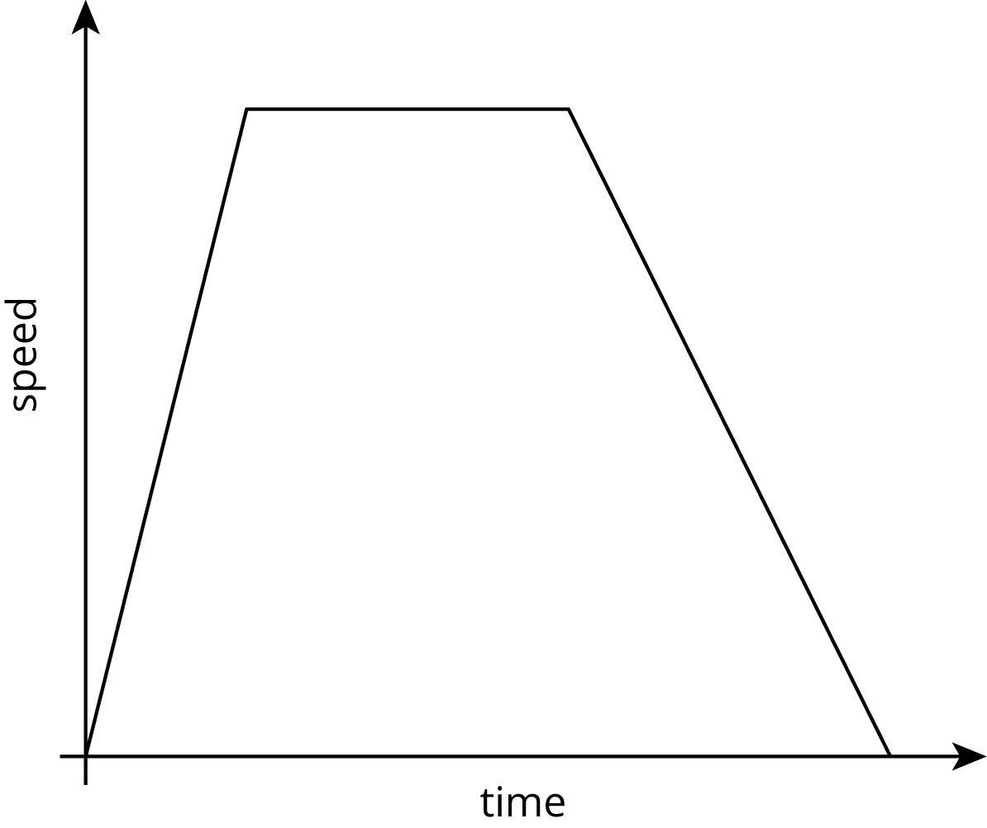
The graph shows the speed of a car as a function of time. Describe what a person watching the car would see.
© CC BY Open Up Resources. Adaptations CC BY IM.

