Lesson 16 Practice Problems
- Write three numerical expressions that are equivalent to $\left(0.0004\right)⋅\left(0.005\right)$.
- Find each product. Show your reasoning.
  - $\left(1.2\right)⋅\left(0.11\right)$
  - $\left(0.34\right)⋅\left(0.02\right)$
  - $120⋅\left(0.002\right)$
- You can use a rectangle to represent $\left(0.3\right)⋅\left(0.5\right)$.
  - What must the side length of each square represent for the rectangle to correctly represent $\left(0.3\right)⋅\left(0.5\right)$?
  - What area is represented by each square?
  - What is $\left(0.3\right)⋅\left(0.5\right)$? Show your reasoning.
- 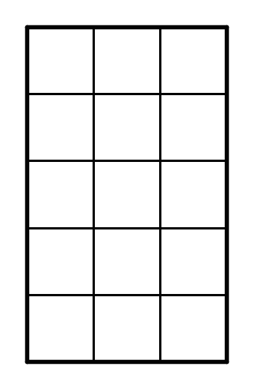
- Here is a rectangle that has been partitioned into four smaller rectangles.
- 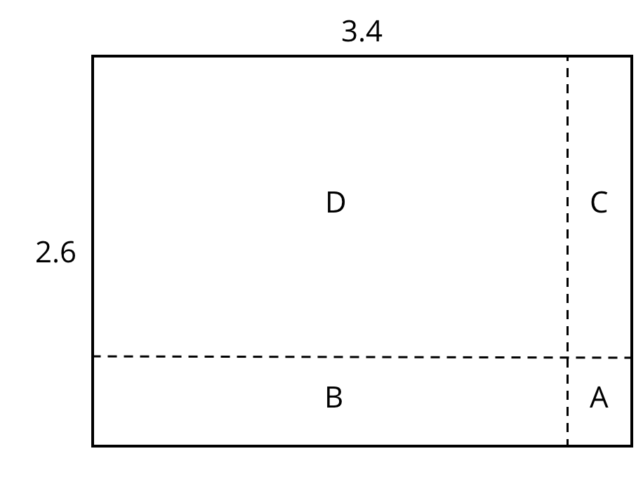
- For each expression, choose the sub-rectangle whose area, in square units, matches the expression.
  - $3⋅\left(0.6\right)$
  - $\left(0.4\right)⋅2$
  - $\left(0.4\right)⋅\left(0.6\right)$
  - $3⋅2$
- (From Unit 3, Lesson 17.)
- Find the value of $\frac{49}{50}÷\frac{7}{6}$ using any method.
- (From Unit 3, Lesson 7.)
- Calculate each difference. Show your reasoning.
  - $13.2−1.78$
  - $23.11−0.376$
  - $0.9−0.245$
- (From Unit 3, Lesson 15.)
© CC BY Open Up Resources. Adaptations CC BY IM.

