Lesson 9: Patrones en la tabla de multiplicar

Standards Alignments
Addressing | 3.OA.C.7, 3.OA.D.9

Teacher-facing Learning Goals
- Identify arithmetic patterns in the multiplication table and use them to find unknown multiplication facts.
- Recognize that multiplication is commutative.

Student-facing Learning Goals
- Encontremos patrones en la tabla de multiplicar y usémoslos para multiplicar.

Lesson Purpose
The purpose of this lesson is for students to identify and explain patterns in the multiplication table.
Students may have worked with the multiplication table in an optional lesson in a previous unit. In this lesson, they observe patterns and structures in the multiplication table that highlight properties of multiplication and are helpful for multiplying numbers. Although there is an opportunity to highlight multiple properties, the focus of this lesson is the commutative property (though students are not expected to name the property). Students notice that multiplying two numbers in any order gives the same product and make use of this observation to find unknown products (MP8).

Access for:

Students with Disabilities
- Action and Expression (Activity 2)

English Learners
- MLR2 (Activity 1)

Instructional Routines
Notice and Wonder (Warm-up)

Lesson Timeline
Warm-up | 10 min
Activity 1 | 20 min
Activity 2 | 15 min
Lesson Synthesis | 10 min
Cool-down | 5 min

Teacher Reflection Question
What surprised you about student thinking in the first activity?

Cool-down
(to be completed at the end of the lesson) 5min
Encuentra el producto desconocido

Standards Alignments
Addressing | 3.OA.D.9

Student-facing Task Statement
¿Qué número debería ir en lugar del signo de interrogación? Explica o muestra tu razonamiento.
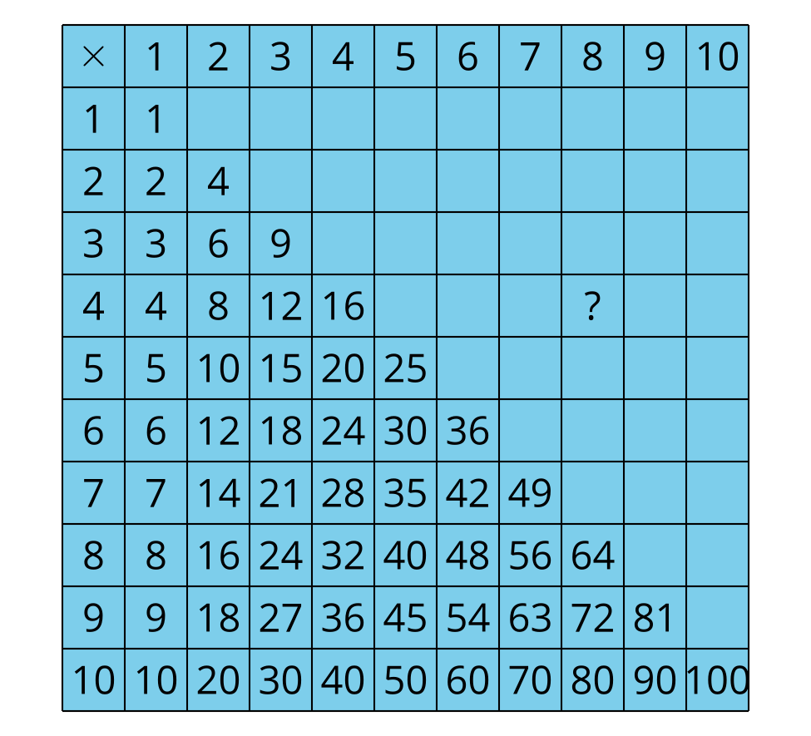

Student Responses
32. Sample responses: The table shows that $4×8$ is 32, and I know that $8×4$ has the same value as $4×8$, so it is also 32. I know that $4×4$ or 4 groups of 4 is 16. I added another 16 to get $8×4$, and $16+16=32$.

